CSCI 43018 – Research Project

Intelligent Drug Sales Forecasting and Healthcare
-Insights with Artificial Intelligence

Bope Ranasinghage Gihan Lakmal
CS/2020/015

Prepared Under the supervision of
Prof N G J Dias

Submitted in [partial] fulfilment of the requirements for the
Bachelor of Science Honours in Computer Science Degree

Faculty of Computing and Technology
University of Kelaniya
[2023/2024]

Declaration
I, Bope Ranasinghage Gihan Lakmal, hereby declare that the thesis entitled Intelligent Drug Sales Forecasting and Healthcare -Insights with Artificial Intelligence”, submitted to the Faculty of Computing and Technology, University of Kelaniya, in fulfilment of the requirements for the award of the degree of Bachelor of Science Honours in Computer Science, is the result of my own independent work carried out under the guidance and supervision of Prof N G J Dias. This work has not been submitted, in whole or in part, to any conference, journal, book, university, or other institution for the purpose of obtaining any degree, diploma, or other academic qualification. I confirm that all sources of information and ideas from other works have been properly acknowledged in accordance with accepted academic conventions.

Name of the Student: ______B R G Lakmal_____________________
Student Number: ______CS/2020/015_________________________
Signature of the Student: _______________________
Date: __________________________________________

Name of the Supervisor: _________________________
Department: _____________________________________
Signature of the Supervisor: ______________________
Date: ____________________________________________

Abstract
The pharmaceutical sector depends heavily on accurate demand forecasting to maintain proper stock levels, reduce medicine shortages, avoid overstocking, and support better healthcare service delivery. In Sri Lanka, predicting drug sales for areas is important because medicine demand can vary according to region, seasonal patterns, patient behaviour, disease trends, and healthcare access. Traditional forecasting methods are often limited when handling complex sales patterns, especially when the data contains non-linear trends, sudden changes, and differences between drug categories. Therefore, this research project focuses on developing an intelligent machine learning-based system for predicting drug sales data for areas in Sri Lanka.
The main objective of this project is to design and implement a drug sales prediction system that can forecast future pharmaceutical sales using historical sales data. The system uses multiple forecasting models, including statistical, machine learning, deep learning, and advanced artificial intelligence techniques. The implemented models include XGBoost, LightGBM, SARIMAX, Prophet, LSTM, GRU, Transformer, Temporal Fusion Transformer, N-BEATS, and Informer-based forecasting models. In addition to basic forecasting, the project also includes advanced components such as ensemble forecasting, meta-learning, neural architecture search, federated learning, causal inference, uncertainty estimation, and explainability. These components help improve prediction performance, support comparison between models, and provide more meaningful interpretation of the forecasting results.

The system was implemented as a microservice-based application with separate services for forecasting, model training, explainability, advanced AI functions, API gateway operations, and frontend interaction. A web-based user interface was developed to allow users to select drug categories, choose forecasting models, enter prediction dates, view forecast results, and access explanation outputs. The backend services expose REST API endpoints for forecasting, training, explainability, meta-learning, neural architecture search, federated learning, and causal analysis. The project also includes Docker-based deployment support, Kubernetes configuration, monitoring endpoints, and service health checks, making the implementation suitable for research demonstration and future deployment.

The dataset used in this research consists of historical pharmaceutical sales records categorized into multiple drug groups from C1 to C8. These categories represent different pharmaceutical product types, and the models were trained to identify time-series patterns within each category. The system evaluates forecasting behaviour using common performance measures such as Mean Absolute Error, Root Mean Squared Error, Mean Absolute Percentage Error, and related model comparison metrics. The inclusion of explainability techniques, such as SHAP-based and fallback feature importance analysis, helps identify how lagged sales values and temporal features influence the prediction results. Causal analysis was also included to examine possible relationships between temporal factors and drug sales behaviour.

The final implementation demonstrates that machine learning and deep learning methods can be effectively applied to pharmaceutical sales forecasting in a Sri Lankan context. The system provides a practical platform for analysing historical drug sales, forecasting future demand, comparing multiple models, and supporting data-driven decision-making. This research can assist pharmacies, healthcare planners, distributors, and decision-makers in improving inventory management, reducing medicine wastage, and planning pharmaceutical supply more effectively. Overall, the project contributes a complete AI-based forecasting framework for predicting drug sales data for specific areas in Sri Lanka, combining predictive accuracy, explainability, scalability, and practical usability.

Acknowledgement
I would like to express my sincere gratitude to everyone who supported me throughout the completion of this research project, Intelligent Drug Sales Forecasting and Healthcare -Insights with Artificial Intelligence.
First and foremost, I am deeply thankful to my supervisor, Professor Niomal Dias, for the valuable guidance, encouragement, and continuous support provided during this research. The advice and feedback given throughout the project helped me improve both the technical implementation and the overall quality of this thesis.
I would also like to thank the academic staff of Faculty of computing for providing the knowledge, resources, and learning environment that supported the successful completion of this work. Their guidance throughout my academic journey has been highly valuable.
My sincere appreciation goes to my family for their patience, motivation, and emotional support during the entire research process. Their encouragement gave me the strength to continue working hard, especially during challenging stages of the project.
I am also grateful to my workplace supervisor Mr. Sajeepan and Mr. Arun Balasundaram who shared ideas, gave feedback, and supported me in different ways while completing this research. Their support helped me stay focused and confident.
Finally, I would like to thank everyone who contributed directly or indirectly to the successful completion of this thesis. This research has been an important learning experience for me, and I am truly grateful for all the support I received.

Table of Contents
Chapter 1: Introduction 7
1.1. BACKGROUND OF THE STUDY 9
1.2. PROBLEM STATEMENT 10
1.3. RESEARCH GAP 11
1.4. AIM AND OBJECTIVE 13
1.5. SCOPE OF THE STUDY 14
1.6. SIGNIFICANCE OF THE STUDY 14
1.7. STRUCTURE OF THE THESIS 15
Chapter 2: Literature Review 17
Chapter 3: Methodology 23
3.1 SYSTEM WORKFLOW 23
3.2 DATASET DESCRIPTION 26
3.3 DATA PREPROCESSING 27
3.4 TIME-SERIES FEATURE ENGINEERING 29
3.5 DATA NORMALIZATION AND SCALING 30
3.6 TIME-SERIES TRAIN-TEST SPLITTING 31
3.7 FORECASTING MODEL DEVELOPMENT 32
3.7.1 Statistical Models 34
3.7.2 Machine Learning Models 34
3.7.3 Deep Learning Models 35
3.7.4 Ensemble Forecasting 36
3.8 MODEL TRAINING PROCESS 37
3.9 FORECASTING PROCESS 39
3.10 EXPLAIN ABILITY METHOD 40
3.11 ADVANCED AI MODULES 42
3.11.1 Meta-Learning 42
3.11.2 Neural Architecture Search 42
3.11.3 Federated Learning 43
3.11.4 Causal Inference 43
3.12 SYSTEM ARCHITECTURE 44
3.13 API DESIGN 45
3.14 WEB APPLICATION DESIGN 46
3.15 DEPLOYMENT AND MONITORING 47
3.16 EVALUATION METHOD 48
Chapter 4: Results and Analysis 50
4.1 STATISTICAL FORECASTING APPROACH 50
4.1.1 Experimental Setup for Drug Sales Time-Series Forecasting 51
4.2 MACHINE LEARNING APPROACH 55
4.2.1 Experiments with Lag-Based Machine Learning Models 56
4.3 DEEP LEARNING APPROACH 60
4.3.1 Experiments with Sequential Deep Learning Models 61
4.4 ENSEMBLE FORECASTING APPROACH 66
4.4.1 Experiments with Combined Forecasting Outputs 67
4.5 EXPLAINABILITY APPROACH 70
4.5.1 Experiments with Explainable Forecasting Outputs 71
4.6 ADVANCED AI APPROACH 74
4.6.1 Experiments with Advanced AI Modules 75
4.7 SYSTEM IMPLEMENTATION EXPERIMENTS 80
4.7.1 Experiments with Web Application Workflow 80
4.8 API AND ENDPOINT TESTING 84
4.8.1 Experimental Setup for API Testing 84
4.9 DEPLOYMENT AND MONITORING EXPERIMENTS 89
4.9.1 Docker-Based Deployment Testing 89
4.9.2 Docker Compose Multi-Service Testing 90
4.9.3 Kubernetes Configuration Testing 90
4.9.4 Prometheus Metrics Testing 90
4.10 BEST FORECASTING MODEL DISCUSSION 90
4.10.1 Best Statistical Model 91
4.10.2 Best Machine Learning Model 91
4.10.3 Best Deep Learning Model 91
4.10.4 Best Overall Forecasting Approach 92
4.10.5 Practical Suitability for Pharmacy Decision-Making 92
Chapter 5: Discussion 94
Chapter 6: Conclusion 98
6.1 INTRODUCTION 98
6.2 ACHIEVEMENT OF RESEARCH OBJECTIVES 99
6.3 SUMMARY OF KEY FINDINGS 100
6.4 RESEARCH CONTRIBUTIONS 101
6.5 PRACTICAL IMPLICATIONS 102
6.6 LIMITATIONS OF THE STUDY 103
6.7 RECOMMENDATIONS FOR FUTURE WORK 104
6.8 FINAL CONCLUSION 105

Appendix B API Endpoint Testing Results
Appendix C Model Performance Results
Appendix D System Screenshots
Appendix E Deployment Configuration Samples

List of Tables

Table ‎4-1: Category-Wise Performance of SARIMAX and Prophet 49
Table ‎4-2: Average Performance Comparison of Statistical Forecasting Models 52
Table ‎4-3: Category-Wise Performance of XGBoost and LightGBM 54
Table ‎4-4: Average Performance Comparison of Machine Learning Models 57
Table ‎4-5: Category-Wise MAE of the Main Deep Learning Models 59
Table ‎4-6: Average Performance Comparison of the Main Deep Learning Models 63
Table ‎4-7: Category-Wise Performance of Ensemble Forecasting Methods 65
Table ‎4-8: Selected Ensemble Forecasting Results 66
Table ‎4-9: Average Performance Comparison of Ensemble Forecasting Methods 66
Table ‎4-10: C1 XGBoost Fallback Lag-Importance Results 69
Table ‎4-11: Live API Validation of Advanced AI Modules 72
Table ‎4-12: Best C1 Architecture Returned by the NAS Endpoint 73
Table ‎4-13: Leading C1 Candidate Drivers Returned by Causal Discovery 75
Table ‎4-14: Live System Endpoint Validation Results 77
Table ‎4-15: Reported Final API Testing Summary 85
Table ‎4-16: Overall Average Performance of Forecasting Models 87
Table ‎5-1: Best Forecasting Model for Each Drug Category Based on MAE 91

List of Figures
Figure ‎1:1: Drug Category Classification Used in the Study 14
Figure ‎3:1:Data Preprocessing Pipeline 24
Figure ‎3:2:Drug Category Classification Used in the Study 26
Figure ‎3:3:Time-Series Feature Engineering Process 29
Figure ‎3:4: Time-Series Train-Test Splitting Method 31
Figure ‎3:5: Forecasting Model Development Workflow 32
Figure ‎3:6: Model Training and Artifact Storage Flow 37
Figure ‎3:7: Forecasting Request-Response Flow 39
Figure ‎3:8: Explainability Workflow for Forecasting Outputs 40
Figure ‎3:9: Advanced AI Module Workflow 42
Figure ‎3:10: Microservice-Based System Architecture 44
Figure ‎3:11: API Gateway Communication Flow 45
Figure ‎4:1: C1 Drug Sales Forecast Using the SARIMAX Model 52
Figure ‎4:2: C1 Drug Sales Forecast Using the Prophet Model 53
Figure ‎4:3: Category-Wise MAE Comparison of SARIMAX and Prophet 55
Figure ‎4:4: C1 Drug Sales Forecast Using the XGBoost Model 57
Figure ‎4:5: C1 Drug Sales Forecast Using the LightGBM Model 58
Figure ‎4:6: Category-Wise MAE Comparison of XGBoost and LightGBM 60
Figure ‎4:7: C1 Drug Sales Forecast Using the LSTM Model 62
Figure ‎4:8: C1 Drug Sales Forecast Using the GRU Model 63
Figure ‎4:9: C1 Drug Sales Forecast Using the Transformer Model 64
Figure ‎4:10: Category-Wise MAE Comparison of LSTM, GRU, and Transformer 66
Figure ‎4:11: Category-Wise MAE Comparison of Ensemble Forecasting Methods 70
Figure ‎4:12: C1 XGBoost Fallback Lag-Feature Importance 73
Figure ‎4:13: C1 XGBoost Fallback Lag-Contribution Analysis 73
Figure ‎4:14: Hidden-Layer Dimensions of the Best C1 NAS Architecture 77
Figure ‎4:15: Correlations of Leading C1 Candidate Sales Drivers 79
Figure ‎4:16: Live Drug Sales Forecasting Web Interface 82
Figure ‎4:17: Live Historical Forecast Endpoint Test Result 85
Figure ‎4:18: C1 XGBoost Training-Artifact Verification 86
Figure ‎4:19: Live Explainability Endpoint Test Result 86
Figure ‎4:20: Live Advanced-AI Endpoint Test Results 87
Figure ‎4:21: Live Health and Availability Endpoint Results 88
Figure ‎4:22: Current Automated API and Service Smoke-Test Summary 89
Figure ‎4:23: Overall Average MAE and RMSE Comparison of Forecasting Models 92
Figure ‎5:1: Category-Wise Best Forecasting Model Based on MAE 95

Introduction
The healthcare sector depends strongly on the continuous availability of medicines. Medicines are not ordinary commercial products because their availability directly affects patient treatment, recovery, and public health. Pharmacies, hospitals, medical distributors, and healthcare authorities must ensure that the right medicines are available at the right time and in the right quantity. When this process is not managed properly, it can create serious consequences. A shortage of essential medicines can delay treatment, increase patient risk, and reduce the quality of healthcare services. On the other hand, excessive stock can lead to expired medicines, financial loss, storage problems, and unnecessary wastage. Therefore, medicine stock management is both a healthcare issue and an inventory planning issue.
Drug sales forecasting is an important method that can support better medicine stock planning. By analysing historical sales data, pharmacies and healthcare organizations can identify demand patterns and estimate future sales more accurately. Previous research on pharmaceutical drug sales prediction has shown that time-series forecasting can support categorical medicine demand prediction and improve planning decisions [1]. These forecasts can help decision makers decide how much stock to purchase, when to reorder medicines, and which categories of medicines may require more attention. In the pharmaceutical domain, demand can change due to many reasons, including seasonal illness, regional disease patterns, doctor prescriptions, patient purchasing behaviour, economic conditions, and supply chain limitations. Because of this, manual stock estimation alone is not enough for reliable decision making.
In the Sri Lankan context, pharmaceutical stock planning has become more challenging due to recent national and global events. The COVID-19 pandemic affected the importation, transportation, and distribution of medicines. Travel restrictions, supplier delays, and changes in healthcare access created uncertainty in medicine demand and availability. After that, the financial crisis in Sri Lanka created further pressure on the pharmaceutical sector. Foreign currency shortages, import restrictions, price increases, and supply delays affected the availability of many medicines. These situations showed the importance of having intelligent and data-driven systems that can support medicine demand forecasting and reduce the risk of shortages.
The demand for medicines can also vary from one area to another. A pharmacy located near a hospital may have different sales behaviour compared to a pharmacy in a residential or rural area. Similarly, areas with higher population density, different income levels, and different disease patterns may show different sales trends. For example, respiratory medicines may have higher demand during periods of increased cough, asthma, or breathing related illnesses, while antihistamines may increase during allergy related seasons. Pain relief and anti-inflammatory medicines may also show repeated demand patterns because they are commonly used by many patients. Therefore, forecasting drug sales for specific areas is useful for understanding local demand behaviour.
Traditional forecasting methods and manual estimation techniques are often limited when dealing with real world pharmaceutical sales data. Drug sales data is usually time-dependent, meaning that past sales values can influence future sales values. Sales may also contain trends, seasonal changes, sudden increases, and irregular fluctuations. Time-series forecasting research has shown that sequential models are useful when historical values and temporal dependencies influence future outputs [2] . A single forecasting method may not perform well for every drug category because each category can have different demand behaviour. Therefore, this research uses multiple forecasting approaches, including statistical models, machine learning models, deep learning models, and ensemble forecasting methods. Machine learning methods such as XGBoost have also been explored in recent drug sales prediction research, showing their usefulness for structured forecasting problems [3]. This allows the system to compare different models and identify suitable forecasting behaviour for different drug categories.
The dataset in this research is organized into eight drug sales categories, labelled C1 to C8. These categories represent common pharmaceutical groups such as anti-inflammatory drugs, analgesics, anxiolytics, sedatives, respiratory medicines, and antihistamines. The dataset was prepared in a category-wise time-series format so that each category could be analysed separately. Original data was collected from two pharmacies in Kurunegala. However, because pharmaceutical sales data is sensitive business information, it was difficult to collect a large amount of complete real-world data. Some pharmacy owners were not willing to share full records due to concerns related to privacy, tax, and business confidentiality. Therefore, synthetic data was also used to strengthen the dataset. The final dataset is a hybrid dataset that combines original pharmacy sales data and synthetic data.
This research does not focus only on producing a prediction value. It aims to develop a complete intelligent forecasting system that can be used practically. Artificial intelligence has been widely applied in healthcare-related prediction and decision-support tasks, including disease prediction, image based diagnosis, and medical analytics [1] [4, 5] [6]. These studies show that AI-based approaches can identify meaningful patterns from healthcare data and support more informed decision-making. In the same direction, this project applies AI methods to pharmaceutical sales forecasting. The system includes a web-based interface where a user can select a drug category, choose a forecasting model, enter a future date, and view the predicted sales result. The backend is designed using a microservice-based architecture with separate services for forecasting, training, explainability, advanced AI functions, API gateway handling, and frontend interaction. This architecture makes the system easier to maintain, test, deploy, and extend in the future.
Explainability is another important part of this research. In healthcare related systems, users should be able to understand the reason behind a prediction. A forecast value without explanation may not be enough for pharmacy decision-making. Previous research on explainable artificial intelligence in sales forecasting has highlighted the importance of transparency for business decision support [7]. For example, a pharmacy owner may want to know whether the prediction was mainly influenced by recent sales, older sales patterns, weekly changes, monthly trends, or other time-series features. To address this need, the system includes explainability methods such as SHAP-based analysis and fallback feature importance techniques. These methods help make the forecasting output more transparent and understandable.
The project also explores advanced artificial intelligence concepts such as meta-learning, neural architecture search, federated learning, and causal inference. Meta-learning is useful for studying how knowledge from one drug category can support another category. Neural architecture search supports automated model improvement. Federated learning is important for privacy-preserving forecasting, especially when multiple pharmacies may want to train models without directly sharing raw data. Causal inference helps examine possible relationships between time-related factors and sales behaviour. These advanced modules increase the research value of the system and show possible future directions for pharmaceutical forecasting.
Overall, this research presents an AI based drug sales prediction system for specific areas in Sri Lanka. It combines time-series forecasting, machine learning, deep learning, explainability, advanced AI modules, web application development, API-based access, and deployment preparation. The purpose of the system is to support better pharmacy stock planning, reduce medicine shortages, minimize wastage, and improve data-driven decision-making in the pharmaceutical sector. This study demonstrates how artificial intelligence can be applied to a practical healthcare problem and how forecasting systems can support both business efficiency and public health outcomes.

BACKGROUND OF THE STUDY
In the healthcare sector, the availability of medicines plays a major role in maintaining public health and ensuring proper patient care. Pharmacies, hospitals, distributors, and healthcare authorities must manage drug stocks carefully because both medicine shortages and overstocking can create serious problems. If essential medicines are not available at the correct time, patients may face treatment delays, increased health risks, and higher medical costs. At the same time, if medicines are overstocked, pharmacies and suppliers may experience financial losses due to expired stock, poor inventory turnover, and unnecessary wastage. Therefore, accurate drug sales prediction has become an important requirement for improving pharmaceutical supply chain management. Previous research on categorical drug sales prediction has shown that forecasting methods can support pharmaceutical demand planning and inventory-related decision-making [1].
In Sri Lanka, the need for reliable medicine demand forecasting became more important after recent national and global challenges. During the COVID-19 pandemic in 2019 and the following years, medicine supply chains were affected due to import restrictions, transport limitations, and changes in patient purchasing behaviour. Later, the Sri Lankan financial crisis in 2022 created further issues such as import limitations, foreign currency shortages, increased medicine prices, and delays in pharmaceutical supply. These situations showed that pharmacies and healthcare suppliers need better planning methods to maintain essential medicine availability during uncertain periods.
Drug demand can vary based on different factors such as location, seasonal disease patterns, population behaviour, healthcare access, climate conditions, and regional treatment requirements. For example, respiratory-related medicines may show higher demand during rainy periods or seasons with increased breathing difficulties, while antihistamines may increase during allergy-related periods. Similarly, sales patterns can be different across areas due to population density, income levels, nearby hospitals, prescription behaviour, and customer purchasing habits. Because of these variations, simple manual estimation methods are not enough to support reliable medicine stock planning. A data-driven forecasting system is required to identify patterns in historical drug sales and predict future demand more accurately. Since drug sales data is time-dependent, time-series forecasting methods are suitable because they can learn patterns from past observations and support future demand prediction [2].

PROBLEM STATEMENT
The main problem addressed in this research is the difficulty of accurately predicting future pharmaceutical drug sales for specific areas based on the data in Sri Lanka. Many pharmacies still depend on manual experience, rough estimation, or previous purchasing habits when deciding future stock levels. Although this may work in stable conditions, it becomes less reliable when demand changes due to seasonal patterns, disease outbreaks, economic problems, medicine price changes, or supply chain restrictions. Previous research has shown that pharmaceutical drug sales prediction can support better categorical demand forecasting and planning decisions [1].
If future demand is underestimated, pharmacies may not have enough stock to serve patients. This can directly affect patient treatment, especially for medicines used for pain relief, respiratory conditions, allergies, anxiety, and other common health needs. If demand is overestimated, pharmacies may purchase more stock than required, which can lead to expired medicines, financial loss, and storage issues. Therefore, poor forecasting affects both business performance and healthcare service quality.
Another problem is that many existing forecasting approaches are limited to single models or simple prediction methods. They may not compare statistical, machine learning, and deep learning models together. Time-series forecasting research shows that different forecasting methods can behave differently depending on the structure, temporal dependencies, and complexity of the data [2]. Some systems also do not provide explainability, which means users cannot understand why a prediction was made. In a healthcare-related environment, this is a limitation because pharmacy owners and healthcare planners need understandable results before making inventory decisions. Explainable AI has been identified as important for improving transparency and supporting decision-making in forecasting-based business systems [7]. Therefore, this research focuses on developing a complete AI-based drug sales forecasting system that supports prediction, model comparison, explainability, and practical web/API-based usage.

RESEARCH GAP
Although many studies have been conducted on sales forecasting, healthcare analytics, and pharmaceutical demand prediction, several gaps still remain when applying these approaches to real-world drug sales forecasting in Sri Lanka. Many existing forecasting systems are developed for general retail sales, finance, energy demand, or large-scale business forecasting, but only a limited number of studies focus specifically on pharmaceutical drug sales prediction. Pharmaceutical sales forecasting is different from ordinary product sales forecasting because medicine demand is directly connected with public health, disease patterns, seasonal illnesses, healthcare access, supply chain limitations, and patient treatment needs. Therefore, a forecasting method that works for general sales data may not be fully suitable for predicting drug demand in a healthcare environment.
Another major research gap is the lack of Sri Lanka-specific pharmaceutical forecasting systems. Sri Lanka has experienced several recent disruptions that affected medicine availability, including COVID-19-related import restrictions, global shipping delays, and the 2022 financial crisis. These conditions created medicine shortages, import delays, price changes, and uncertainty in pharmaceutical supply planning. However, most existing forecasting studies do not consider the practical challenges faced by Sri Lankan pharmacies, distributors, and healthcare authorities. As a result, there is a need for a forecasting system that is designed around local pharmaceutical sales data and can support category-wise demand prediction in the Sri Lankan context.
Most existing approaches also focus on a single forecasting model or a limited set of techniques. Some studies use traditional statistical methods such as ARIMA, SARIMAX, or Prophet, while others use machine learning models such as XGBoost or deep learning models such as LSTM. However, relying on one model can limit forecasting reliability because different drug categories may behave differently. Some categories may follow seasonal patterns, some may show non-linear demand changes, and others may depend strongly on recent sales trends. Therefore, there is a gap in systems that compare multiple statistical, machine learning, deep learning, and ensemble models within the same forecasting framework.
A common limitation in many forecasting systems is the lack of explainability. In healthcare-related decision-making, users need to understand the reason behind a prediction before trusting it. To address this issue, the proposed system includes an explainability component using SHAP-based feature importance analysis. This allows users to identify which previous sales patterns contributed most strongly to the forecast, improving transparency and trust in the prediction results. Many machine learning and deep learning models can produce accurate outputs, but they often behave like black-box systems. This creates difficulty for pharmacists, distributors, and healthcare planners who need to justify purchasing and stock management decisions. Existing drug sales forecasting studies often focus mainly on prediction accuracy and provide limited explanation about which historical features or lagged sales values influenced the forecast. Therefore, there is a need for explainable forecasting systems that provide both prediction results and interpretable support. Another gap is that most research implementations remain as isolated experiments, notebooks, or standalone scripts. They may show forecasting results, but they are not always developed into complete usable systems. A practical healthcare forecasting solution should provide API access, web-based interaction, model training support, health monitoring, and deployment readiness. Many existing studies do not include microservice architecture, frontend dashboards, API gateways, Docker deployment, Kubernetes configuration, or monitoring endpoints. This creates a gap between research models and real-world deployable healthcare analytics systems.
There is also limited use of advanced AI techniques such as meta-learning, neural architecture search, federated learning, and causal inference in pharmaceutical sales prediction.
Meta-learning can support adaptation between drug categories, neural architecture search can help identify suitable model structures, federated learning can support privacy preserving training across multiple pharmacies or branches, and causal inference can provide deeper understanding of possible factors influencing drug sales. However, these methods are still rarely integrated into drug sales forecasting systems. This research addresses these gaps by developing a complete AI-based drug sales prediction system that combines multiple forecasting models, explainability, advanced AI modules, API-based access, and microservice-based deployment for pharmaceutical sales forecasting in Sri Lanka.

AIM AND OBJECTIVE
The aim of this research is to develop an AI-based drug sales forecasting system for predicting future category-wise pharmaceutical demand in specific areas of Sri Lanka.
The objectives of this research are:
- To collect and prepare historical drug sales data under category-wise groups from C1 to C8.
- To preprocess and format the dataset into a suitable time-series structure for forecasting.
- To implement statistical forecasting models such as SARIMAX and Prophet.
- To implement machine learning models such as XGBoost and LightGBM using lag-based features.
- To implement deep learning models such as LSTM, GRU, Transformer, TFT, N-BEATS, and Informer for sequential sales forecasting.
- To compare model performance using evaluation metrics such as MAE, RMSE, and MAPE.
- To include explainability methods such as SHAP and fallback feature importance analysis.
- To develop a web-based interface and API-based backend for practical forecasting access.
- To design the system using a microservice-based architecture with deployment support through Docker and Kubernetes.

SCOPE OF THE STUDY
The scope of this research is limited to predicting pharmaceutical drug sales using historical category-wise sales data. The dataset is organized into eight drug categories, labelled C1 to C8. These categories include anti-inflammatory drugs, analgesics, anxiolytics, sedatives, respiratory medicines, and antihistamines. The research focuses on forecasting future sales values for these categories rather than predicting individual patient prescriptions or medical diagnoses.
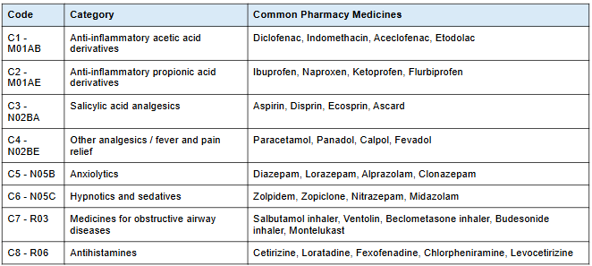
Figure ‎1:1: Drug Category Classification Used in the Study
The dataset used in this project is a hybrid dataset. Original sales data was collected from two pharmacies in Kurunegala, but the available real data was limited because pharmacy owners were not willing to share complete sensitive business records due to tax, privacy, and commercial concerns. Therefore, synthetic data was also used to increase the dataset size and support model training and testing. The final dataset combines original pharmacy sales data and synthetic data.
This research covers data preprocessing, feature engineering, model training, forecasting, model evaluation, explainability, API development, web application design, and deployment preparation. However, the system is not intended to replace doctors, pharmacists, or healthcare authorities. It is designed as a decision-support tool that can help users understand future sales trends and make better stock planning decisions.

SIGNIFICANCE OF THE STUDY
This research is significant because it applies artificial intelligence to a practical healthcare and pharmacy related problem in Sri Lanka. Artificial intelligence has already shown strong potential in healthcare prediction and decision-support applications, including disease prediction and medical image-based diagnosis [8] [4] [5] [6]. Accurate drug sales forecasting can help pharmacies maintain better stock levels, reduce medicine shortages, avoid overstocking, and minimize expired medicine wastage. Previous research on categorical drug sales forecasting has shown that time-series based prediction can support pharmaceutical demand planning and improve inventory-related decision-making [1]. This is especially important in countries where medicine imports, supply chains, and prices can be affected by economic and political conditions.
The system can support pharmacy owners by giving them data-driven forecasts instead of depending only on manual judgement. It can also support distributors and healthcare planners by identifying future demand patterns for different medicine categories. Since the system includes multiple forecasting models, users can compare model behaviour and choose a suitable forecasting approach based on accuracy and practical needs. Time-series forecasting research shows that different forecasting models may perform differently depending on the structure and temporal behaviour of the dataset [2]. Therefore, comparing statistical, machine learning, and deep learning models is useful for identifying the most suitable forecasting approach for each drug category.
Another important significance of this research is explainability. By including SHAP-based analysis and fallback feature importance methods, the system helps users understand the reason behind forecast outputs. Explainable AI has been recognized as important for improving transparency and supporting decision-making in forecasting-based business systems [7]. This improves trust and makes the system more useful for real decision-making. The microservice-based architecture, API gateway, frontend dashboard, Docker support, Kubernetes configuration, and monitoring features also make the project more practical as a deployable software solution.

STRUCTURE OF THE THESIS
This thesis is organized into six chapters. Chapter 1 introduces the research background, problem statement, research gap, aim, objectives, scope, and significance of the study. Chapter 2 reviews related literature on artificial intelligence in healthcare, drug sales forecasting, time-series forecasting, machine learning, deep learning, explainable AI, and advanced AI methods. Chapter 3 explains the methodology used in the research, including dataset description, preprocessing, feature engineering, forecasting models, explainability methods, system architecture, API design, web application design, deployment, and evaluation methods.
Chapter 4 presents the results and analysis of the implemented system. It discusses the performance of statistical models, machine learning models, deep learning models, ensemble forecasting, explainability outputs, advanced AI modules, web application testing, API endpoint testing, and deployment testing. Chapter 5 discusses the findings in relation to the research objectives, including model performance, practical usefulness, strengths, limitations, and future improvements. Chapter 6 concludes the thesis by summarizing the overall research outcomes and explaining how the project objectives were achieved

Literature Review
The use of artificial intelligence and machine learning in healthcare has increased rapidly during recent years because these technologies can support prediction, diagnosis, planning, and decision-making. In healthcare environments, accurate prediction is highly important because decisions are often connected with patient safety, treatment availability, resource allocation, and cost management. Many recent studies show that machine learning and deep learning models can identify hidden patterns from medical data more effectively than traditional manual analysis. For example, Abbas et al. [1] proposed an explainable artificial intelligence-based model for ocular disease prediction, showing how AI can be used not only to make predictions but also to improve transparency in healthcare decision making. Similarly, Khan et al. [2], Nazir et al. [3], Gamage et al. [4], and Wijesinghe et al. [5] applied deep learning techniques for medical image-based disease recognition. Although these studies mainly focus on disease identification, they show the broader importance of AI in healthcare and support the idea that intelligent systems can improve medical decision-making when properly designed and evaluated.
In the pharmaceutical domain, one of the most important challenges is predicting future drug demand accurately and in advance. Drug sales forecasting helps pharmacies, hospitals, distributors, importers, and healthcare authorities maintain proper stock levels and avoid both shortages and overstocking. This requirement became more important during recent crisis periods in Sri Lanka. During the COVID-19 pandemic that began in 2019 and continued into the following years, international transportation restrictions, lockdowns, shipping delays, and interruptions in global supply chains affected the availability of many essential goods, including medicines. Since Sri Lanka depends significantly on imported pharmaceutical products and raw materials, any delay in importation can directly affect medicine availability in local pharmacies and hospitals. Later, the 2022 financial and economic crisis created further pressure on the healthcare supply chain. Foreign currency shortages, import restrictions, increased prices, fuel shortages, and delays in supplier payments made it difficult to import medicines on time. As a result, the country experienced shortages of several pharmaceutical products, while healthcare providers and patients faced uncertainty regarding medicine availability.
These situations show that traditional manual stock estimation methods are not sufficient during unstable economic and public health conditions. If future demand is underestimated, essential medicines may become unavailable at the exact time patients need them, which can delay treatment, increase health risks, and reduce public trust in the healthcare system. This is especially serious for drugs required for chronic illnesses, pain management, respiratory conditions, infections, and emergency treatment. On the other hand, if future demand is overestimated, pharmacies and suppliers may purchase excessive stock, which can lead to expired medicines, storage issues, unnecessary financial burden, and wastage of limited resources. During periods of import restrictions and economic instability, these mistakes become even more costly because medicine procurement decisions must be made carefully with limited foreign exchange and restricted supply channels. Therefore, drug sales prediction is not only a business or inventory management problem, but also a healthcare planning and national resource management problem.
Time-series forecasting is commonly used for sales prediction because sales data usually depends on time-based patterns. Historical sales values often contain trends, seasonality, sudden changes, and repeating cycles. In pharmaceutical sales, these patterns may be influenced by disease outbreaks, seasonal illness, climate changes, holidays, healthcare access, and patient behaviour. A time-series forecasting system attempts to learn from previous sales values and estimate future demand. In this type of problem, the order of data is important because the past directly influences the future. Therefore, random data splitting is usually not suitable for time-series forecasting. Instead, historical records must be used carefully so that the model learns from earlier periods and predicts later periods. This makes drug sales forecasting different from ordinary classification or regression problems.
Traditional statistical forecasting methods such as ARIMA, SARIMAX, and Prophet are widely used for time-series data because they can model trend and seasonal behaviour. SARIMAX is useful when the data contains autoregressive patterns, moving average behaviour, and seasonal effects. Prophet is also popular because it is designed to handle trend changes and seasonality in a relatively flexible manner. These models are useful as baseline approaches because they provide interpretable forecasting behaviour and are suitable for many standard time-series problems. However, pharmaceutical sales data can be more complex because medicine demand may change due to non-linear patterns, irregular demand spikes, sudden shortages, and category-specific differences. Therefore, traditional statistical methods alone may not always be sufficient.
Ekanayake et al. [6] directly addressed the problem of predicting medical drug sales in a specific area using categorical drug sales data and time-series forecasting. Their study is highly relevant to this research because it focuses on pharmaceutical sales prediction in a Sri Lankan context. The study demonstrates that historical categorical drug sales data can be used to forecast future sales and support decision-making in medicine supply management.
This provides a strong foundation for the present project, which extends the idea further by implementing a complete forecasting system with multiple models, web-based interaction, explainability, advanced AI components, and microservice-based deployment.
Machine learning models such as XGBoost and LightGBM have become popular for forecasting and regression tasks because they can capture non-linear relationships and handle structured data effectively. XGBoost is especially useful in sales prediction because it builds an ensemble of decision trees and improves performance through gradient boosting. Xiong [10] proposed an AI-driven model for drug sales prediction using XGBoost and enhanced optimization techniques, showing that boosting-based models can be effective for pharmaceutical demand forecasting. This supports the use of XGBoost in the current research, especially for category-wise drug sales prediction using lag-based features generated from historical sales records. LightGBM is another gradient boosting framework that is suitable for efficient model training and structured forecasting tasks. These models are useful because they can learn relationships between previous sales values and future sales outputs without requiring strict statistical assumptions.
Deep learning methods are also widely used in time-series forecasting because they can learn complex temporal patterns from sequential data. Recurrent Neural Networks, especially Long Short-Term Memory networks and Gated Recurrent Units, are commonly used when the prediction depends on previous time steps. Hewamalage, Bergmeir, and Bandara [8] reviewed recurrent neural networks for time-series forecasting and discussed their strengths, limitations, and future directions. Their work shows that RNN-based models are useful for capturing temporal dependencies but also require careful design, preprocessing, and evaluation. In the current project, LSTM and GRU models are included because drug sales data contains sequential behaviour where previous sales values can influence future demand.
Transformer-based models have also become important in modern forecasting because they use attention mechanisms to learn relationships across time steps. Unlike traditional recurrent models, Transformers can capture long-range dependencies more effectively and can process sequences in a more flexible way. In this project, Transformer-based approaches such as Transformer, Temporal Fusion Transformer, N-BEATS, and Informer models are considered to improve forecasting ability and compare deep learning performance against traditional and machine learning models. These models are useful when drug sales patterns are affected by both short-term and long-term changes. By including multiple deep learning models, the system does not depend on a single architecture and can compare how different sequence learning methods behave for pharmaceutical sales data.
Another important area in the literature is explainable artificial intelligence. In healthcare-related systems, prediction accuracy alone is not enough. Users should also be able to understand how and why the system produces a particular output. Explainability is especially important in medical and pharmaceutical applications because decision-makers must trust the system before using its recommendations. Lim and Zohdy [9] discussed explainable artificial intelligence for business decision support using sales forecasting as a case study. Their work highlights the importance of transparency in forecasting systems, especially when predictions are used for operational decisions. This directly supports the explainability component of the present research, where SHAP-based analysis and fallback feature importance methods are used to explain the contribution of lagged sales features and temporal patterns.
In this project, explainability is connected directly to the forecasting workflow. When the system predicts future sales for a selected drug category, it is also important to identify which past sales values or temporal patterns influenced the output. For example, lagged sales values may show whether recent demand has a strong effect on the predicted result. This type of explanation can help pharmacists, distributors, and healthcare planners understand whether the forecast is based on stable historical behaviour or recent changes in demand. In real healthcare decision-making, this is valuable because users may be reluctant to rely on a black-box prediction without any supporting explanation. Therefore, explainability improves both technical transparency and practical usability.
In addition to forecasting and explainability, this project also investigates several advanced artificial intelligence techniques that can strengthen pharmaceutical sales prediction beyond a single-model forecasting approach. The system mainly focuses on category-wise drug sales forecasting using historical time-series data from C1 to C8 drug categories, but it extends the prediction pipeline with meta-learning, neural architecture search, federated learning, and causal inference modules. Meta-learning is included because drug categories may not always have equal sales behaviour, data volume, or forecasting difficulty. In a real pharmaceutical environment, some drug groups may have long and stable sales histories, while others may have limited or irregular records due to changes in demand, supplier availability, seasonal illnesses, or import restrictions. A meta-learning approach allows the system to learn transferable patterns across multiple drug categories and then adapt this learned knowledge to a target category with fewer samples or different sales behaviour.
Neural Architecture Search is another advanced component included in this project to reduce the manual effort involved in selecting suitable neural network structures for drug sales prediction. Since time-series forecasting performance can depend heavily on model structure, number of layers, hidden units, activation behaviour, and training configuration, manual experimentation can become time-consuming and inconsistent. The NAS component explores different architecture configurations and attempts to identify better-performing structures for the given drug category. This supports automated model optimization and makes the system more research-oriented because it does not depend only on fixed predefined models.
Federated learning is also included as a future-ready design for pharmaceutical forecasting because real sales data may belong to different pharmacies, hospitals, distributors, or regional branches. In practice, these organizations may not be willing or legally allowed to share raw sales records due to privacy, commercial sensitivity, or operational restrictions. Federated learning provides a privacy-preserving training mechanism where multiple clients can train local models using their own data, and only model updates are aggregated to build a global model. This makes the system suitable for a distributed healthcare environment where drug sales prediction can be improved using data from many locations without centralizing sensitive records.
Causal inference is used to move the system beyond correlation-based forecasting. Most forecasting models can identify patterns between historical inputs and future sales, but they do not directly explain whether a particular temporal factor may influence changes in drug demand. The causal analysis module in this project examines relationships between variables such as sales lag values, weekly trends, seasonal indicators, and sales behaviour. This helps the system provide more meaningful analytical insight rather than only producing a numerical forecast. For example, if lagged sales values or seasonal indicators show a strong relationship with future demand, decision-makers can better understand the reasons behind predicted changes. This is important in pharmaceutical planning because demand may be influenced by healthcare events, seasonal diseases, regional behaviour, and supply conditions.
A major difference between this research and many existing forecasting studies is that the present project is not limited to model training alone. It is implemented as a complete system with a microservice-based architecture. The system includes separate services for forecasting, model training, explainability, advanced AI processing, frontend interaction, and API gateway routing. This design improves maintainability because each service has a separate responsibility. For example, the forecasting service handles prediction requests, the training service handles model training, the explainability service provides interpretation outputs, and the advanced AI service handles NAS, federated learning, and causal inference functions. The API gateway provides a single access point for backend functions, while the frontend service allows users to interact with the system through a web interface.
This system-level design is important because a practical healthcare analytics system must be usable, testable, and deployable. A forecasting model that works only in a notebook or script may be useful for experimentation, but it may not be suitable for real users. In contrast, a web-based and API-based system allows users to select drug categories, choose models, enter prediction dates, and view forecast results through an interface. The project also includes Docker support, Kubernetes configuration, monitoring endpoints, and service health checks. These features show that the system is designed not only for academic experimentation but also for future deployment and scaling.

Overall, the reviewed literature shows that artificial intelligence has strong potential in healthcare prediction, pharmaceutical sales forecasting, and decision support. Previous studies have demonstrated the effectiveness of deep learning in medical applications [1]-[5], the relevance of time-series forecasting for drug sales prediction [6], the usefulness of recurrent neural networks in forecasting [8], the importance of explainability in sales forecasting [9], and the strength of XGBoost-based models for drug sales prediction [10]. However, many existing approaches focus only on a single model, a limited experiment, or a standalone forecasting pipeline. The present research addresses this limitation by developing a complete AI-based drug sales prediction system for specific areas in Sri Lanka. The implemented system combines statistical forecasting models, machine learning models, deep learning models, ensemble forecasting, explainability, meta-learning, neural architecture search, federated learning, causal inference, API-based access, and web-based visualization. It is also designed using a microservice architecture with separate services for forecasting, training, explainability, advanced AI operations, frontend interaction, and API gateway routing. This makes the project not only a forecasting experiment but also a complete deployable healthcare analytics platform that can support real-world pharmaceutical demand planning, inventory management, and decision-making in the Sri Lankan healthcare context.

Methodology
In this research, an AI-based pharmaceutical drug sales prediction system is developed to forecast future drug sales for specific categories and areas in Sri Lanka. The system is designed using historical time-series sales data, where drug categories are represented from C1 to C8. The overall methodology follows a complete forecasting pipeline, starting from data collection and preprocessing, then moving into feature engineering, model training, prediction generation, explainability, evaluation, and system deployment.
The framework integrates multiple forecasting approaches instead of depending on a single model. Statistical models, machine learning models, deep learning models, and advanced AI-based methods are used to analyse different types of sales patterns. Statistical models such as SARIMAX and Prophet are used to identify trend and seasonality. Machine learning models such as XGBoost and LightGBM are used to learn non-linear relationships from lag-based sales features. Deep learning models such as LSTM, GRU, Transformer, TFT, N-BEATS, and Informer are used to capture sequential and long-term time-series behaviour. In addition, advanced modules such as meta-learning, neural architecture search, federated learning, and causal inference are included to improve research depth and future scalability.
The system is implemented as a microservice-based application with separate services for forecasting, model training, explainability, advanced AI processing, frontend interaction, and API gateway routing. This structure allows the system to be modular, testable, scalable, and easier to maintain. A web-based interface is also developed so that users can select a drug category, choose a forecasting model, enter a prediction date, and view the forecast output with visual results.
The methodology also includes explainability techniques to make the prediction results more understandable. SHAP-based analysis and fallback feature importance methods are used to identify how previous sales values and temporal features influence the forecast. This is important because pharmaceutical forecasting supports healthcare and stock management decisions, where users need both prediction accuracy and interpretability. The overall system methodology is represented in the block diagram below.

SYSTEM WORKFLOW
The system workflow of this research is designed as a complete end-to-end pharmaceutical drug sales prediction pipeline. The process begins with the collection of historical drug sales data, where sales records are organized according to different pharmaceutical categories from C1 to C8. These raw sales records are treated as time-series data because each sales value is connected to a specific date or time period. After collecting the data, preprocessing is carried out to prepare the dataset for model training. This includes reading the category-wise CSV files, parsing date values, arranging records in chronological order, handling missing or inconsistent values, and preparing the sales column as the prediction target.
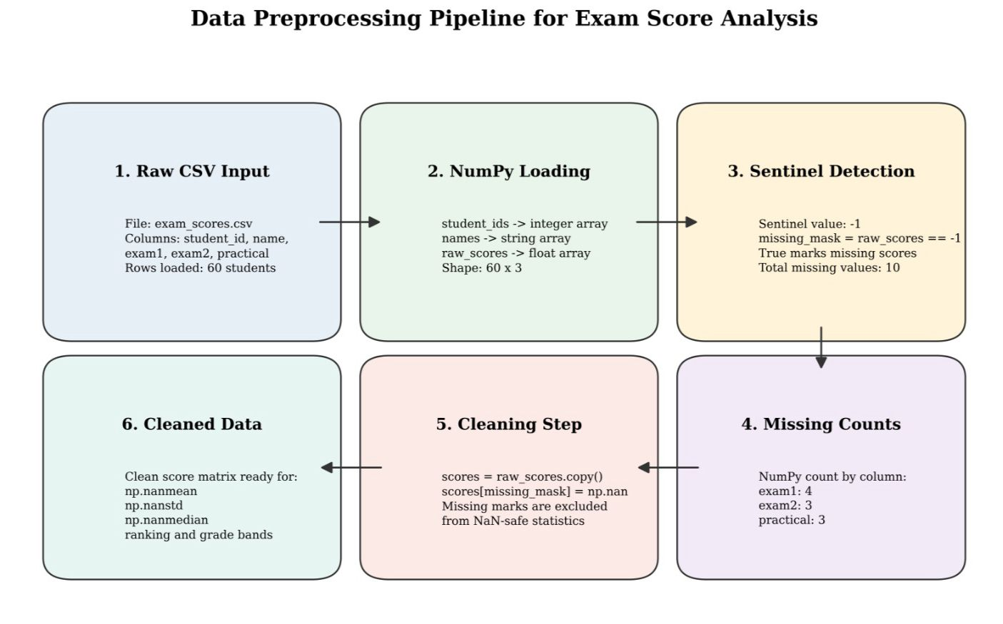
Figure ‎3:1:Data Preprocessing Pipeline

After preprocessing, feature engineering is performed to convert the raw time-series data into a suitable format for forecasting models. Since future drug sales are highly influenced by previous sales behaviour, lag features are generated from past sales values. These lag features allow machine learning models such as XGBoost and LightGBM to learn the relationship between previous demand and future sales. For deep learning models, the sales data is transformed into sequential input windows so that models such as LSTM, GRU, Transformer, TFT, N-BEATS, and Informer can learn temporal patterns from historical sequences. Additional time-based patterns such as trend and seasonality are also considered where applicable.
Once the data is prepared, the model training stage is carried out. Different forecasting models are trained separately for each drug category so that the unique sales behaviour of each category can be captured. Statistical models such as SARIMAX and Prophet are used to model trend and seasonal behaviour. Machine learning models such as XGBoost and LightGBM are trained using lag-based features. Deep learning models such as LSTM, GRU, and Transformer-based architectures are trained using normalized sequential data. The trained models and related scaler files are saved as model artifacts so that they can be reused later during forecasting without retraining every time.
During the forecasting stage, the user selects a drug category, forecasting model, and prediction date through the web interface. This request is sent to the backend API, where the relevant trained model is loaded and used to generate the predicted drug sales value. If the selected date belongs to the historical data period, the system can return the closest available actual value. If the date is in the future, the selected model performs forecasting based on the learned historical sales patterns. The forecast result is returned with details such as predicted sales value, selected category, model used, prediction date, and a visualization output.
After generating the forecast, the explainability stage provides interpretation for the prediction. SHAP-based explainability or fallback feature importance methods are used to identify which previous sales values or lag features contributed most to the prediction. This is important because pharmaceutical forecasting supports decision-making, and users need to understand the reason behind the predicted demand. The explainability output helps users interpret whether the forecast is mainly influenced by recent sales behaviour, seasonal changes, or other time-based patterns.
Finally, the system delivers the output through both a web application and REST API services. The web interface allows users to interact with the system visually by selecting inputs and viewing forecast results, charts, and explanation outputs. The API layer allows forecasting, training, explainability, and advanced AI functions to be accessed programmatically. The complete workflow is supported by a microservice architecture, where separate services handle forecasting, training, explainability, advanced AI operations, frontend interaction, and API gateway routing. This workflow makes the system modular, scalable, and suitable for future deployment in pharmaceutical demand planning environments.

DATASET DESCRIPTION

Figure ‎3:2:Drug Category Classification Used in the Study

The dataset used in this research was developed using a combination of real pharmaceutical sales data and synthetic data. At the beginning of the project, the main objective was to collect original drug sales records directly from pharmacies in Sri Lanka. For this purpose, data was collected from two pharmacies located in the Kurunegala area. These records provided an initial understanding of how pharmaceutical sales vary over time and how different drug groups show different demand patterns. The collected data included sales information related to commonly sold medicine categories, and these records were used as the foundation for building the dataset.
However, during the data collection process, it was difficult to obtain a large amount of real pharmacy sales data. Many pharmacy owners were not willing to share detailed sales records because pharmaceutical sales information is sensitive business data. Some owners were concerned about privacy, tax-related issues, commercial confidentiality, and possible misuse of business information. Because of these limitations, the amount of real data collected was not sufficient to train and evaluate multiple forecasting models effectively. Since machine learning and deep learning models require a reasonable amount of historical data to learn sales patterns, the dataset was expanded using synthetic data generation.
Therefore, the final dataset used in this research can be considered a hybrid dataset, consisting of both original pharmacy sales data and synthetically generated data. The real data collected from the Kurunegala pharmacies was used to understand realistic sales behaviour, while the synthetic data was generated to increase the dataset size and support model training. The synthetic data was designed to follow similar time-series characteristics such as trend, fluctuation, and category-wise variation. This approach allowed the system to train and test different forecasting models while still being based on real pharmaceutical sales patterns.
The final dataset is organized into eight drug categories, named C1 to C8. Each category represents a different group of pharmaceutical products. These categories were created manually by grouping medicines according to their usage and sales behaviour. Category-wise organization is important because different drug groups may have different demand patterns. For example, some drugs may show seasonal demand, while others may have more stable or irregular sales behavior. By separating the dataset into C1 to C8 categories, the forecasting system can train and predict sales for each drug group individually.
The dataset is stored in a time-series format. Each record contains a date value and a corresponding sales value for a specific drug category. The date column represents the time period of the sales record, while the sales column represents the quantity or sales amount recorded for that category. Since the data is time-dependent, the order of the records is important. Earlier records are used to learn historical patterns, and later records are used for testing and forecasting.
For implementation, the dataset is stored as category-wise CSV files. Separate CSV files are maintained for each drug category, such as C1.csv, C2.csv, C3.csv, and so on up to C8.csv. This structure makes it easier to load, preprocess, train, and forecast each category independently. The model training pipeline reads the relevant category file, prepares the time-series data, creates lag features or sequential input windows, and trains the selected forecasting model. This category-wise file structure also supports future expansion, where additional drug categories or area-specific datasets can be added to the system.
Overall, the dataset used in this research represents a practical solution to the data availability challenges in pharmaceutical sales forecasting. Although collecting large-scale real pharmacy data was difficult due to privacy and business sensitivity, the hybrid dataset allowed the research to proceed while preserving realistic sales behaviour. The combination of original Kurunegala pharmacy data and synthetic time-series data provided a suitable foundation for developing, training, and evaluating the proposed drug sales prediction system.

DATA PREPROCESSING
Data preprocessing is an important stage in this research because the forecasting models require clean and properly formatted time-series data. The original dataset contained pharmaceutical sales records collected from pharmacies and later expanded using synthetic data. Before using these records for model training, the data had to be arranged into a consistent structure so that each drug category could be processed separately. Since the final dataset contains multiple drug categories from C1 to C8, preprocessing was performed category-wise.
The first preprocessing step was date parsing. Each sales record was connected with a specific date or time period, so the date column had to be converted into a proper date-time format. This allowed the system to recognize the chronological order of the records and treat the dataset as time-series data. Date parsing is especially important in forecasting because the order of data points directly affects model training. After converting the date values, the records were sorted according to time so that earlier sales values appeared before later sales values.
The next step was missing value handling. In real-world pharmacy data, missing values can occur due to incomplete records, manual entry mistakes, unavailable sales logs, or data collection limitations. Missing values can negatively affect model training and may produce inaccurate forecasts if they are not handled properly. Therefore, the dataset was checked for missing or invalid values before training. Where possible, missing values were corrected or filled using suitable methods such as forward filling, backward filling, or interpolation based on nearby sales records. If any records were highly inconsistent or unusable, they were removed from the dataset.
After handling missing values, the dataset was formatted category-wise. Each drug category from C1 to C8 was stored in a separate CSV file. This made it easier to train and evaluate models independently for each category. Category-wise formatting is useful because different drug categories can have different demand patterns. For example, one category may show seasonal demand, while another may show stable or irregular sales behaviour. By separating the data, the model can learn the unique sales behaviour of each category instead of mixing all drug groups into one general pattern.
Data cleaning was also carried out to improve dataset quality. This included removing duplicate records, checking incorrect date formats, ensuring numerical sales values, and identifying unusual sales entries. Since the dataset contains both original and synthetic records, cleaning helped maintain consistency between both data sources. Sales values were checked to make sure they were suitable for forecasting and did not contain invalid text values or incorrect formats. This step helped reduce noise and prepared the dataset for reliable feature creation.
Finally, the pre-processed data was prepared for model input. For machine learning models such as XGBoost and LightGBM, lag features were created from previous sales values so that the models could learn how past demand influences future demand. For deep learning models such as LSTM, GRU, and Transformer-based models, the sales data was converted into sequential input windows. These input sequences allow the models to learn temporal patterns from historical sales behaviour. For models that require scaling, the data was normalized before training. After preprocessing, the cleaned and formatted data became suitable for statistical forecasting, machine learning, deep learning, and advanced AI-based forecasting models.

TIME-SERIES FEATURE ENGINEERING
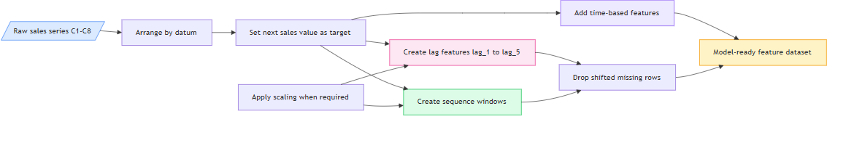
Figure ‎3:3:Time-Series Feature Engineering Process

In this project, feature engineering was performed to convert the category-wise drug sales records into a suitable format for different forecasting models. Since the dataset is time-series based, the most important information comes from previous sales values and time-related patterns. Drug sales usually do not change randomly; the demand for a future date is often influenced by the sales behaviour of previous days or weeks. Therefore, past sales values, time order, trend behaviour, and seasonal patterns were considered during feature preparation.
The main feature engineering method used in the project is lag feature generation. For machine learning models such as XGBoost and LightGBM, previous sales values are converted into lag features. For example, if the system predicts the next sales value for category C1, it uses a fixed number of previous sales records as input. In the implementation, lag-based forecasting is used so that the model can learn the relationship between recent historical sales and the next expected sales value. These lag features help the model identify whether sales are increasing, decreasing, or remaining stable.
For deep learning models such as LSTM, GRU, Transformer, TFT, N-BEATS, and Informer, the sales records are prepared as sequential windows. Instead of using only one previous value, a sequence of past sales values is given to the model. This allows the model to learn temporal behaviour from the data. LSTM and GRU models are useful for learning short-term and medium-term dependencies, while Transformer-based models can capture longer relationships in the sales sequence. This is important because pharmaceutical sales may follow repeated demand behaviour across time.
prophet is also used in this project to model trend and seasonality in the category-wise drug sales data. For Prophet, the date column is formatted as ds, and the sales value is formatted as y, which is the required input structure for Prophet forecasting. This allows Prophet to analyse historical sales movement over time and generate future sales predictions. Prophet is useful in this research because pharmaceutical sales may contain seasonal patterns, gradual trend changes, and repeated demand behaviour across weekly or monthly periods. By including Prophet, the system can compare traditional time-series forecasting behaviour with machine learning and deep learning models.
Trend-based features are also important in this project. A trend shows whether the sales of a drug category are generally increasing, decreasing, or moving steadily over time. In pharmaceutical sales, a trend may happen due to changes in patient demand, medicine availability, seasonal illnesses, or supply limitations. By considering the sales movement across time, the forecasting models can better understand long-term behaviour instead of only depending on a single previous value.
Seasonal and time-related behavior is also considered in the advanced analysis part of the project. The causal inference module creates temporal features such as week, month, quarter, year, lag values, and seasonal indicators. These features help analyze whether drug sales are affected by time-based patterns. For example, some medicines may have higher demand during rainy seasons, respiratory illness periods, or allergy-related periods. Monthly and weekly patterns are useful because pharmaceutical demand can change depending on seasonal disease behavior and patient purchasing habits.
Past sales values are important because they represent the most direct signal of future demand. If a drug category has shown high sales in recent periods, there is a possibility that demand may continue unless there is a sudden external change. Similarly, if sales have decreased over several previous periods, the future demand may also be lower. By using lag features, sequential windows, Prophet-based date formatting, trend information, and seasonal time-based variables, the system prepares the dataset in a way that allows different forecasting models to learn meaningful drug sales patterns from the C1-C8 category-wise data.

DATA NORMALIZATION AND SCALING
Data normalization and scaling were applied in this project to prepare the drug sales time-series data for different forecasting models. Since the sales values can vary between drug categories, using raw values directly may affect the training stability of some models, especially deep learning models. Models such as LSTM, GRU, Transformer, TFT, N-BEATS, and Informer learn from sequential numerical inputs, so scaling helps keep the input values within a suitable range and improves training efficiency.
In the implementation, MinMaxScaler was used for models such as LSTM, GRU, Transformer, and LightGBM. This scaler transforms the sales values into a normalized range, allowing the models to learn patterns without being affected by large differences in numerical scale. For other advanced deep learning models such as TFT, N-BEATS, and Informer, StandardScaler was used to standardize the data based on mean and standard deviation. This is useful for models that perform better when the input data is cantered and scaled.
After training, the scaler objects were saved separately with the trained models. This is important because the same scaling process must be used again during forecasting. When the system loads a trained model to predict future drug sales, it also loads the corresponding scaler file. The input data is first transformed using the saved scaler, and after prediction, the forecasted value is converted back into the original sales scale using inverse transformation. This ensures that the final output shown to the user is in the actual sales value format, not in the normalized scale.Therefore, normalization and scaling are important preprocessing steps in this project because they support stable model training, improve compatibility with deep learning architectures, and ensure that predictions can be correctly transformed back into meaningful pharmaceutical sales values.

TIME-SERIES TRAIN-TEST SPLITTING
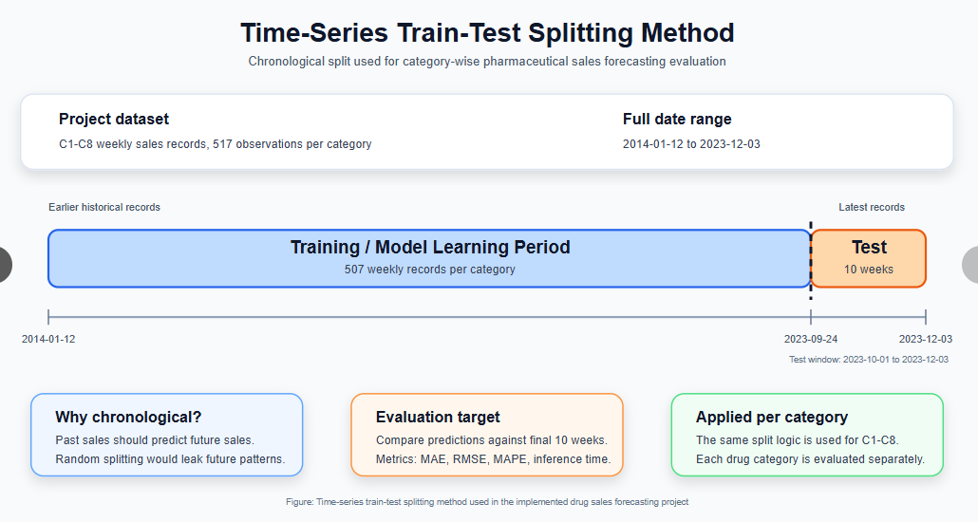
Figure ‎3:4: Time-Series Train-Test Splitting Method

In this project, the drug sales dataset is handled as time-series data because each sales value is connected to a specific date or time period. Therefore, the order of the records is very important. Unlike normal machine learning datasets, time-series data should not be randomly shuffled before training and testing. If random splitting is used, future sales values may appear in the training set while earlier values appear in the testing set. This can cause data leakage and give unrealistic model performance because the model would indirectly learn information from the future.
To avoid this issue, the dataset was split while preserving chronological order. Earlier sales records were used for model training, and later sales records were used for testing and evaluation. This method better represents the real-world forecasting situation, where a model is trained using past sales data and then used to predict future demand. For example, the system learns from previous historical sales values of a drug category and then forecasts sales for upcoming time periods.
This chronological splitting approach was applied category-wise for the C1 to C8 drug sales datasets. Each category was treated as an individual time-series forecasting problem. By using earlier data for training and later data for testing, the models could be evaluated based on how well they predict unseen future sales behaviour. This is important because pharmaceutical sales forecasting is mainly concerned with future demand planning, not random record prediction.
Maintaining the correct time order also helps models learn realistic trend and seasonal patterns. If the data were shuffled, models such as SARIMAX, Prophet, LSTM, GRU, Transformer, and other forecasting models would lose the natural sequence of sales behaviour. Therefore, time-series train-test splitting was used to preserve the temporal structure of the dataset and ensure that evaluation results are closer to real forecasting conditions.

FORECASTING MODEL DEVELOPMENT

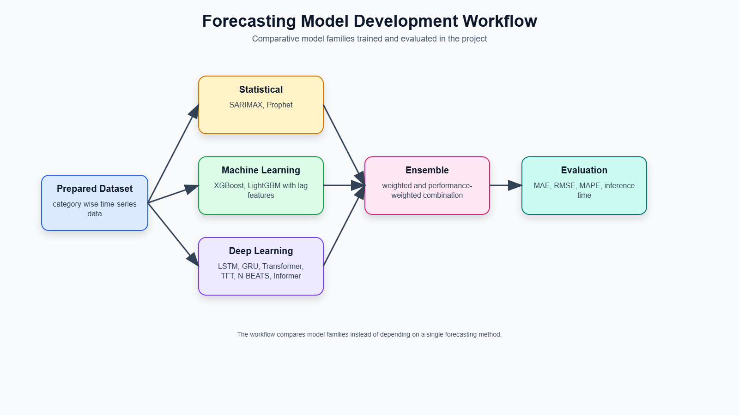
Figure ‎3:5: Forecasting Model Development Workflow

Forecasting model development is one of the main stages of this research. The purpose of this stage is to train and implement different forecasting models that can predict future pharmaceutical drug sales using historical category-wise sales data. Since drug demand can behave differently across categories, the system does not depend on a single forecasting method. Instead, multiple model types are developed and compared, including statistical models, machine learning models, deep learning models, and ensemble-based approaches.
The dataset is divided into drug categories from C1 to C8, and each category is treated as a separate forecasting problem. This category-wise approach allows the models to learn the individual sales behaviour of each drug group. Some categories may have stable sales patterns, while others may show seasonal, irregular, or trend-based changes. By training models separately for each category, the system can produce more focused predictions instead of using one generalized model for all drug categories.
The model development process begins by preparing the data according to the requirements of each model. For statistical forecasting models such as SARIMAX and Prophet, the data is prepared in a time-series format with date and sales values. For machine learning models such as XGBoost and LightGBM, lag features are created from previous sales values so that the models can learn how past demand affects future sales. For deep learning models such as LSTM, GRU, Transformer, TFT, N-BEATS, and Informer, the data is converted into sequential input windows and scaled using appropriate normalization or standardization techniques.
After preparing the input data, models are trained and saved as artifacts so that they can be reused during forecasting. The system stores trained models in separate folders according to model type and category. This allows the forecasting service to load the required model when a user selects a category, model type, and prediction date from the web interface or API request. The use of saved model artifacts avoids unnecessary retraining during prediction and makes the forecasting process faster and more practical.
The project includes a wide range of forecasting models because each model has different strengths. Statistical models are useful for understanding trend and seasonality. Machine learning models are effective for learning non-linear relationships from lag features. Deep learning models can capture sequential and long-term dependencies from historical sales patterns. Ensemble forecasting is used to improve reliability by combining or comparing multiple model outputs. This multi-model development strategy helps the system identify which approaches are most suitable for pharmaceutical drug sales prediction.
Overall, forecasting model development in this project is designed to support accurate, flexible, and category-wise drug sales prediction. By implementing multiple forecasting techniques and saving trained models for later use, the system becomes capable of comparing model performance, generating future sales forecasts, and supporting better pharmaceutical demand planning.

Statistical Models
Statistical forecasting models were included in this project to provide traditional time-series forecasting support and to compare their performance with machine learning and deep learning methods. These models are useful because they are designed to analyse historical patterns such as trend, seasonality, and temporal dependency.
The first statistical model used in this research is SARIMAX. SARIMAX is an extension of ARIMA that can model seasonal behaviour in time-series data. It uses past values, moving average components, and seasonal patterns to predict future sales. In the context of pharmaceutical drug sales, SARIMAX is useful because some drug categories may show repeating demand behavior over time. For example, certain medicines may show higher sales during particular seasons or disease periods. SARIMAX helps capture such structured time-based patterns from the historical sales records.
The second statistical model used in the project is Prophet. Prophet is a time-series forecasting model designed to handle trend and seasonality in historical data. In this project, the date column is prepared as ds, and the sales value is prepared as y, which is the required input format for Prophet. Prophet is useful because it can model long-term trend changes and repeated seasonal behaviour. This makes it suitable for analysing category-wise drug sales patterns where demand may change across weekly or monthly periods.

Machine Learning Models
Machine learning models were used to learn non-linear relationships between previous sales values and future demand. Unlike statistical models, machine learning models do not require strict assumptions about the structure of the time series. Instead, they learn patterns directly from input features created from the historical sales data.
The first machine learning model used in this project is XGBoost. XGBoost is a gradient boosting algorithm that builds multiple decision trees and combines them to improve prediction accuracy. In this research, lag features are created from previous sales values and used as inputs to the XGBoost model. This allows the model to learn how recent sales behaviour affects future sales. XGBoost is useful for drug sales forecasting because it can capture non-linear patterns and handle structured tabular features effectively.
The second machine learning model used is LightGBM. LightGBM is another gradient boosting framework that is known for efficient training and good performance on structured data. Similar to XGBoost, LightGBM uses lag-based features generated from the historical sales records. It is included in the system to compare another boosting-based approach with XGBoost and other forecasting models. Since pharmaceutical sales patterns may vary across drug categories, using both XGBoost and LightGBM helps evaluate which machine learning method performs better for different category-wise sales behaviours.

Deep Learning Models
Deep learning models were included because drug sales data is sequential and may contain complex temporal patterns. These models can learn relationships across multiple time steps and are useful when future sales depend on both recent and earlier historical behaviour. Before training deep learning models, the sales data is usually normalized or standardized and converted into sequential input windows.
The LSTM model is used because it is designed to learn long-term dependencies in sequence data. It can remember useful information from previous time steps and use it to predict future sales. This is important when a drug category has demand patterns that continue over several weeks or months.
The GRU model is also used as a recurrent neural network approach. GRU is similar to LSTM but has a simpler structure, which can make training faster while still capturing temporal dependencies. It is useful for comparing whether a lighter recurrent model can perform well for drug sales forecasting.
The Transformer model is included because it uses attention mechanisms to learn relationships between different points in a sequence. Unlike recurrent models, Transformers can focus on important time steps directly. This is useful when sales behaviour depends on both recent and older sales patterns.
The Temporal Fusion Transformer (TFT) is included as an advanced forecasting model designed for time-series prediction. TFT can capture temporal relationships and is useful for complex forecasting tasks where multiple time-related patterns may influence the output.
The N-BEATS model is another deep learning forecasting architecture used in this project. It is designed specifically for time-series forecasting and can learn trend and pattern representations from historical sales data.
The Informer model is included because it is designed for long-sequence time-series forecasting. It is useful when the model needs to capture longer historical dependencies while maintaining efficient computation.
By including these deep learning models, the project can compare traditional recurrent models, attention-based models, and specialized time-series forecasting architectures.

Ensemble Forecasting
Ensemble forecasting is used in this project to improve prediction reliability by combining or comparing outputs from multiple forecasting models. Since each model has different strengths, a single model may not always perform best for every drug category. For example, SARIMAX or Prophet may perform better when the sales pattern has clear seasonality, while XGBoost or LightGBM may perform better when lag-based non-linear relationships are stronger. Deep learning models may be more useful when the sales pattern contains complex sequential behaviour.
The ensemble approach helps reduce dependence on one model by considering multiple forecasting outputs. In the system, model predictions can be compared using evaluation metrics such as MAE, RMSE, and MAPE. The best-performing model can then be identified for each category, or ensemble outputs can be used to provide more stable forecasting behaviour. This is useful in pharmaceutical sales prediction because different drug categories from C1 to C8 may not follow the same demand pattern.
Overall, ensemble forecasting supports better decision-making by allowing the system to evaluate different models and reduce forecasting uncertainty. Instead of assuming one model is always best, the system compares statistical, machine learning, and deep learning models to identify the most suitable forecasting approach for category-wise drug sales prediction.

MODEL TRAINING PROCESS
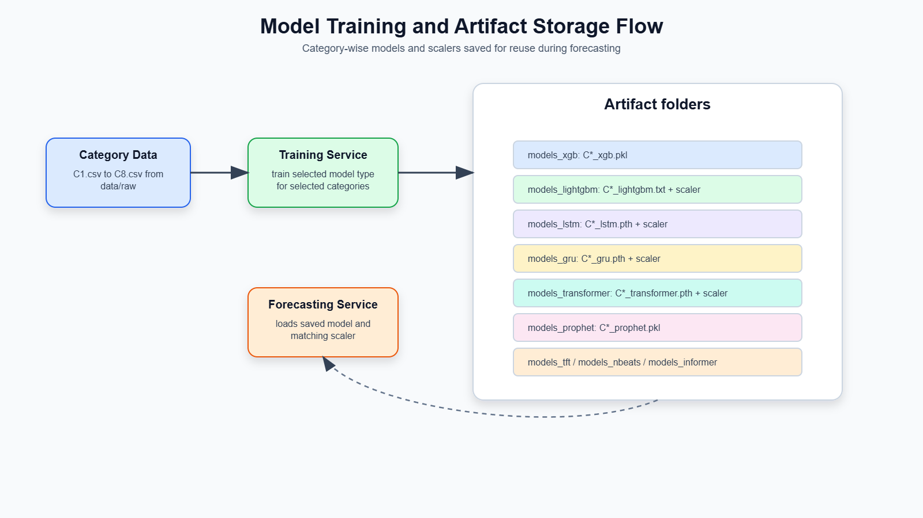
Figure ‎3:6: Model Training and Artifact Storage Flow
The model training process in this project is designed to train forecasting models separately for each pharmaceutical drug category. The dataset is organized into eight categories, from C1 to C8, and each category is treated as an individual time-series forecasting problem. This category-wise training approach is important because different drug groups may have different sales patterns. Some categories may show stable demand, while others may have seasonal changes, sudden increases, or irregular sales behaviour. By training models separately for each category, the system can learn the unique behaviour of each drug group more accurately.
During training, the relevant category-wise CSV file is loaded from the dataset. The sales data is then pre-processed and transformed according to the selected model type. For machine learning models such as XGBoost and LightGBM, lag features are generated from previous sales values. For deep learning models such as LSTM, GRU, Transformer, TFT, N-BEATS, and Informer, the sales data is converted into sequential input windows and normalized or standardized using suitable scalers. Statistical models such as Prophet and SARIMAX use the time-series structure directly to learn trend and seasonal patterns.
After each model is trained, the trained model is saved as a model artifact. These saved artifacts allow the system to reuse trained models during forecasting without retraining them every time a prediction request is made. The project stores trained models in separate folders based on model type. For example, XGBoost models are stored in the models_xgb folder, LightGBM models are stored in the models_lightgbm folder, LSTM models are stored in the models_lstm folder, GRU models are stored in the models_gru folder, Transformer models are stored in the models_transformer folder, and similar folders are used for other models such as Prophet, TFT, N-BEATS, and Informer. This folder structure makes the system organized and allows the forecasting service to load the correct model based on the selected category and model type.
For models that require scaling, the scaler files are also saved together with the trained model artifacts. This is important because the same scaler used during training must also be used during forecasting. During prediction, the input data is transformed using the saved scaler, and the predicted output is converted back into the original sales scale using inverse transformation. This ensures that the final forecast value shown to the user is meaningful and understandable.
The project also includes a dedicated training service as part of the microservice architecture. This service provides an API endpoint for running model training. Through the training endpoint, a request can specify the model type and the required drug categories. The backend then loads the relevant data, trains the selected model, and saves the generated model artifacts into the correct model folder. This design makes the training process more modular and allows training to be triggered separately from forecasting. As a result, the system can support future retraining when new sales data becomes available.
Overall, the model training process ensures that each drug category has its own trained forecasting models, saved artifacts, and reusable scaler files. This supports efficient forecasting, organized model management, and future system expansion.

FORECASTING PROCESS
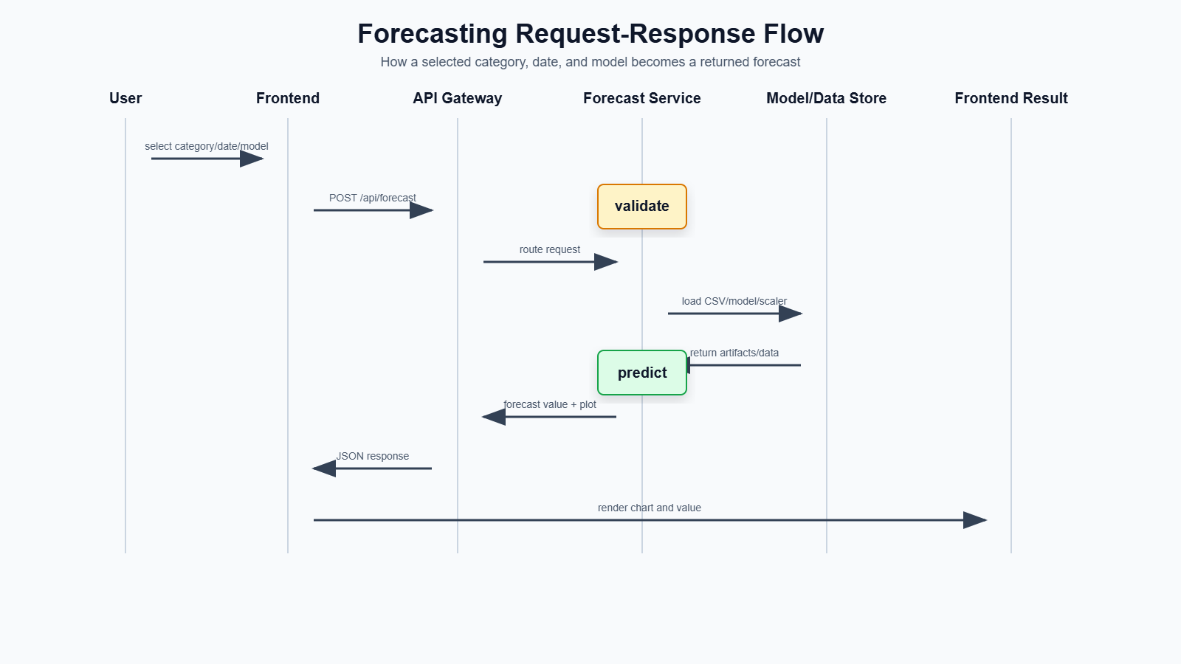
Figure ‎3:7: Forecasting Request-Response Flow

The forecasting process in this project begins from the user interface, where the user selects the required drug category, prediction date, and forecasting model. The drug category is selected from the available C1 to C8 categories, and the model can be selected from the implemented forecasting methods such as SARIMAX, Prophet, XGBoost, LightGBM, LSTM, GRU, Transformer, or ensemble-based forecasting. The user also enters the date for which the future drug sales value should be predicted. After these inputs are provided, the frontend sends the request to the backend forecasting API.
When the backend receives the forecasting request, it first checks the selected drug category, date, and model type. The system then loads the relevant category-wise sales dataset and identifies whether the requested date belongs to the historical data period or a future period. If the selected date is within the historical data range, the system can return the closest available actual sales value from the dataset. If the selected date is in the future, the system continues with the forecasting process and loads the trained model related to the selected category and model type.
For future forecasting, the backend uses the saved trained model artifacts from the model storage folders. Depending on the model type, the system also loads the corresponding scaler file if scaling was used during training. For example, deep learning models such as LSTM, GRU, Transformer, TFT, N-BEATS, and Informer require normalized or standardized input data. Therefore, the same scaler used during training is applied again during prediction. For machine learning models such as XGBoost and LightGBM, lag features are generated from the most recent historical sales values before prediction.
After the correct model and input format are prepared, the forecasting model predicts the future sales value for the selected category and date. The predicted output is then converted back into the original sales scale if scaling was applied. This ensures that the final forecast value is meaningful to the user. The system also records which model was used to generate the prediction so that the output can clearly show the selected forecasting approach.
Finally, the forecast result is returned to the frontend through the API response. The response includes the predicted sales value, drug category, input date, closest reference date, model used, and plot information. A chart is generated to visualize the historical sales pattern together with the forecasted value. This allows the user to understand the prediction in a visual form rather than only reading a numerical output. Through this process, the system provides a complete forecasting workflow from user input to model prediction and visual result display.

EXPLAIN ABILITY METHOD

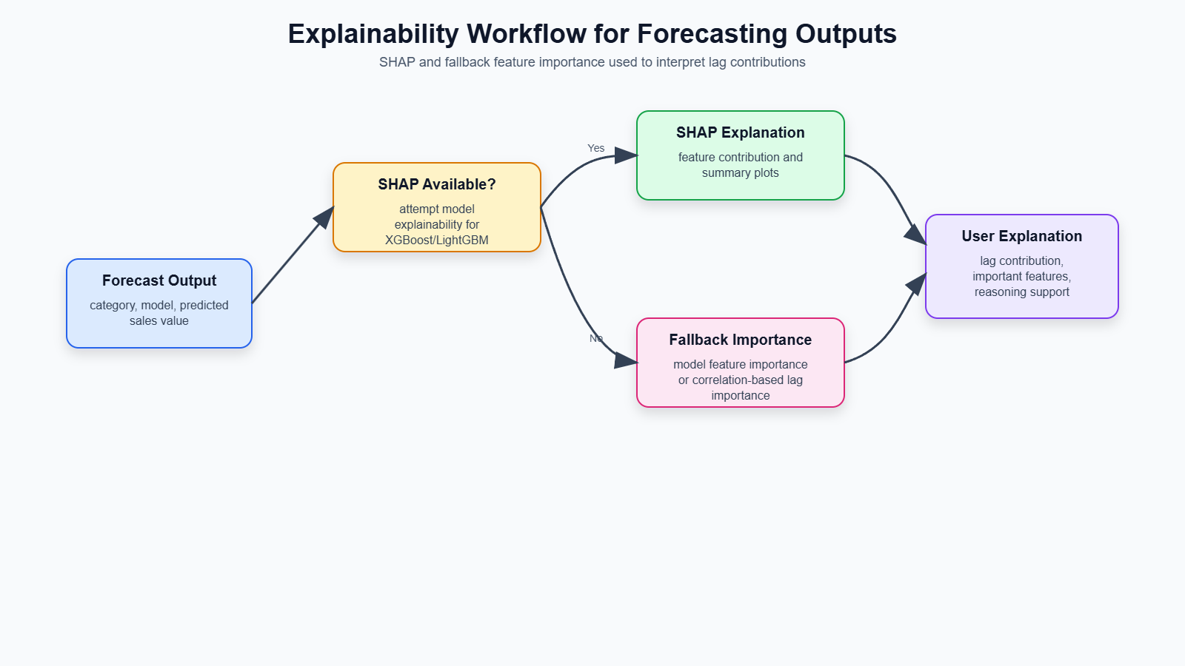
Figure ‎3:8: Explainability Workflow for Forecasting Outputs

Explainability is included in this project to make the forecasting results more understandable and useful for pharmaceutical decision-making. In drug sales prediction, simply showing a predicted value is not always enough. Pharmacists, distributors, and healthcare planners need to understand why the system predicted a certain sales value before using it for stock planning or purchasing decisions. Therefore, the system includes explainability support to identify which historical sales patterns contributed to the prediction.
The main explainability technique used in this project is SHAP-based analysis. SHAP helps estimate the contribution of each input feature to the model output. In the context of this project, the most important input features are usually lag features created from previous sales values. These lag values represent recent sales behaviour, and SHAP can show which past sales periods had a stronger influence on the final forecast. This allows users to understand whether the prediction is mainly affected by very recent sales, earlier demand behaviour, or a combination of multiple lagged values.
However, because explainability tools can sometimes face compatibility or runtime limitations depending on the model and environment, the project also includes fallback feature importance methods. If SHAP is not available or cannot generate a result for a selected model, the system uses model-based feature importance or historical correlation-based importance to estimate the contribution of lag features. This ensures that the explainability endpoint can still provide useful output even when full SHAP analysis is not possible.
Lag contribution is especially important in pharmaceutical sales forecasting because previous demand is one of the strongest indicators of future demand. For example, if a drug category has shown increasing sales in recent weeks, the forecast may also increase. By showing the importance of previous sales values, the system gives users more confidence in the prediction. This is useful for pharmacy decisions such as stock ordering, inventory balancing, and identifying categories that may need closer monitoring.
Overall, the explainability method improves transparency and trust in the forecasting system. It helps convert the system from a black-box prediction tool into a decision-support platform that provides both forecast values and reasoning behind those values.

ADVANCED AI MODULES
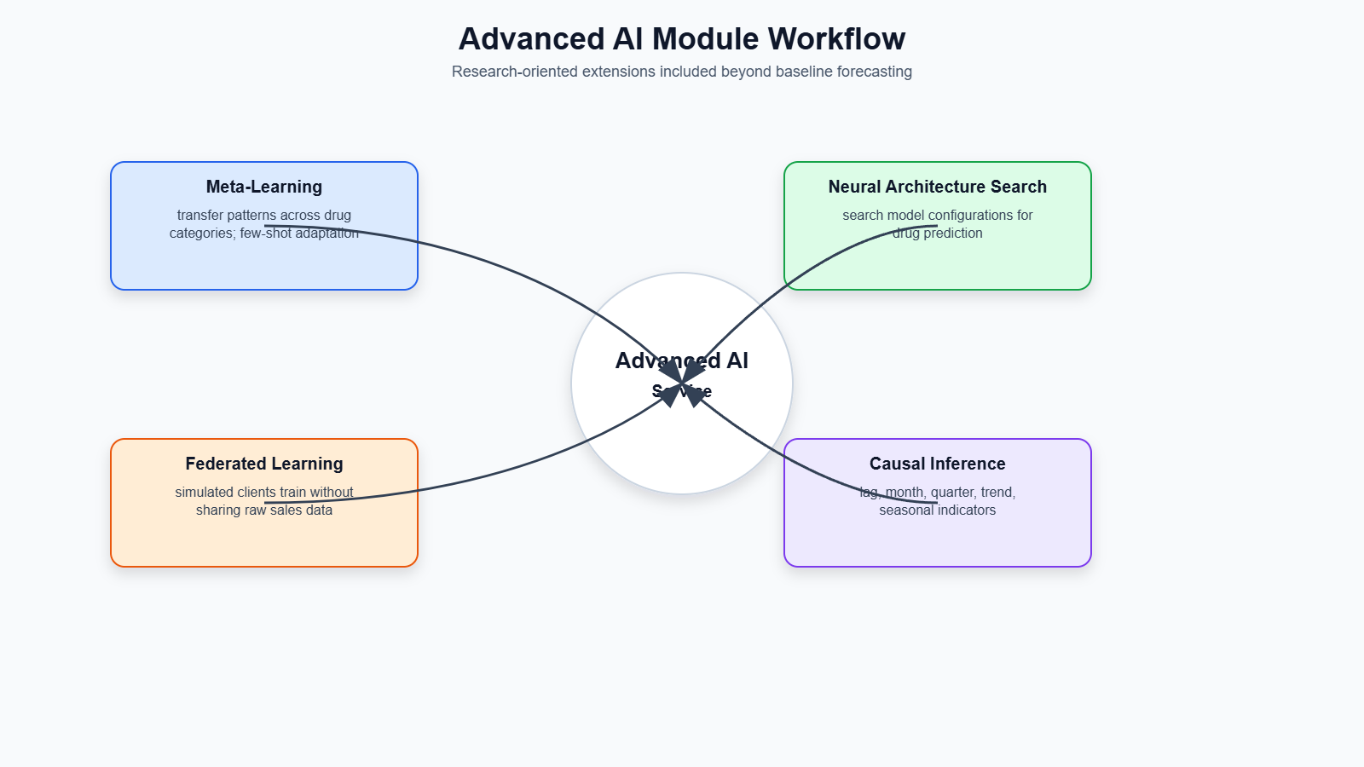
Figure ‎3:9: Advanced AI Module Workflow

Meta-Learning
Meta-learning is included in this project to explore how knowledge learned from one drug category can support forecasting in another category. Since the dataset is divided into C1 to C8 drug categories, each category may have different sales behavior and data availability. Some categories may have stronger historical patterns, while others may show irregular or limited sales behavior. Meta-learning helps the system learn transferable patterns across categories and adapt to a target category more efficiently. This is useful for future expansion when new drug categories or area-specific datasets are added to the system.

Neural Architecture Search
Neural Architecture Search is used to support automated model structure exploration. In deep learning forecasting, model performance can depend on the number of layers, hidden units, activation functions, and other architectural settings. Manually testing many architectures can be time-consuming. The NAS module explores possible neural network configurations and attempts to identify better model structures for drug sales prediction. This makes the system more flexible and research-oriented because it does not depend only on manually selected architectures.

Federated Learning
Federated learning is included as a privacy-preserving learning approach. In a real pharmaceutical environment, sales data may be stored separately by different pharmacies, hospitals, distributors, or regional branches. These organizations may not want to share raw sales records because of privacy, tax, or business confidentiality concerns. Federated learning allows local clients to train models using their own data and share only model updates instead of raw data. These updates can then be aggregated into a global model. This approach is suitable for future pharmacy-based forecasting systems where multiple locations contribute to model improvement without directly exposing sensitive sales data.

Causal Inference
Causal inference is used to analyse possible relationships between time-based factors and drug sales behaviour. Forecasting models can predict future values, but they do not always explain whether a particular factor may influence changes in demand. The causal inference module creates features such as lagged sales values, week, month, quarter, year, trend, and seasonal indicators. These features are used to explore possible causal relationships and understand how temporal patterns may affect drug sales. This helps the system provide deeper analytical insight in addition to numerical forecasting.

SYSTEM ARCHITECTURE
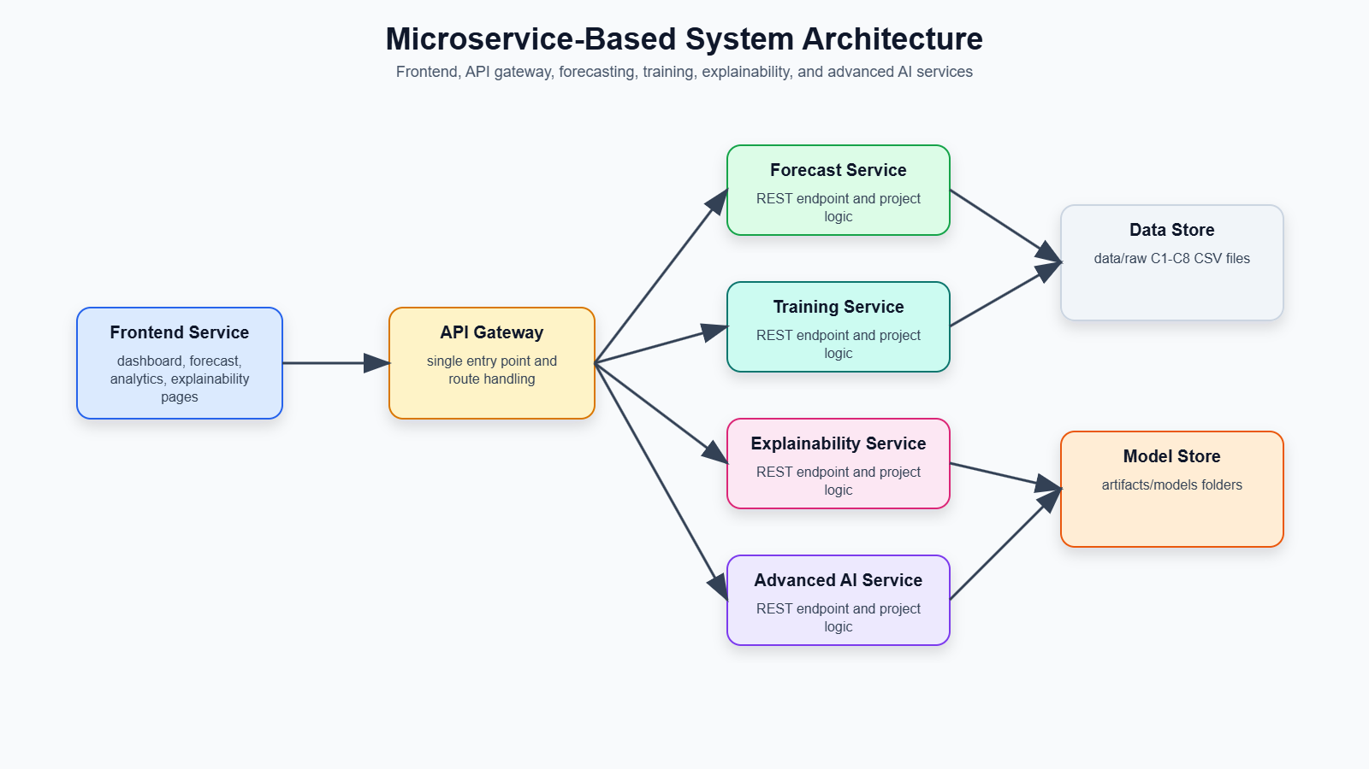
Figure ‎3:10: Microservice-Based System Architecture

The proposed system is implemented using a microservice-based architecture. This architecture separates the system into different services, where each service has a specific responsibility. This improves maintainability, scalability, and testing because each component can be developed and updated independently.
The frontend service provides the web-based user interface. Through this interface, users can select a drug category, choose a forecasting model, enter a prediction date, and view the forecast result. The frontend also contains pages for analytics, explainability, advanced AI functions, causal analysis, and branch/location visualization.
The API gateway acts as the main communication layer between the frontend and backend services. It receives requests from the frontend and routes them to the correct backend functionality. The API gateway provides endpoints for forecasting, explainability, meta-learning, neural architecture search, federated learning, causal inference, and system status. This gives the frontend a single access point instead of directly calling many different services.
The forecast service is responsible for generating drug sales predictions. It loads the relevant category-wise dataset, identifies the selected forecasting model, loads the trained model artifact, prepares the input features, and returns the predicted sales value. This service handles the main forecasting logic of the system.
The training service is responsible for training forecasting models. It supports training models for selected categories and model types. After training, the generated model artifacts and scaler files are saved in the relevant model folders. This service allows the system to retrain models when new data becomes available.
The explainability service provides interpretation for forecasting outputs. It uses SHAP-based analysis where possible and fallback feature importance methods when SHAP is unavailable. This service helps users understand which lag features or historical sales values influenced the prediction.
The advanced AI service contains the research-oriented AI modules of the system. It supports neural architecture search, federated learning, and causal inference operations. These modules extend the system beyond basic forecasting and provide future-ready capabilities for more intelligent pharmaceutical demand prediction.
Overall, the system architecture supports a complete workflow from user input to forecasting, explanation, model training, advanced analysis, and deployment. By separating these responsibilities into microservices, the project becomes more organized, scalable, and suitable for future real-world implementation.

API DESIGN

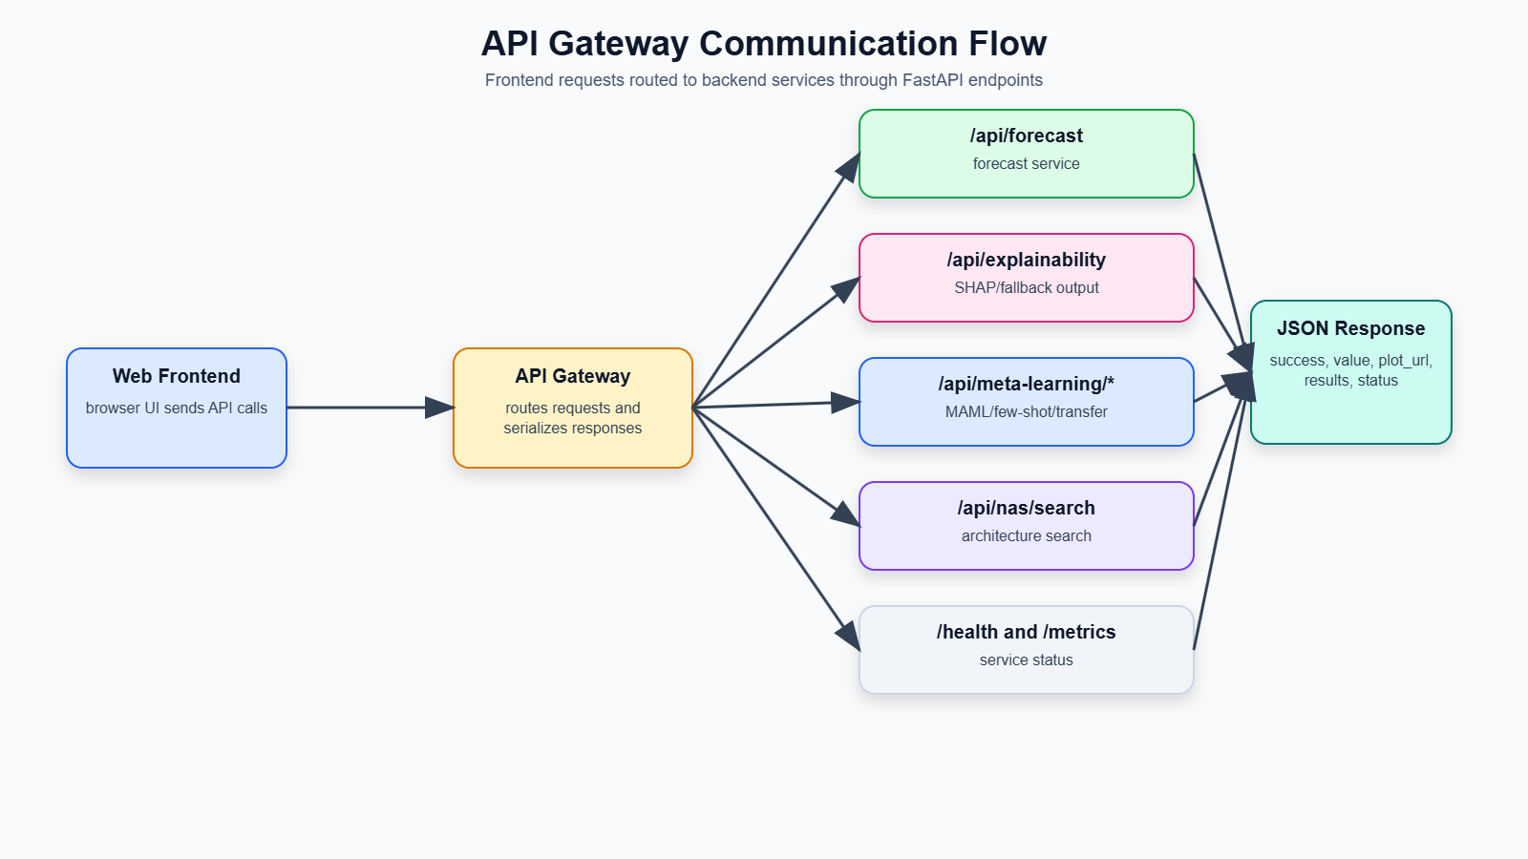
Figure ‎3:11: API Gateway Communication Flow

The system provides REST API endpoints to allow communication between the frontend interface and backend services. The API layer is important because it makes the forecasting system accessible through both the web application and programmatic requests. The API gateway acts as the main access point and routes requests to the relevant backend functionality.
The forecast endpoint is used to generate drug sales predictions. It accepts inputs such as drug category, prediction date, and selected model type. After receiving the request, the backend loads the required category data and trained model, performs forecasting, and returns the predicted sales value, model used, input date, reference date, and plot information.
The training endpoint is used to train forecasting models. It allows the system to train selected model types for selected drug categories. After training, the generated model files and scaler files are saved in the correct artifact folders. This endpoint supports future retraining when new sales data becomes available.
The explainability endpoint provides interpretation for prediction results. It uses SHAP-based analysis where possible and fallback feature importance methods when SHAP is unavailable. This endpoint returns information about important lag features and their contribution to the forecast.
The advanced AI endpoints are used for research-oriented functions such as meta-learning, neural architecture search, federated learning, and causal inference. These endpoints allow the system to run advanced model adaptation, automated architecture exploration, privacy-preserving training, and causal analysis.
The system also includes health and metrics endpoints. Health endpoints are used to check whether each service is running correctly. Metrics endpoints expose service-level monitoring information such as request counts and uptime. These endpoints are useful for debugging, testing, and monitoring the system during deployment.

WEB APPLICATION DESIGN
The web application provides a user-friendly interface for interacting with the drug sales prediction system. Instead of using only command-line scripts or API calls, users can access the system through a browser-based frontend. This makes the system easier to use for non-technical users such as pharmacy staff, healthcare planners, and decision-makers.
The dashboard acts as the main entry point of the system. It provides navigation to the major functions of the application, including forecasting, analytics, explainability, advanced AI features, causal analysis, and branch/location-related views.
The forecast page allows users to generate predictions. On this page, the user selects a drug category from C1 to C8, chooses a forecasting model, and enters the prediction date. After submitting the request, the system displays the predicted sales value, selected model, forecast date, and a chart showing the forecast result.
The model selection feature allows users to choose between different forecasting approaches such as SARIMAX, Prophet, XGBoost, LightGBM, LSTM, GRU, Transformer, and ensemble-based forecasting. This makes it possible to compare how different models behave for the same drug category and prediction date.
The explainability page provides interpretation outputs for forecasting results. It helps users understand which previous sales values or lag features influenced the prediction. This supports better trust and decision-making because users can see the reasoning behind the forecast.
The advanced AI pages provide access to research-oriented modules such as meta-learning, neural architecture search, federated learning, and causal inference. These pages allow users to interact with advanced analysis functions and explore deeper AI-based forecasting support.

DEPLOYMENT AND MONITORING
The project includes deployment and monitoring support to make the system more practical and scalable. Since the system is designed using a microservice architecture, deployment tools are used to run multiple services consistently.
Docker is used to containerize the application. Containerization allows the system and its dependencies to be packaged together so that the services can run in a consistent environment. This reduces issues caused by differences between development and deployment machines.
Docker Compose is used to run multiple services together during local deployment. It defines the services, ports, environment variables, and service connections required for the system. This makes it easier to start the API gateway, frontend service, forecasting service, training service, explainability service, advanced AI service, and supporting services together.
Kubernetes configuration is also included to support future cloud or production deployment. Kubernetes helps manage multiple containers, service scaling, networking, and deployment configuration. The project includes Kubernetes manifests for the different microservices, which makes the system more suitable for scalable deployment.
Prometheus metrics are included for monitoring service behaviour. Each service exposes a metrics endpoint that can provide information such as service uptime, request count, request duration, and service health. These metrics are useful for monitoring the reliability and performance of the system.
Health checks are also included for each service. A health endpoint returns whether the service is running correctly. This is useful during testing and deployment because it allows developers or deployment platforms to confirm that each service is active and responsive.

EVALUATION METHOD
The evaluation method of this project includes both forecasting evaluation and system-level validation. Since the project is not only a model experiment but also a complete web-based microservice system, both prediction performance and endpoint reliability are considered.
For forecasting evaluation, common error metrics such as Mean Absolute Error (MAE), Root Mean Squared Error (RMSE) and Mean Absolute Percentage Error (MAPE) are used. MAE measures the average absolute difference between actual and predicted sales values. RMSE gives more weight to larger errors and is useful for identifying models that make large prediction mistakes. MAPE shows the prediction error as a percentage, making it easier to understand the relative forecasting accuracy.
These metrics are useful for comparing different models such as SARIMAX, Prophet, XGBoost, LightGBM, LSTM, GRU, Transformer, and ensemble models. Since different drug categories may show different behaviour, evaluation is performed category-wise where possible. This helps identify which models are more suitable for different categories of pharmaceutical sales.
In addition to model performance, endpoint testing was used for system validation. The backend services were tested by sending requests to the health, forecasting, training, explainability, advanced AI, and API gateway endpoints. This confirms that the services respond correctly and that the system workflow functions as expected. During final testing, all tested endpoints successfully passed, showing that the API layer and service communication were working properly.
System validation also includes checking whether the frontend can communicate with the backend, whether forecast results are returned correctly, whether trained models can be loaded, whether explanation outputs are generated, and whether monitoring endpoints are available. This combined evaluation method ensures that the project is assessed both as a forecasting model system and as a practical software implementation.

Results and Analysis
This chapter presents the experimental results of the implemented drug sales prediction system. The experiments were conducted to evaluate the forecasting capability of different model groups used in the project. Since the dataset is organized into eight pharmaceutical drug categories, C1 to C8, each category was treated as an individual time-series forecasting problem. The purpose of this chapter is to compare how different forecasting models behave across these categories and identify which approaches are more suitable for pharmaceutical sales prediction.
The experiments were evaluated using three main forecasting error metrics: Mean Absolute Error (MAE), Root Mean Squared Error (RMSE), and Mean Absolute Percentage Error (MAPE). MAE measures the average absolute difference between actual and predicted sales values. RMSE gives higher penalty to larger forecasting errors. MAPE expresses the error as a percentage, which helps compare relative forecasting performance. In addition to these metrics, inference time was also considered because the final system is designed as a web-based forecasting application where users expect fast prediction responses.

STATISTICAL FORECASTING APPROACH
Statistical forecasting models were used as the first major group of experiments in this research. These models are commonly used for time-series forecasting because they are designed to learn patterns from historical time-ordered data. In this project, statistical models were mainly used to understand trend, seasonality, and baseline forecasting behaviour in pharmaceutical drug sales data.
The statistical forecasting approach included two models: SARIMAX and Prophet. SARIMAX was selected because it can model autoregressive behaviour, moving average effects, and seasonal time-series patterns. Prophet was selected because it is designed to handle time-series data with trend and seasonality using a simple date-value structure. These models were applied to the C1 to C8 drug sales categories and evaluated using the same forecasting metrics used for the other model groups.

Experimental Setup for Drug Sales Time-Series Forecasting
The statistical forecasting experiments were conducted using the category-wise drug sales dataset. Each drug category was stored as a separate time-series dataset, where the date column represented the time period and the sales column represented the recorded sales value. The models were trained and tested separately for each category so that the unique sales behaviour of each drug group could be analysed.
For this experiment, the chronological order of the dataset was preserved. This is important because time-series forecasting must use past data to predict future values. The data was not randomly shuffled because doing so would create data leakage and produce unrealistic evaluation results. Earlier records were used for model learning, while later records were used to evaluate forecasting performance.
The statistical models were evaluated for all eight drug categories. The main objective was to determine whether traditional time-series forecasting methods could effectively predict pharmaceutical sales data. The results were compared using MAE, RMSE, MAPE, and average inference time. These results were later compared with machine learning, deep learning, and ensemble forecasting models.
Table ‎4-1: Category-Wise Performance of SARIMAX and Prophet
Category | SARIMAX MAE | SARIMAX RMSE | SARIMAX MAPE (%) | Prophet MAE | Prophet RMSE | Prophet MAPE (%)
C1 | 19.1074 | 22.5140 | 40.5356 | 10.5368 | 13.5162 | 21.1628
C2 | 18.5494 | 20.9198 | 51.5160 | 13.1088 | 14.6696 | 56.3744
C3 | 17.6812 | 22.8587 | 44.2430 | 10.2570 | 12.2604 | 41.5235
C4 | 96.2937 | 132.9443 | 29.0270 | 143.8519 | 165.7533 | 68.3645
C5 | 29.1626 | 32.3775 | 40.3108 | 32.7109 | 35.2496 | 52.8368
C6 | 5.3813 | 6.7422 | 67.5257 | 4.8752 | 5.6446 | 107.3593
C7 | 40.0671 | 46.6166 | 113.3336 | 31.1265 | 38.4060 | 143.5574
C8 | 17.7142 | 22.3134 | 62.0024 | 14.0789 | 15.9109 | 213.0493

SARIMAX Forecasting for Category-Wise Drug Sales
SARIMAX was implemented as one of the main statistical forecasting models in this project. SARIMAX is an extension of ARIMA that supports seasonal components. This makes it useful for datasets where sales values may repeat in weekly, monthly, or seasonal patterns. In pharmaceutical sales forecasting, such patterns may occur due to seasonal illnesses, changes in patient demand, availability of medicines, or repeated purchasing behavior.
In this project, SARIMAX was applied separately to each drug category from C1 to C8. The model attempted to learn the relationship between previous sales values and future sales values using autoregressive and moving average components. Since SARIMAX is a statistical model, it does not require lag features in the same way as XGBoost or LightGBM. Instead, it models the time-series structure directly.
The SARIMAX model produced mixed results across the different categories. It performed reasonably well for some categories, especially where the data had more structured time-series behavior. However, it was less effective for categories with stronger non-linear or irregular patterns. Based on the final results, SARIMAX achieved an average MAE of 30.4946, average RMSE of 38.4108, and average MAPE of 56.0618 across all categories. The average inference time was 0.1498 seconds, showing that SARIMAX was relatively fast compared with Prophet.
The results show that SARIMAX is useful as a baseline statistical forecasting model. It provides a traditional comparison point for evaluating whether more advanced models improve forecasting accuracy. However, SARIMAX alone was not the best overall model in the project because machine learning and deep learning models achieved better results in several categories.
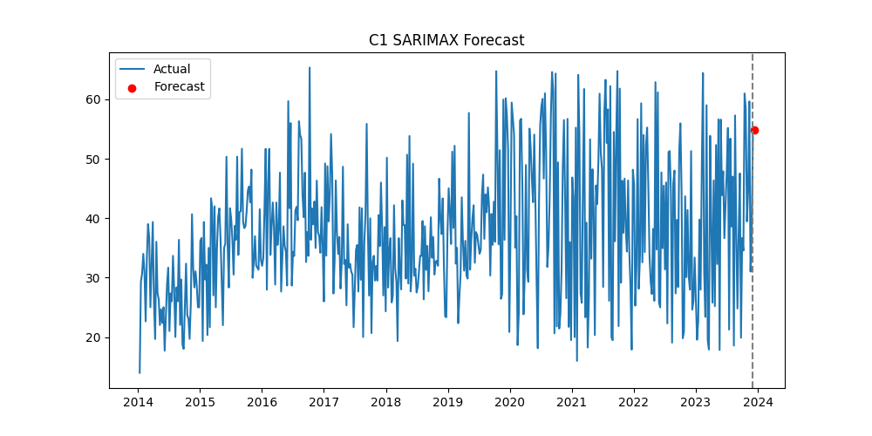
Figure ‎4:1: C1 Drug Sales Forecast Using the SARIMAX Model

Prophet Forecasting with Trend and Seasonality
Prophet was also included as a statistical forecasting model in this research. Prophet is designed to model time-series data using trend and seasonality components. In this project, the drug sales data was formatted according to Prophet’s required structure, where the date column was represented as ds and the sales value was represented as y. This allowed Prophet to analyze time-based sales movement and generate future predictions.
Prophet was useful because pharmaceutical sales may contain seasonal and trend-based behavior. For example, some medicine categories may show higher demand during specific periods due to respiratory illnesses, allergy seasons, rainy seasons, or repeated patient purchasing patterns. Prophet is designed to detect such time-related changes and model them in a forecasting process.
In the experiment, Prophet performed well for some individual categories. For example, Prophet achieved better MAE than SARIMAX in several categories such as C1, C2, C3, C6, C7, and C8. This indicates that Prophet was able to capture useful trend and seasonality patterns for many drug categories. However, its performance was weaker in some categories, especially C4, where the error was much higher than SARIMAX. Because of this, Prophet’s overall average MAE and MAPE were weaker than SARIMAX.
Across all categories, Prophet achieved an average MAE of 32.5682, average RMSE of 37.6763, and average MAPE of 88.0285. Its average inference time was 0.8725 seconds, making it slower than SARIMAX and most other tested models. These results show that Prophet is useful for trend and seasonality analysis, but it may not always be the most efficient or accurate model for pharmaceutical sales forecasting.
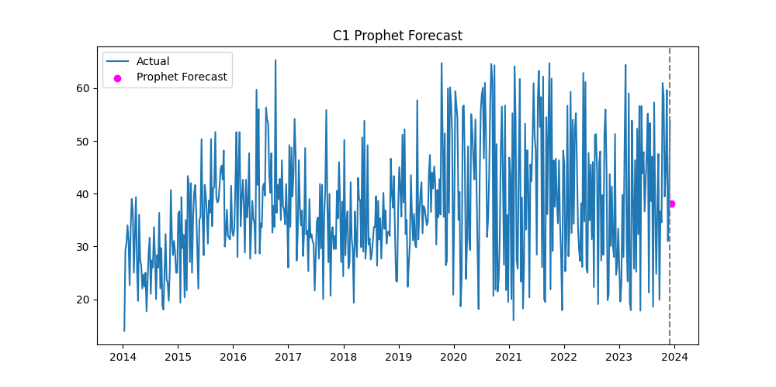
Figure ‎4:2: C1 Drug Sales Forecast Using the Prophet Model

Historical Sales Forecasting Baseline
In addition to future forecasting, the system also includes a historical sales baseline behaviour. If the user selects a date that already exists within the historical dataset, the forecasting service does not generate a future prediction. Instead, it returns the closest available historical sales value from the dataset. This behaviour is important because the system supports both historical lookup and future forecasting.
For example, if a user selects a past date for category C1, the backend identifies the closest matching date from the dataset and returns the actual recorded sales value. In this case, the model used is identified as Historical Data instead of a forecasting model. This feature prevents unnecessary prediction when actual data is already available.
This baseline is useful for validating the system workflow. It confirms that the backend can correctly load category-wise data, parse dates, identify whether a selected date is historical or future, and return the correct response. It also improves user experience because users can inspect past sales values through the same forecasting interface.

Statistical Model Comparison
The comparison between SARIMAX and Prophet shows that both models have strengths and limitations. SARIMAX performed better overall in terms of average MAE, MAPE, and inference time. Prophet achieved slightly better average RMSE, but its MAPE and inference time were weaker. Prophet also performed better than SARIMAX in several individual categories, but its poor performance in some categories increased its overall average error.
A summary of the statistical model performance is shown below.

Table ‎4-2: Average Performance Comparison of Statistical Forecasting Models
Model | Average MAE | Average RMSE | Average MAPE (%) | Average Inference Time (s)
SARIMAX | 30.4946 | 38.4108 | 56.0618 | 0.1498
Prophet | 32.5682 | 37.6763 | 88.0285 | 0.8725

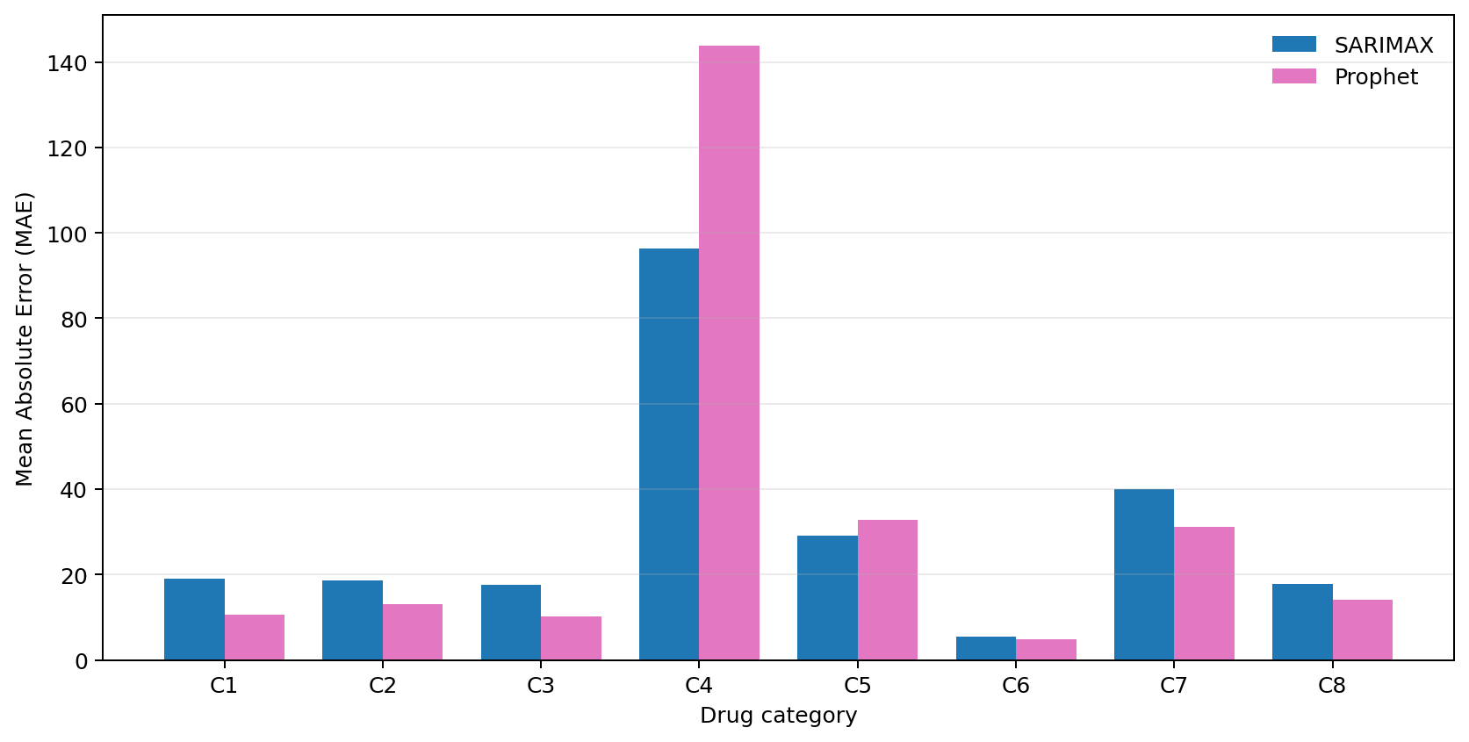
Figure ‎4:3: Category-Wise MAE Comparison of SARIMAX and Prophet

Based on these results, SARIMAX can be considered the better statistical model for this project overall because it had lower MAE, lower MAPE, and faster inference time. Prophet was still valuable because it performed well in several individual categories and provided trend-seasonality-based forecasting. However, neither SARIMAX nor Prophet achieved the best overall performance when compared with the full set of machine learning and deep learning models.
Therefore, the statistical forecasting experiments show that traditional time-series models are useful as baseline models and for understanding trend and seasonality. However, for category-wise pharmaceutical drug sales prediction, more flexible models such as LightGBM, LSTM, GRU, and ensemble-based methods are required to improve forecasting accuracy across different sales patterns.

MACHINE LEARNING APPROACH
The second group of experiments focused on machine learning-based forecasting models. In this project, machine learning models were used to learn the relationship between previous drug sales values and future sales demand. Unlike traditional statistical models, machine learning models do not require strict assumptions about the structure of the time-series data. Instead, they learn patterns directly from engineered input features.
For the machine learning approach, the raw time-series sales data was converted into a supervised learning format using lag features. Lag features represent previous sales values that are used as input variables for predicting the next sales value. This method is suitable for models such as XGBoost and LightGBM because they work effectively with structured tabular data. The main idea behind this approach is that future drug sales are strongly influenced by recent historical sales behavior.
Two machine learning models were evaluated in this research: XGBoost and LightGBM. Both models are gradient boosting-based algorithms, but they use different training strategies and optimization methods. These models were tested across all drug categories from C1 to C8 and evaluated using MAE, RMSE, MAPE, and inference time.

Experiments with Lag-Based Machine Learning Models
The lag-based machine learning experiments were conducted by transforming each category-wise time-series dataset into input-output pairs. A fixed number of previous sales values were used as input features, and the next sales value was used as the prediction target. This allowed the models to learn how recent sales behavior affects future demand.
For example, when predicting the next sales value for a category such as C1, the model uses previous sales values from earlier time steps as input. These lag values help the model identify whether the sales trend is increasing, decreasing, or remaining stable. The same process was applied separately for each drug category so that the models could learn category-specific demand behavior.
The machine learning models were trained and saved as model artifacts. During forecasting, the backend loads the selected model and generates the prediction using the most recent sales values from the dataset. This makes the machine learning approach practical for real-time prediction through the web interface and API.

Table ‎4-3: Category-Wise Performance of XGBoost and LightGBM
Category | XGBoost MAE | XGBoost RMSE | XGBoost MAPE (%) | LightGBM MAE | LightGBM RMSE | LightGBM MAPE (%)
C1 | 10.9012 | 12.3420 | 23.2977 | 10.2061 | 13.5706 | 19.6222
C2 | 13.8605 | 15.2164 | 44.9367 | 14.0368 | 15.9747 | 57.4618
C3 | 16.9471 | 18.7485 | 60.3954 | 13.0881 | 15.3859 | 44.3339
C4 | 85.4242 | 97.5089 | 35.7980 | 72.6065 | 92.3468 | 29.3020
C5 | 29.0716 | 34.7092 | 44.6566 | 26.9909 | 32.4470 | 38.3756
C6 | 4.3514 | 5.2600 | 78.6966 | 3.4860 | 4.2950 | 68.6662
C7 | 26.0462 | 33.0924 | 106.2338 | 32.4237 | 39.8748 | 90.2034
C8 | 17.1414 | 22.8859 | 297.2098 | 14.1443 | 17.4359 | 243.4210

XGBoost Forecasting Using Lag Features
XGBoost was implemented as one of the main machine learning models in this project. XGBoost is a gradient boosting algorithm that builds multiple decision trees sequentially. Each new tree attempts to correct the errors made by the previous trees. This makes XGBoost powerful for regression tasks such as sales forecasting.
In this project, XGBoost was trained using lag features generated from historical drug sales values. The model used previous sales records as input and learned to predict the next sales value. Since XGBoost can capture non-linear relationships, it is useful for pharmaceutical sales data where demand may not follow a simple linear pattern.
The experimental results show that XGBoost performed better than the statistical models in terms of average MAE and RMSE. Across all categories, XGBoost achieved an average MAE of 25.4679, average RMSE of 29.9704, and average MAPE of 86.4031. Although its MAPE was relatively high due to category-level percentage error variation, it achieved strong absolute error performance.
One of the main advantages of XGBoost in this project was its speed. It recorded an average inference time of 0.0343 seconds, making it the fastest model among the tested forecasting models. This is important for a web-based forecasting system because users expect quick responses after submitting prediction requests. Therefore, XGBoost is useful when fast prediction is required.
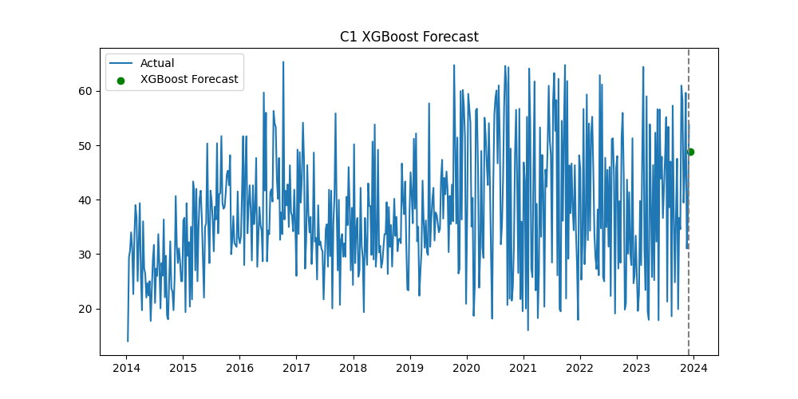
Figure ‎4:4: C1 Drug Sales Forecast Using the XGBoost Model

LightGBM Forecasting Using Normalized Lag Features
LightGBM was also implemented as a machine learning forecasting model. Similar to XGBoost, LightGBM is a gradient boosting framework that uses decision trees. However, LightGBM is designed to be efficient and fast, especially for structured data. In this project, LightGBM used lag-based features created from previous sales values.
Before training LightGBM, the sales values were scaled using MinMaxScaler. This helped normalize the numerical range of the data and allowed the model to train more consistently. After prediction, the forecasted values were converted back to the original sales scale using inverse transformation. This ensured that the final output shown to the user was meaningful and understandable.
LightGBM produced the best overall MAE and RMSE results among all evaluated models. Across all categories, LightGBM achieved an average MAE of 23.3728, average RMSE of 28.9163, and average MAPE of 73.9233. It also maintained a good average inference time of 0.1074 seconds. These results show that LightGBM was highly effective for category-wise drug sales forecasting in this project.
LightGBM performed especially well because it could learn non-linear relationships from lag features while maintaining efficient computation. Since drug sales patterns can differ across categories, LightGBM’s ability to model structured historical features made it suitable for this forecasting task.
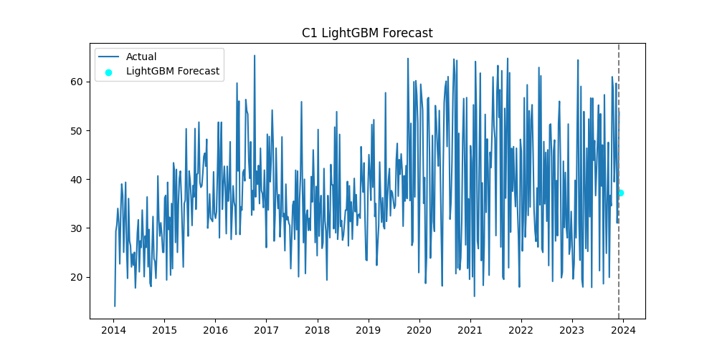
Figure ‎4:5: C1 Drug Sales Forecast Using the LightGBM Model

Feature Importance Analysis for Lag-Based Models
Feature importance analysis was used to understand which lag features contributed most to the predictions made by machine learning models. Since XGBoost and LightGBM use previous sales values as input features, feature importance can show which past sales periods had the strongest influence on the predicted future sales value.
This is important in pharmaceutical sales forecasting because decision-makers need to understand the reason behind a forecast. If the model gives high importance to recent lag values, it means the prediction is strongly influenced by recent demand changes. If older lag values have higher importance, it may indicate a longer repeating pattern in the sales data.
The project includes explainability support through SHAP-based methods and fallback feature importance analysis. When SHAP is available, it can provide more detailed explanations of how each feature affects the model output. When SHAP is not available, the fallback method uses model feature importance or correlation-based importance. This ensures that the system can still provide explanation output for lag-based models.
Feature importance analysis helps improve trust in the forecasting system. Instead of only showing a numerical prediction, the system can show which historical sales values influenced the prediction. This is useful for pharmacists and distributors when making stock-related decisions.

Machine Learning Model Performance Comparison
The machine learning experiments showed that both XGBoost and LightGBM were effective for drug sales forecasting. Compared with the statistical models, both machine learning models achieved better average MAE and RMSE. This shows that lag-based machine learning models were better at capturing non-linear patterns in the category-wise sales data.
A summary of the machine learning model performance is shown below.

Table ‎4-4: Average Performance Comparison of Machine Learning Models
Model | Average MAE | Average RMSE | Average MAPE (%) | Average Inference Time (s)
XGBoost | 25.4679 | 29.9704 | 86.4031 | 0.0343
LightGBM | 23.3728 | 28.9163 | 73.9233 | 0.1074

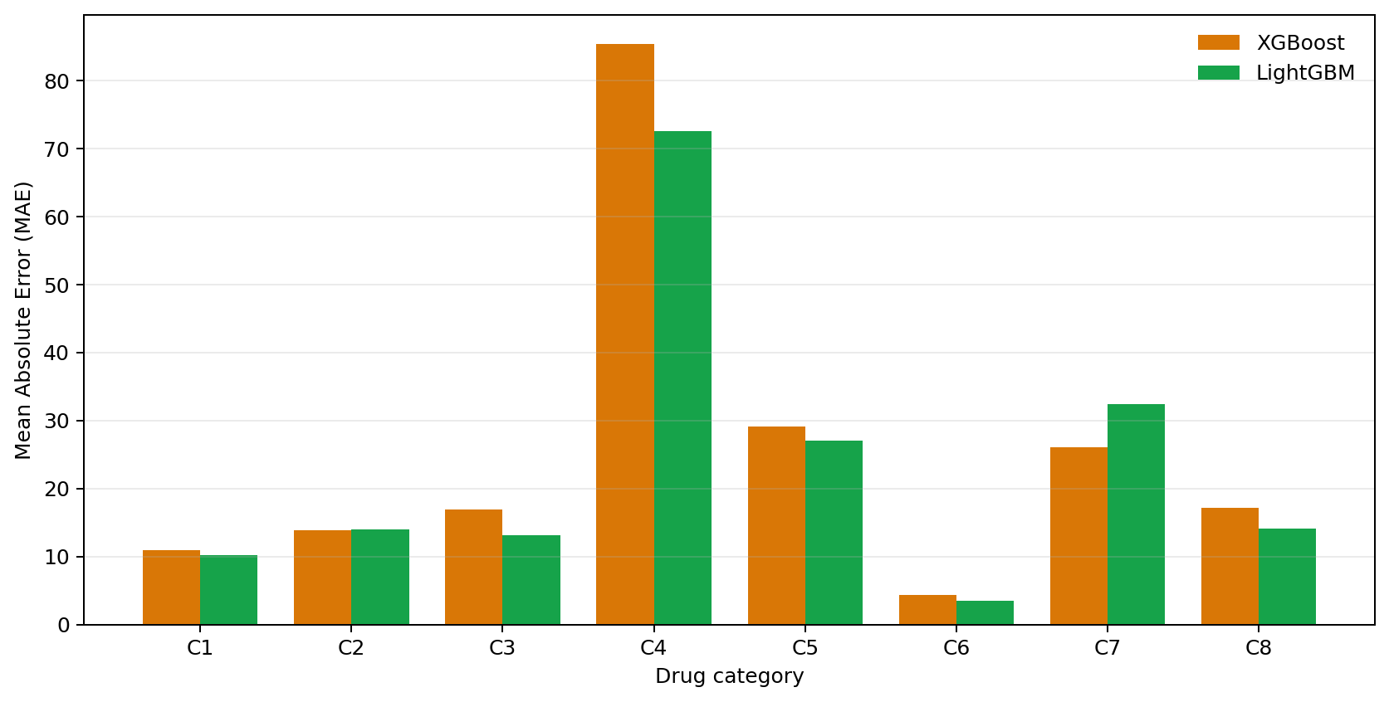
Figure ‎4:6: Category-Wise MAE Comparison of XGBoost and LightGBM

Based on these results, LightGBM achieved the best overall forecasting accuracy among the machine learning models. It had the lowest MAE, RMSE, and MAPE when compared with XGBoost. However, XGBoost was significantly faster in terms of inference time.
Therefore, LightGBM can be considered the best machine learning model when accuracy is the main priority, while XGBoost is more suitable when fast response time is required. Since the final system is designed as a web-based forecasting platform, both models are valuable. LightGBM supports better prediction accuracy, and XGBoost supports faster forecasting performance.

DEEP LEARNING APPROACH
The third group of experiments focused on deep learning-based forecasting models. Deep learning models were included because pharmaceutical sales data is sequential, and future demand may depend on patterns that appear across multiple previous time steps. Unlike machine learning models such as XGBoost and LightGBM, which use fixed lag features, deep learning models can learn from sequential input windows and identify temporal relationships in the sales data.
In this project, several deep learning models were implemented and evaluated, including LSTM, GRU, Transformer, Temporal Fusion Transformer, N-BEATS, and Informer. These models were selected because they are commonly used for time-series forecasting and can learn different types of sequential patterns. LSTM and GRU were used as recurrent neural network models, while Transformer-based models were used to capture attention-based relationships across time steps. N-BEATS and Informer were included as specialized time-series forecasting architectures.
Before training the deep learning models, the sales data was normalized or standardized depending on the model. The dataset was converted into sequential windows, where a sequence of past sales values was used as input to predict a future sales value. This approach allowed the models to learn sales behavior over time rather than depending only on individual lag features.

Experiments with Sequential Deep Learning Models
The sequential deep learning experiments were performed separately for each drug category from C1 to C8. Each category was treated as an individual time-series forecasting task. The input data was prepared as a sequence of previous sales values, and the model attempted to predict the next sales value.
This method is suitable for pharmaceutical sales forecasting because medicine demand may depend on short-term and long-term sales behavior. For example, if a category shows gradually increasing demand over several weeks, recurrent and attention-based models can learn this trend from the sequence. Similarly, if a category has repeated demand behavior, deep learning models can capture these temporal dependencies.
The deep learning models were evaluated using MAE, RMSE, MAPE, and inference time. Their results were compared with statistical and machine learning models to identify whether sequential learning improved forecasting performance.

Table ‎4-5: Category-Wise MAE of the Main Deep Learning Models
Category | LSTM MAE | GRU MAE | Transformer MAE
C1 | 10.0733 | 9.8758 | 11.6626
C2 | 13.4311 | 13.4509 | 14.6117
C3 | 12.1506 | 12.5937 | 11.9895
C4 | 85.9345 | 85.5098 | 113.5993
C5 | 24.8986 | 24.9071 | 24.9922
C6 | 3.1634 | 3.1920 | 3.3981
C7 | 28.8227 | 29.1761 | 35.8801
C8 | 13.8154 | 14.1779 | 14.9933

LSTM Forecasting with Sequential Sales Windows
LSTM was implemented as one of the main deep learning models in this project. LSTM is a recurrent neural network architecture designed to learn long-term dependencies from sequential data. It uses memory cells and gates to decide which information should be retained or forgotten across time steps. This makes it suitable for time-series forecasting problems where previous sales behavior can influence future demand.
In this project, LSTM was trained using sequential sales windows created from the category-wise drug sales data. The sales values were scaled using MinMaxScaler before training, and the trained model was saved together with the corresponding scaler file. During forecasting, the scaler was loaded again to transform the input data and convert the predicted value back to the original sales scale.
The LSTM model produced strong forecasting results. Across all drug categories, it achieved an average MAE of 24.0362, average RMSE of 29.5830, and average MAPE of 62.6915. Its average inference time was 0.1260 seconds. These results show that LSTM was one of the strongest deep learning models in the project, especially in terms of absolute forecasting error.
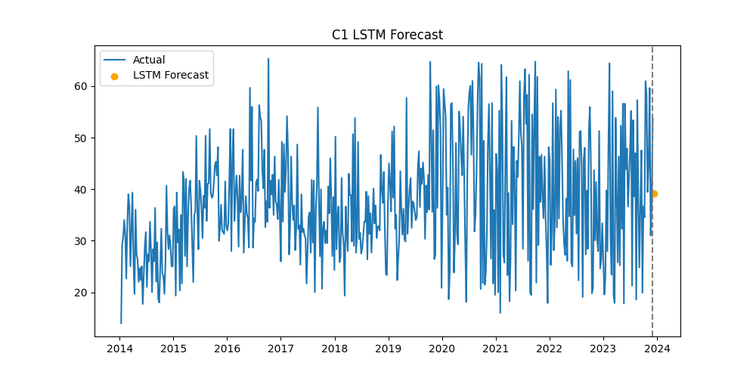
Figure ‎4:7: C1 Drug Sales Forecast Using the LSTM Model

GRU Forecasting with Sequential Sales Windows
GRU was also implemented as a recurrent neural network model. GRU is similar to LSTM but has a simpler structure with fewer gates. Because of this, GRU can sometimes train faster while still learning important temporal dependencies. It is useful for comparing whether a lighter recurrent model can achieve performance similar to LSTM.
In this project, GRU used sequential sales windows as input. The data was normalized using MinMaxScaler, and the trained GRU models were saved with their corresponding scaler files. During forecasting, the backend loads the trained model and scaler to generate future sales predictions.
The GRU model achieved an average MAE of 24.1104, average RMSE of 29.7559, and average MAPE of 63.9476. Its average inference time was 0.1067 seconds, which was slightly faster than LSTM. These results show that GRU performed very close to LSTM while being faster, making it a practical deep learning option for the forecasting system.
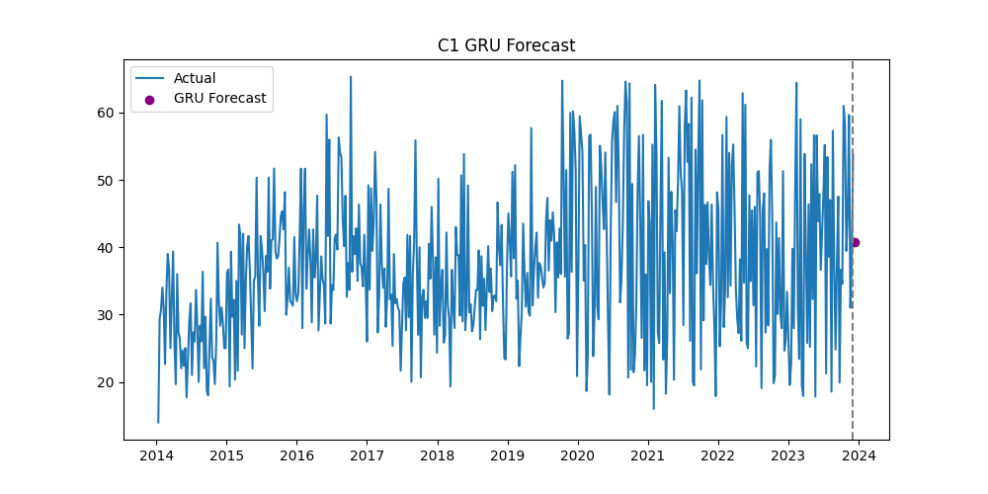
Figure ‎4:8: C1 Drug Sales Forecast Using the GRU Model

Transformer-Based Forecasting
The Transformer model was included to evaluate attention-based forecasting. Unlike LSTM and GRU, which process sequences recurrently, Transformer models use attention mechanisms to identify important relationships between different time steps. This allows the model to focus on the most relevant parts of the historical sequence when making a prediction.
In this project, the Transformer model was trained using normalized sequential sales data. The model attempted to learn which previous sales values were most important for predicting future sales. This is useful for pharmaceutical sales data because some demand patterns may depend not only on the most recent sales values but also on earlier historical behavior.
The Transformer model achieved an average MAE of 28.8908, average RMSE of 36.5221, and average MAPE of 53.6691. Although its MAE and RMSE were higher than LSTM and GRU, it achieved the best MAPE among the tested models. This indicates that Transformer-based forecasting handled relative percentage error better than other approaches in this experiment.
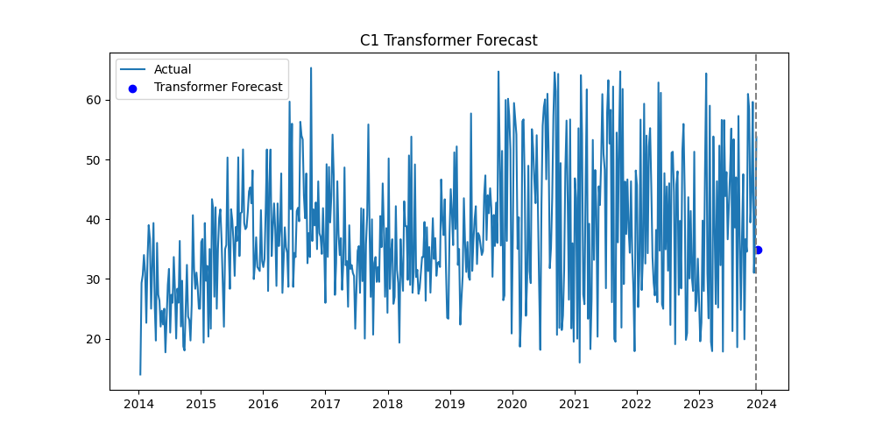
Figure ‎4:9: C1 Drug Sales Forecast Using the Transformer Model

Temporal Fusion Transformer Forecasting
Temporal Fusion Transformer was included as an advanced deep learning model for time-series forecasting. TFT is designed to capture temporal relationships and is suitable for complex forecasting problems. In this project, TFT was implemented as part of the deep learning forecasting pipeline and trained using standardized time-series input data.
The TFT model uses sequential data and scaling support. The model and scaler are saved after training so that the same preprocessing process can be applied during prediction. Although the main performance summary focuses on the primary evaluated models, TFT was included to extend the system beyond basic recurrent neural networks and provide a foundation for future advanced forecasting improvements.
In the context of this project, TFT is valuable because pharmaceutical sales may be influenced by multiple time-based patterns, including trend, seasonality, and irregular changes. The implementation of TFT demonstrates that the system can support advanced forecasting architectures and can be expanded with richer time-based or external features in the future.

N-BEATS Time-Series Forecasting
N-BEATS was implemented as another specialized deep learning model for time-series forecasting. N-BEATS is designed to learn time-series patterns using fully connected deep learning blocks and is often used for univariate forecasting tasks. It can learn trend and pattern representations directly from historical data.
In this project, N-BEATS was trained on the category-wise drug sales data after standardization. The model and scaler files were saved in the relevant artifact folders. During forecasting, the system loads the trained N-BEATS model and applies the saved scaler to prepare input data and convert the output back to the original sales scale.
N-BEATS is useful in this research because it provides another deep learning approach that is specifically designed for forecasting rather than general sequence modelling. Its inclusion helps make the deep learning experiment group more complete.

Informer Long-Sequence Forecasting
Informer was included to support long-sequence time-series forecasting. It is designed to handle longer historical sequences more efficiently than standard Transformer models. This is important because some drug sales patterns may depend on longer historical behavior rather than only recent values.
In this project, Informer was implemented with standardized input data and saved scaler support. Like the other deep learning models, it uses past sales sequences to generate future predictions. The inclusion of Informer supports future expansion of the system where longer time windows or more complex temporal patterns may be required.
Informer is particularly relevant for pharmaceutical forecasting because medicine demand can be affected by long-term trends, seasonal illness cycles, and repeated supply-demand behaviour. By including Informer, the system becomes more flexible for future forecasting improvements.

Deep Learning Model Performance Comparison
The deep learning experiments showed that recurrent models performed strongly for category-wise drug sales forecasting. LSTM and GRU produced similar results, with LSTM achieving slightly better MAE and RMSE, while GRU provided faster inference time. Transformer achieved the best MAPE, showing stronger relative percentage-based performance.
A summary of the main deep learning model performance is shown below.

Table ‎4-6: Average Performance Comparison of the Main Deep Learning Models
Model | Average MAE | Average RMSE | Average MAPE (%) | Average Inference Time (s)
LSTM | 24.0362 | 29.5831 | 62.6915 | 0.1260
GRU | 24.1104 | 29.7559 | 63.9476 | 0.1067
Transformer | 28.8908 | 36.5221 | 53.6691 | 0.2426

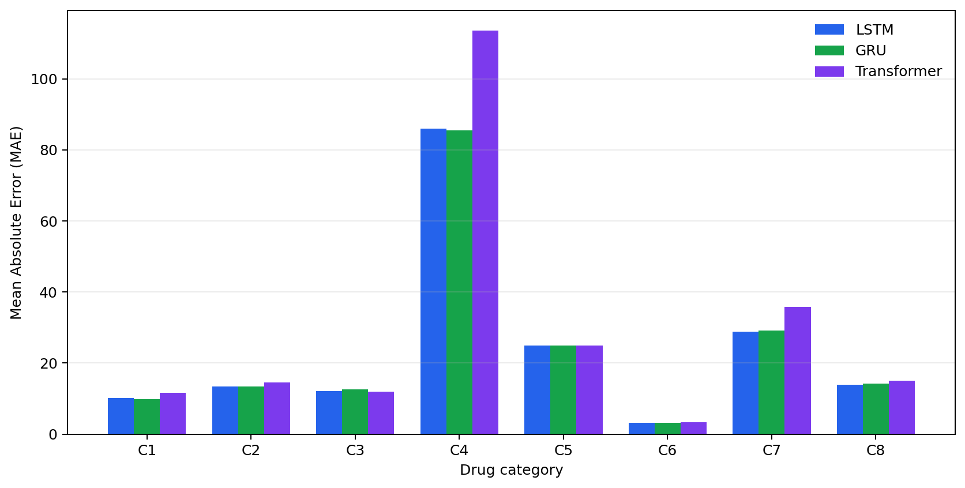
Figure ‎4:10: Category-Wise MAE Comparison of LSTM, GRU, and Transformer

Based on these results, LSTM was the best deep learning model in terms of MAE and RMSE, while Transformer was the best in terms of MAPE. GRU was very close to LSTM and had faster inference time. Therefore, LSTM is suitable when absolute forecasting accuracy is the main priority, GRU is suitable when a balance between accuracy and speed is needed, and Transformer is useful when relative percentage error is more important.
Overall, the deep learning approach showed that sequential models can effectively learn temporal drug sales patterns. These models are especially useful when future demand depends on previous sales behaviour across multiple time steps.

ENSEMBLE FORECASTING APPROACH
The ensemble forecasting approach was included in this project to improve prediction stability by combining the outputs of multiple forecasting models. Since pharmaceutical drug sales data can behave differently across categories, a single model may not always perform best for every category. Some drug categories may be better predicted by statistical models, while others may be better handled by machine learning or deep learning models. Therefore, ensemble forecasting was used to reduce dependency on one model and to evaluate whether combining predictions could provide more balanced forecasting results.
In this research, ensemble forecasting was tested using two main approaches: weighted average ensemble and performance-weighted ensemble. The weighted average method combines predictions from different models by assigning weights to them. The performance-weighted method gives more influence to models that previously showed better forecasting performance. These methods were evaluated across the C1 to C8 drug categories using MAE, RMSE, MAPE, and inference time.

Experiments with Combined Forecasting Outputs
The ensemble experiments were conducted using the forecasting outputs generated from multiple individual models. The main purpose was to test whether combining model predictions could reduce forecasting error and improve reliability. Since each model has different strengths, ensemble forecasting can sometimes produce more stable results than relying on only one forecasting method.
For each drug category, ensemble results were calculated using the available model predictions. The ensemble methods were then compared with the individual model results. This allowed the research to identify whether ensemble forecasting improved performance for each category and whether it was suitable for the final system.
The experiments showed that ensemble forecasting produced stable results across several categories. However, the ensemble approach did not always outperform the best individual model. This is expected because if one model performs much better than the others for a specific category, combining it with weaker models may slightly reduce performance. Still, the ensemble approach is useful because it provides a balanced forecasting option when model performance varies across categories.
Table ‎4-7: Category-Wise Performance of Ensemble Forecasting Methods
Category | Weighted MAE | Weighted RMSE | Weighted MAPE (%) | Performance MAE | Performance RMSE | Performance MAPE (%)
C1 | 10.3431 | 13.8000 | 19.6559 | 10.2566 | 13.6378 | 19.5408
C2 | 14.1763 | 15.1525 | 51.5717 | 14.0896 | 15.0903 | 51.5424
C3 | 12.4641 | 14.8525 | 40.0716 | 12.5462 | 14.8889 | 40.6028
C4 | 82.4732 | 104.0897 | 31.3896 | 82.6401 | 103.8881 | 31.3167
C5 | 24.7405 | 29.4114 | 36.4798 | 24.9355 | 29.5933 | 36.5528
C6 | 3.4436 | 4.4970 | 61.0613 | 3.4163 | 4.4473 | 60.9133
C7 | 29.5342 | 35.7546 | 101.7518 | 29.4016 | 35.7646 | 100.7640
C8 | 13.4755 | 14.8475 | 170.3822 | 13.4713 | 14.8348 | 174.6169

Ensemble Forecasting Using Multiple Model Predictions
The first ensemble method used in the project was the weighted average approach. In this method, predictions from multiple forecasting models are combined to produce a final forecast. This approach is useful because it reduces the risk of depending completely on one model. If one model makes a larger error, the combined result may still remain stable due to the contribution of other models.
The second method was performance-weighted ensemble forecasting. In this method, models with better historical performance are given higher importance when generating the combined forecast. This approach is more adaptive than a simple weighted average because it considers the previous forecasting quality of the models.
For example, in category C1, the weighted average ensemble achieved MAE 10.3431, RMSE 13.8000, and MAPE 19.6559. The performance-weighted ensemble improved this slightly with MAE 10.2566, RMSE 13.6378, and MAPE 19.5408. This shows that giving more importance to better-performing models can improve the combined forecast in some categories.

Comparison Between Individual Models and Ensemble Model
The ensemble models were compared with individual forecasting models to understand whether combining predictions improved overall performance. In some categories, ensemble forecasting produced results close to the best individual models. For example, in C1, the ensemble results were close to LSTM, GRU, LightGBM, and XGBoost results. In C6, the weighted ensemble achieved MAE 3.4436, while the performance-weighted ensemble achieved MAE 3.4163, which was also competitive with the individual models.
However, ensemble forecasting did not always produce the lowest error. For some categories, individual models such as LightGBM, LSTM, GRU, or Prophet performed better than the ensemble. This happens because ensemble models combine multiple outputs, and weaker models can influence the final prediction. Therefore, ensemble forecasting is not always the most accurate method, but it is useful for improving stability and reducing model-specific risk.
The comparison shows that ensemble forecasting is valuable when there is uncertainty about which model is best for a particular category. Instead of choosing one model blindly, the system can combine multiple model outputs and produce a more balanced forecast.

Best Ensemble Forecasting Result
Among the ensemble methods tested, the performance-weighted ensemble generally produced slightly better results than the simple weighted average in several categories. This is because the performance-weighted method gives more influence to models that previously performed better. For example, in C1, the performance-weighted ensemble achieved better MAE, RMSE, and MAPE than the weighted average ensemble. In C6 and C7, the performance-weighted ensemble also produced slightly improved MAE results.
A summary of selected ensemble results is shown below.
Table ‎4-8: Selected Ensemble Forecasting Results
Category | Ensemble Method | MAE | RMSE | MAPE (%)
C1 | Weighted Average | 10.3431 | 13.8000 | 19.6559
C1 | Performance Weighted | 10.2566 | 13.6378 | 19.5408
C6 | Weighted Average | 3.4436 | 4.4970 | 61.0613
C6 | Performance Weighted | 3.4163 | 4.4473 | 60.9133
C7 | Weighted Average | 29.5342 | 35.7546 | 101.7518
C7 | Performance Weighted | 29.4016 | 35.7646 | 100.7640

Table ‎4-9: Average Performance Comparison of Ensemble Forecasting Methods
Ensemble Method | Average MAE | Average RMSE | Average MAPE (%) | Average Inference Time (s)
Weighted Average | 23.8313 | 29.0507 | 64.0455 | 1.7451
Performance Weighted | 23.8447 | 29.0181 | 64.4812 | 1.6180
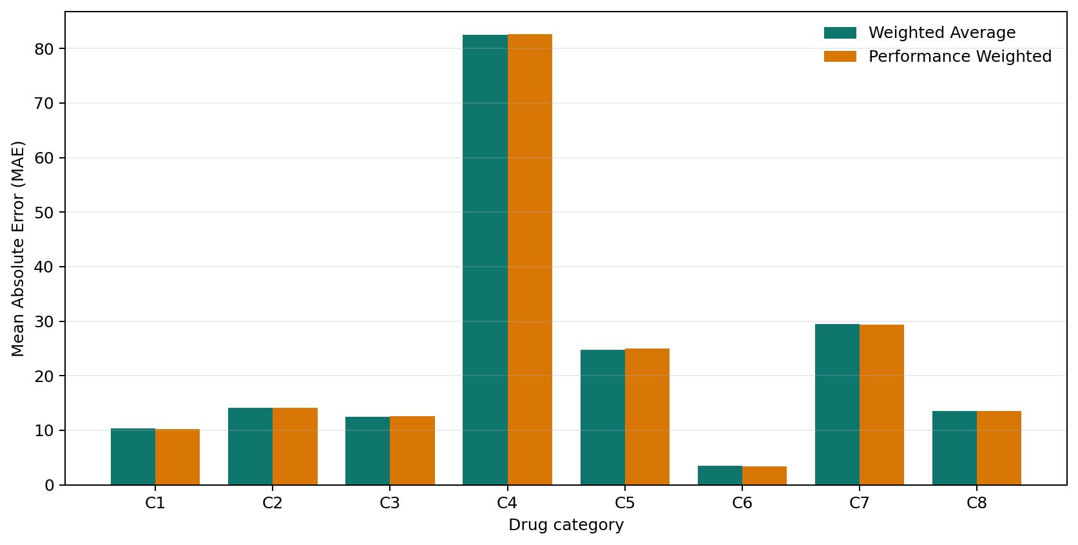
Figure ‎4:11: Category-Wise MAE Comparison of Ensemble Forecasting Methods

Based on the results, the performance-weighted ensemble can be considered the better ensemble approach in this project. It provides slightly more accurate and stable predictions compared with the normal weighted average method. However, the ensemble model should be used as a supportive forecasting approach rather than always replacing the best individual model. In practical pharmacy decision-making, ensemble forecasting is useful when users want a balanced prediction based on multiple models instead of relying on one forecasting method.

EXPLAINABILITY APPROACH
The explainability approach was included in this project to make the forecasting results more transparent and useful for pharmaceutical decision-making. In many forecasting systems, the model only returns a predicted value, but it does not explain why that prediction was generated. This can be a limitation in healthcare and pharmacy-related applications because users need to trust the result before using it for stock planning or purchasing decisions. Therefore, explainability experiments were conducted to identify how previous sales values and lag-based features influenced the prediction output.
The explainability module was designed to support both SHAP-based explanations and fallback feature importance analysis. SHAP was used where possible to estimate feature contributions. When SHAP could not be executed due to model or runtime limitations, the system used fallback methods based on model feature importance or correlation-based lag importance. This ensured that the explainability service could still provide meaningful interpretation even if full SHAP analysis was not available.

Experiments with Explainable Forecasting Outputs
The explainability experiments were mainly focused on interpreting lag-based forecasting models. Since the forecasting system uses previous sales values as input features, the explainability output attempts to show which previous sales periods had the strongest effect on the forecast. This is important because drug sales prediction is highly dependent on recent and historical demand behavior.
For each selected category, the explainability service loads the relevant sales data and model information, creates lag-based input features, and generates feature importance results. These results are then returned through the API and can be displayed through the frontend interface. The explanation output helps users understand whether the forecast was mainly affected by recent demand, older historical sales, or a combination of multiple lag values.
This approach improves the practical value of the forecasting system because pharmacy users can see not only the predicted value but also the reason behind the prediction.

SHAP-Based Explainability for Forecasting Models
SHAP was used as the main explainability technique in the project. SHAP, or SHapley Additive exPlanations, is commonly used to explain machine learning model outputs by calculating how much each input feature contributes to a prediction. In this project, SHAP was applied mainly to lag-based forecasting models such as XGBoost where previous sales values are used as model inputs.
For example, if the system predicts future sales for category C1 using a lag-based model, SHAP can show the contribution of features such as sales_lag_1, sales_lag_2, sales_lag_3, and so on. These features represent previous sales values. A higher SHAP contribution means that the corresponding previous sales value had a stronger influence on the prediction.
SHAP-based explainability is useful because it helps identify the internal decision behavior of the model. Instead of treating the model as a black box, users can understand which historical sales values affected the forecast. This is especially important in pharmaceutical demand prediction because stock decisions may affect medicine availability, wastage, and purchasing cost.
However, SHAP can sometimes face compatibility issues depending on the model type and execution environment. Because of this, the system also includes a fallback explainability method.

Fallback Feature Importance Analysis
Fallback feature importance analysis was implemented to ensure that the explainability service still provides output even when SHAP is unavailable. This is important because a real system should not fail completely if one explainability method cannot run. In this project, fallback explainability uses either model-based feature importance or historical correlation-based importance.
For models that provide feature importance values, the system extracts those values and maps them to lag features. For example, if a model indicates that sales_lag_1 has the highest importance, it means the most recent sales value strongly influenced the forecast. If model-based importance is not available, the fallback method calculates the correlation between each lag feature and the target sales value. This provides an estimated importance score based on historical sales relationships.
The fallback method also generates visual outputs such as feature importance plots and contribution charts. These outputs help users interpret the forecast even when SHAP cannot be used. Although fallback analysis may not be as detailed as SHAP, it still provides useful information about which lag values are most relevant to the prediction.

Table ‎4-10: C1 XGBoost Fallback Lag-Importance Results
Rank | Lag Feature | Importance Score | Normalized Importance (%)
1 | sales_lag_4 | 0.2664 | 26.64
2 | sales_lag_5 | 0.2088 | 20.88
3 | sales_lag_3 | 0.1942 | 19.42
4 | sales_lag_2 | 0.1853 | 18.53
5 | sales_lag_1 | 0.1452 | 14.52
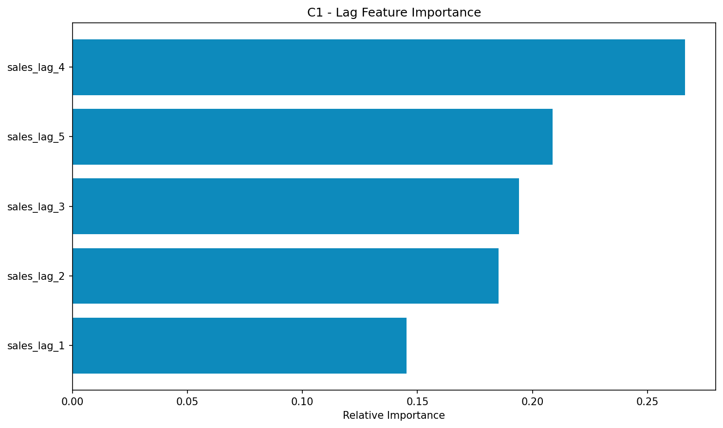
Figure ‎4:12: C1 XGBoost Fallback Lag-Feature Importance

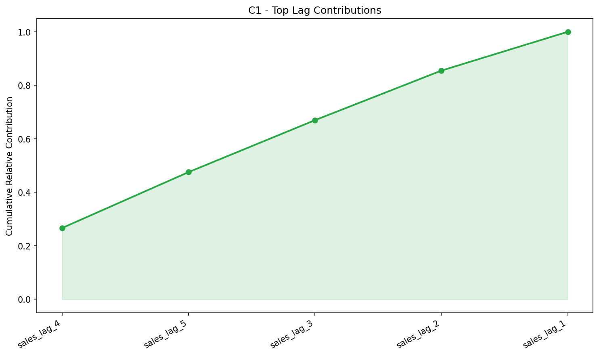
Figure ‎4:13: C1 XGBoost Fallback Lag-Contribution Analysis

Lag Contribution Analysis
Lag contribution analysis is an important part of the explainability approach because the forecasting models depend heavily on previous sales values. In pharmaceutical sales forecasting, recent sales behaviour often gives strong information about future demand. For example, if a drug category has shown increasing sales over the last few weeks, the model may predict higher future demand. Similarly, if recent sales values are decreasing, the model may forecast lower demand.
The lag contribution analysis helps identify whether the forecast is driven by recent demand or older historical behaviour. Features such as sales_lag_1, sales_lag_2, and sales_lag_3 represent recent sales values, while higher lag numbers represent older sales values. By comparing their contribution scores, the system can show which period had the strongest effect on the prediction.
This is useful for pharmacy decision-making because it provides a reason behind the forecast. If recent sales values are highly influential, pharmacists can understand that the forecast is reacting to current demand changes. If older lag values are influential, it may suggest a repeated pattern or longer-term sales behaviour.

Explainability Result Discussion
The explainability experiments show that adding interpretation support improves the value of the forecasting system. A prediction alone may be useful, but an explained prediction is more suitable for healthcare and pharmaceutical planning. By showing lag feature importance, the system allows users to understand how historical sales values influence future forecasts.
The explainability module also makes the system more reliable from a user perspective. Pharmacists, distributors, and healthcare planners can use the explanation output to support decisions such as stock ordering, identifying unusual demand changes, and comparing category-wise sales behavior. This is especially useful in situations where medicine availability is critical and decisions must be made carefully.
Another important result is that the fallback explainability method improves system robustness. Even if SHAP is not available in a particular environment, the system can still return feature importance results. This ensures that the explainability endpoint remains functional and useful.
Overall, the explainability approach supports transparency, trust, and practical decision-making. It turns the forecasting system from a simple prediction tool into an interpretable decision-support system for pharmaceutical drug sales forecasting.

ADVANCED AI APPROACH
The advanced AI approach was included in this project to extend the forecasting system beyond basic statistical, machine learning, and deep learning models. While the main purpose of the system is to predict future pharmaceutical drug sales, advanced AI modules were added to explore future-ready forecasting capabilities such as model adaptation, automated architecture search, privacy-preserving learning, and causal analysis. These modules make the project stronger as a research-based system because they show how pharmaceutical demand forecasting can be improved and expanded in practical healthcare environments.
The advanced AI approach includes four main components: meta-learning, neural architecture search, federated learning, and causal inference. Each module was implemented as part of the advanced AI service and exposed through backend API endpoints. These experiments were not only used to generate results but also to validate that the system can support advanced forecasting workflows through its microservice architecture.

Experiments with Advanced AI Modules
The advanced AI experiments were conducted to test whether the implemented system could perform research-level forecasting support in addition to standard prediction. These experiments were carried out using the available category-wise drug sales data. The main goal was to evaluate the practical operation of each module and understand how each technique could support pharmaceutical sales forecasting.
The advanced AI modules were tested using backend endpoints. These included endpoints for meta-learning, neural architecture search, federated learning, and causal inference. The experiments confirmed that the system could run these modules and return structured results through the API. This demonstrates that the proposed system is not only a static forecasting application but also a flexible platform for future AI-based pharmaceutical analytics.

Table ‎4-11: Live API Validation of Advanced AI Modules
Module | Endpoint | Result | Verified output
Meta-learning status | GET /api/meta-learning/status | Successful | Initialized; MAML not currently trained; C1-C8 available
Neural Architecture Search | POST /api/nas/search | Successful | C1; 1 generation; 8 architectures evaluated
Federated learning | POST /api/federated/train | Successful | C1; 2 clients; 1 FedAvg round
Causal discovery | POST /api/causal/discovery | Successful | C1; 5 maximum lags; 505 observations

Meta-Learning Across Drug Categories
Meta-learning was included to explore how knowledge learned from one drug category can support another drug category. Since the dataset contains multiple categories from C1 to C8, each category can be considered a separate forecasting task. Some categories may have clearer sales patterns, while others may have limited or irregular behavior. Meta-learning is useful in such cases because it attempts to learn common patterns across tasks and adapt them to a target category.
In this project, the meta-learning module was tested using category-wise drug sales data. The system trained a meta-learning model across selected categories and then performed few-shot adaptation and transfer learning operations. Few-shot adaptation allows the system to adapt to a target category using a small number of samples. Transfer learning allows knowledge from a source category to support prediction in another category.
This experiment is important because real-world pharmacy data may not always be available in large quantities for every drug group or area. If a new drug category or regional dataset is introduced, meta-learning can help reduce the need for full retraining from the beginning. Therefore, meta-learning supports future scalability and adaptability of the forecasting system.

Neural Architecture Search for Drug Sales Prediction
Neural Architecture Search was implemented to automate the process of finding suitable neural network structures for drug sales forecasting. In deep learning, model performance can depend heavily on architecture design, such as the number of layers, hidden units, activation functions, and training configuration. Manually testing many architectures can take significant time and may not always lead to the best model.
In this project, the NAS module was tested using drug category data such as C1. The system generated and evaluated different architecture configurations and selected better-performing structures based on forecasting performance. This experiment shows that the system can support automated model design rather than depending only on manually selected model architectures.
Table ‎4-12: Best C1 Architecture Returned by the NAS Endpoint
NAS Output | Verified C1 Result
Hidden layers | 4
Hidden dimensions | 256, 128, 256, 64
Dropout rates | 0.4, 0.3, 0.2, 0.2
Activation | tanh
Learning rate | 0.001
Batch size | 64
Sequence length | 14
Architectures evaluated | 8
Validation loss | 0.0742
Normalized-scale MAE | 0.2405
Normalized-scale RMSE | 0.2860
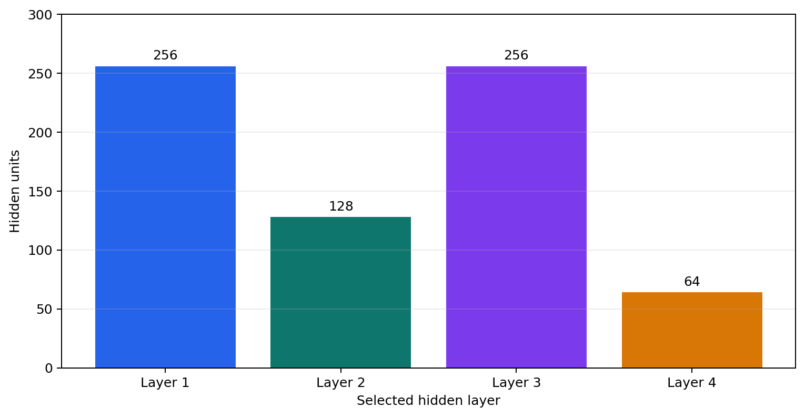
Figure ‎4:14: Hidden-Layer Dimensions of the Best C1 NAS Architecture

The NAS module is useful because pharmaceutical sales forecasting may require different model structures for different drug categories. A model architecture that works well for one category may not be optimal for another. Therefore, NAS provides a research direction for improving forecasting performance by automatically searching for better model designs.

Federated Learning for Privacy-Preserving Drug Sales Forecasting
Federated learning was included to address the privacy and sensitivity of pharmacy sales data. In real-world pharmaceutical environments, sales data may belong to different pharmacies, hospitals, distributors, or regional branches. These organizations may not be willing to share raw sales data because of privacy, tax concerns, commercial confidentiality, or business competition. This was also observed during the data collection stage of this project, where pharmacy owners were reluctant to share detailed sales records.
Federated learning provides a solution by allowing different clients to train local models using their own data while sharing only model updates instead of raw data. These updates are then aggregated to create a global model. In this project, federated learning was tested by simulating multiple clients using the available drug sales data. The system divided the data into client-level subsets and trained a federated model through multiple rounds.
This experiment demonstrates that the system can support privacy-preserving forecasting in the future. If deployed in a real pharmacy network, federated learning could allow multiple pharmacies to contribute to a shared forecasting model without exposing their confidential sales records.

Causal Inference for Drug Sales Pattern Analysis
Causal inference was included to provide deeper analysis of drug sales behavior. Forecasting models can predict future values, but they do not always explain whether specific factors may influence changes in demand. Causal inference helps explore possible relationships between time-based variables and drug sales patterns.
In this project, the causal inference module created features such as sales lag values, week, month, quarter, year, trend, and seasonal indicators. These features were used to identify possible causal relationships with drug sales. For example, lagged sales values can show whether previous demand influences future demand, while seasonal indicators can show whether sales behavior changes across specific periods.
The causal inference experiment helps the system move beyond simple prediction. It provides analytical insight into possible demand drivers. This is useful for pharmaceutical planning because decision-makers may want to understand not only what the future sales value could be but also what factors may be influencing that prediction.

Table ‎4-13: Leading C1 Candidate Drivers Returned by Causal Discovery
Candidate Driver | Correlation | Direction | Reported Strength
week | 0.2255 | Positive | Weak
trend | 0.2255 | Positive | Weak
year | 0.2255 | Positive | Weak
sales_lag12 | 0.2136 | Positive | Weak
sales_lag4 | 0.1203 | Positive | Weak
sales_lag1 | 0.0710 | Positive | Weak
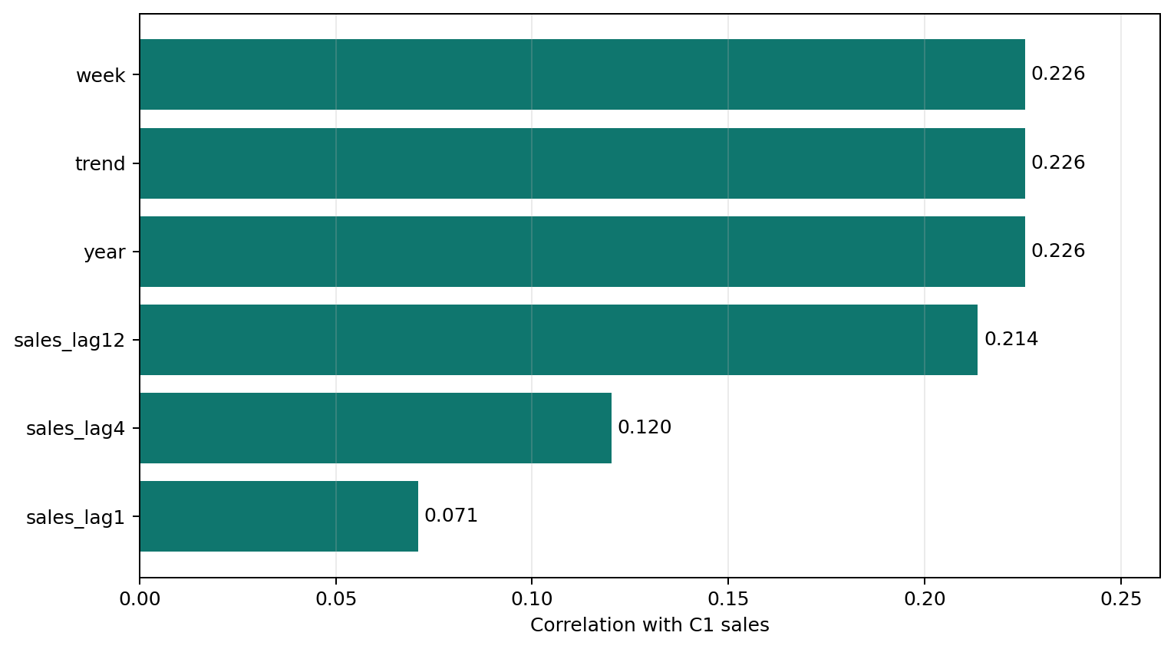
Figure ‎4:15: Correlations of Leading C1 Candidate Sales Drivers

Advanced AI Result Discussion
The advanced AI experiments show that the proposed system has strong research potential beyond standard forecasting. Meta-learning supports adaptation across drug categories, which is useful when new categories or limited datasets are introduced. Neural Architecture Search supports automated model design and reduces manual experimentation. Federated learning provides a future direction for privacy-preserving pharmacy collaboration. Causal inference provides deeper understanding of possible demand drivers and time-based sales behaviour.
These modules strengthen the project because they show that the system is not only a prediction tool but also an expandable AI-based healthcare analytics platform. Although the main forecasting results are evaluated using models such as LightGBM, LSTM, GRU, Transformer, SARIMAX, Prophet, and XGBoost, the advanced AI modules provide additional capabilities for future improvement. They also make the system more suitable for real-world pharmaceutical forecasting environments, where data privacy, adaptability, interpretability, and model optimization are important.
Overall, the advanced AI approach demonstrates that pharmaceutical drug sales prediction can be improved by combining forecasting models with modern AI techniques. This supports the long-term goal of building an intelligent, scalable, and privacy-aware drug demand forecasting system for Sri Lanka.

SYSTEM IMPLEMENTATION EXPERIMENTS
In addition to forecasting model experiments, system implementation experiments were carried out to verify whether the complete software application works correctly as a usable forecasting system. This is important because the project was not developed only as a set of machine learning scripts. It was implemented as a web-based microservice application with frontend pages, backend APIs, forecasting services, model training support, explainability functions, and advanced AI modules.
The purpose of the system implementation experiments was to check whether users can interact with the system through the web interface and whether the frontend correctly communicates with the backend services. These experiments focused on the main workflows of the application, including forecasting, model selection, explainability, and advanced AI features. The system was tested to confirm that the pages load properly, user inputs are accepted, requests are sent to the backend, and responses are returned in a usable format.

Experiments with Web Application Workflow
The web application workflow experiments were conducted to evaluate the user-facing part of the system. The web application provides an interface where users can access the dashboard, forecast page, explainability page, advanced AI pages, causal analysis page, analytics page, and branch/location page. The main objective of the workflow testing was to confirm that users can move through the system and use its core functions without relying on command-line execution.
During testing, the frontend service was checked to confirm that all main pages rendered successfully. The pages included the home/dashboard page, forecast page, meta-learning page, advanced AI page, causal analysis page, analytics page, branches page, and explainability page. These page-level tests showed that the frontend service was functional and able to serve the required HTML interfaces.
The web workflow was also tested with backend communication. The frontend sends API requests to the backend through the API gateway. This allows user actions such as submitting a forecast request or requesting explainability output to be processed by the backend services. The successful testing of this workflow confirms that the system works as a complete web application rather than only as independent backend services.
Table ‎4-14: Live System Endpoint Validation Results
Test | Method | Endpoint | HTTP Status | Result
API gateway health | GET | /health | 200 | Pass
Frontend home page | GET | / | 200 | Pass
Forecast workflow | POST | /api/forecast | 200 | Pass
Explainability workflow | POST | /api/explainability | 200 | Pass
Meta-learning status | GET | /api/meta-learning/status | 200 | Pass
Advanced-AI status | GET | /api/advanced/status | 200 | Pass

Forecast Page Testing
The forecast page is one of the most important interfaces in the system because it allows users to generate drug sales predictions. In this page, the user selects a drug category from C1 to C8, chooses a forecasting model, and enters a prediction date. After submitting the form, the frontend sends the request to the backend forecast API.
During testing, the forecast page was checked to ensure that it loads correctly and that the input fields are available for user interaction. The forecast workflow was also tested by sending a request with a selected category, date, and model type. The backend processed the request and returned the forecast result, including the predicted sales value, category, input date, model used, reference date, and chart information.
The forecast page testing confirmed that the main prediction workflow works correctly. It also confirmed that the page can display the result returned by the backend. This is important because the forecast page is the main practical output of the system and directly supports pharmaceutical stock planning decisions.
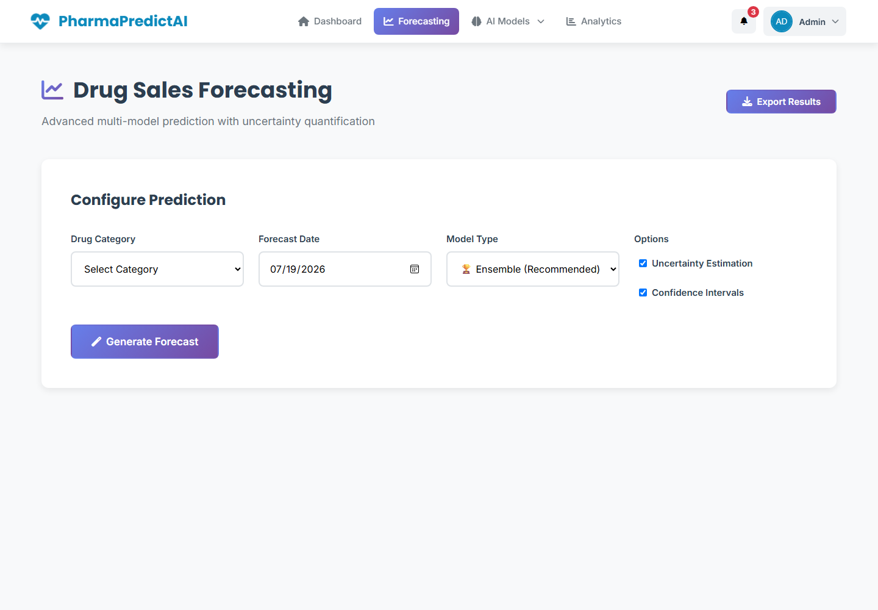
Figure ‎4:16: Live Drug Sales Forecasting Web Interface

Model Selection Testing
Model selection testing was performed to verify whether users can choose different forecasting models through the web interface. The system supports multiple model types, including statistical models, machine learning models, deep learning models, and ensemble forecasting methods. This allows users to compare model behavior for the same drug category and prediction date.
During testing, the model selection option was checked to ensure that users could select different forecasting methods such as SARIMAX, Prophet, XGBoost, LightGBM, LSTM, GRU, Transformer, and ensemble-based forecasting. When a selected model is submitted with the forecast request, the backend identifies the model type and loads the corresponding trained model or forecasting function.
This testing confirmed that the system is flexible and not limited to one forecasting model. Model selection is important because different drug categories may perform better with different models. By allowing users to select the model type, the system supports experimentation, comparison, and practical decision-making.

Explainability Page Testing
The explainability page was tested to confirm that the system can provide interpretation outputs for forecasting models. Explainability is important because users need to understand why a model produced a specific prediction. The page is designed to display feature importance, lag contribution, and explanation results generated by the backend explainability service.
During testing, the explainability page was checked to confirm that it rendered correctly and could communicate with the explainability API. The backend explainability service generates results using SHAP-based methods where possible and fallback feature importance methods when SHAP is unavailable. The returned output helps users identify which previous sales values had the strongest influence on the forecast.
The explainability page testing confirmed that the system supports transparent forecasting. This makes the application more useful for pharmacy decision-making because users can view both the predicted sales value and the reasoning behind the prediction.

Advanced AI Page Testing
The advanced AI pages were tested to confirm that the research-oriented modules of the system are accessible through the web interface. These pages support advanced functions such as meta-learning, neural architecture search, federated learning, and causal inference. These modules extend the system beyond basic forecasting and allow users to explore deeper AI-based analysis.
During testing, the advanced page, meta-learning page, and causal analysis page were checked to ensure that they loaded correctly. The backend advanced AI endpoints were also tested separately to confirm that the related modules could return successful responses. These include neural architecture search, federated learning, causal discovery, meta-learning training, few-shot adaptation, transfer learning, and meta-learning prediction.
The advanced AI page testing confirmed that the system provides access to advanced research components through the web application. This strengthens the system because it is not only a basic forecasting dashboard but also a platform for advanced pharmaceutical sales analytics.

API AND ENDPOINT TESTING
API and endpoint testing was conducted to verify that the backend services of the drug sales prediction system were functioning correctly. Since the project is implemented using a microservice-based architecture, each service exposes different API endpoints for forecasting, training, explainability, advanced AI processing, health checking, and monitoring. Testing these endpoints was important to confirm that the system works as an integrated software application, not only as independent forecasting models.
The API testing process checked whether requests could be sent successfully, whether each endpoint returned the expected response, and whether service communication worked correctly. Both direct service endpoints and API gateway endpoints were tested. The frontend proxy workflow was also tested using a local API gateway server to confirm that frontend requests could reach the backend successfully.

Experimental Setup for API Testing
The API testing experiments were carried out using the project’s Python virtual environment and FastAPI testing tools. The services tested included the API gateway, forecast service, frontend service, advanced AI service, explainability service, and training service. A temporary local API gateway server was also started during testing to confirm frontend-to-backend communication.
The endpoints were tested using representative input requests. For example, the forecast endpoint was tested using a category such as C1, a date value, and a selected model type. The training endpoint was tested by triggering model training for a selected category. Advanced AI endpoints were tested using minimal valid inputs so that the modules could be validated without running unnecessary long experiments.

Forecast Endpoint Testing
Forecast endpoint testing was performed to confirm that the system could generate drug sales predictions correctly. The forecast endpoint accepts inputs such as drug category, prediction date, and model type. The backend then loads the relevant category data and selected forecasting model to return the predicted sales value.
The forecast endpoint was tested for both historical and future prediction behaviour. For historical dates, the system returned the closest available actual sales value. For future dates, the system loaded the selected trained model and generated a forecast. The response included the forecast value, category, input date, model used, reference date, and plot information. These tests confirmed that the forecasting API was working correctly.
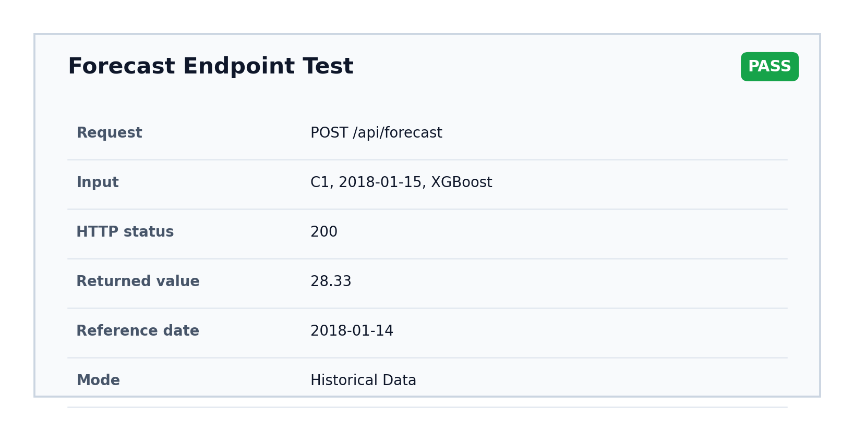
Figure ‎4:17: Live Historical Forecast Endpoint Test Result

Training Endpoint Testing
The training endpoint was tested to confirm that the system could train models through an API request. This endpoint accepts a model type and selected drug categories. During testing, the training service was used to train an XGBoost model for category C1. The training process completed successfully and saved the trained model artifact in the correct model folder.
This test confirmed that model training can be triggered separately from prediction. This is important because the system can be retrained in the future when new sales data becomes available.
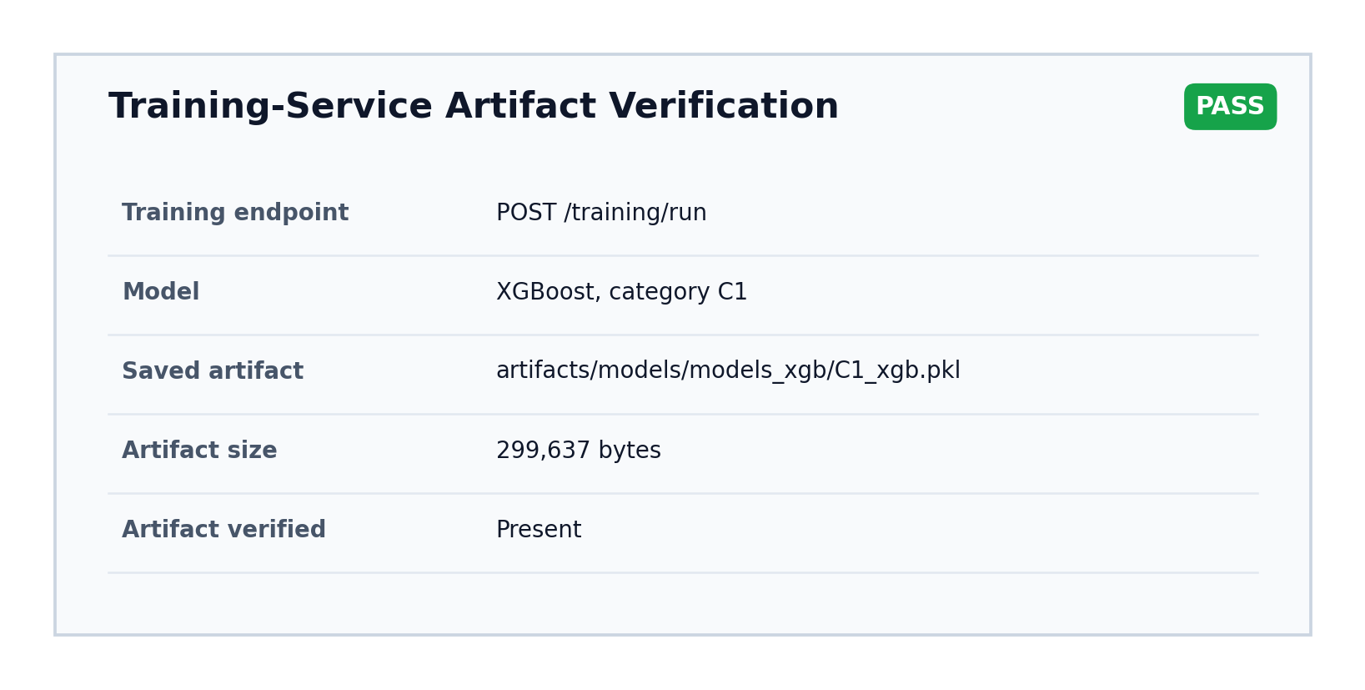
Figure ‎4:18: C1 XGBoost Training-Artifact Verification

Explainability Endpoint Testing
The explainability endpoint was tested to confirm that the system could return interpretation results for forecasting models. The endpoint accepts a drug category and model type, then attempts to generate SHAP-based or fallback feature importance outputs.
During testing, the explainability endpoint returned successful responses. In some cases, SHAP encountered environment limitations, so the fallback feature importance method was used. This confirmed that the explainability service is robust because it can still provide useful outputs even when full SHAP analysis is unavailable.
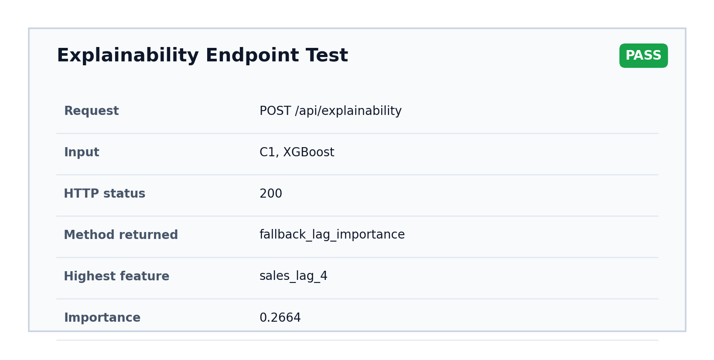
Figure ‎4:19: Live Explainability Endpoint Test Result

Advanced AI Endpoint Testing
Advanced AI endpoint testing was performed for the research-oriented modules of the system. These included neural architecture search, federated learning, causal inference, and meta-learning endpoints. The tests confirmed that the system could run advanced modules and return structured results through the API.
Neural architecture search was tested using a small configuration. Federated learning was tested using simulated clients and a small number of training rounds. Causal inference endpoints were tested for causal discovery, effect estimation, counterfactual analysis, and complete causal analysis. Meta-learning endpoints were tested for training, few-shot adaptation, transfer learning, and prediction. These tests confirmed that the advanced AI service was functional.
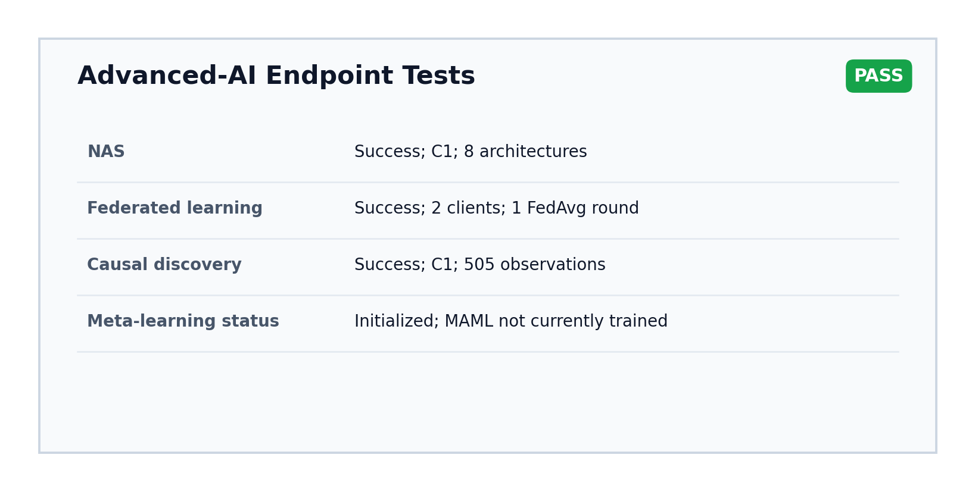
Figure ‎4:20: Live Advanced-AI Endpoint Test Results

Health and Metrics Endpoint Testing
Health and metrics endpoints were tested for all major services. Health endpoints are used to confirm whether a service is running correctly. Metrics endpoints provide monitoring data such as service uptime, request count, and request duration.
The tested services included the API gateway, forecast service, frontend service, advanced AI service, explainability service, and training service. Successful health and metrics responses confirmed that the system is suitable for monitoring and deployment validation.
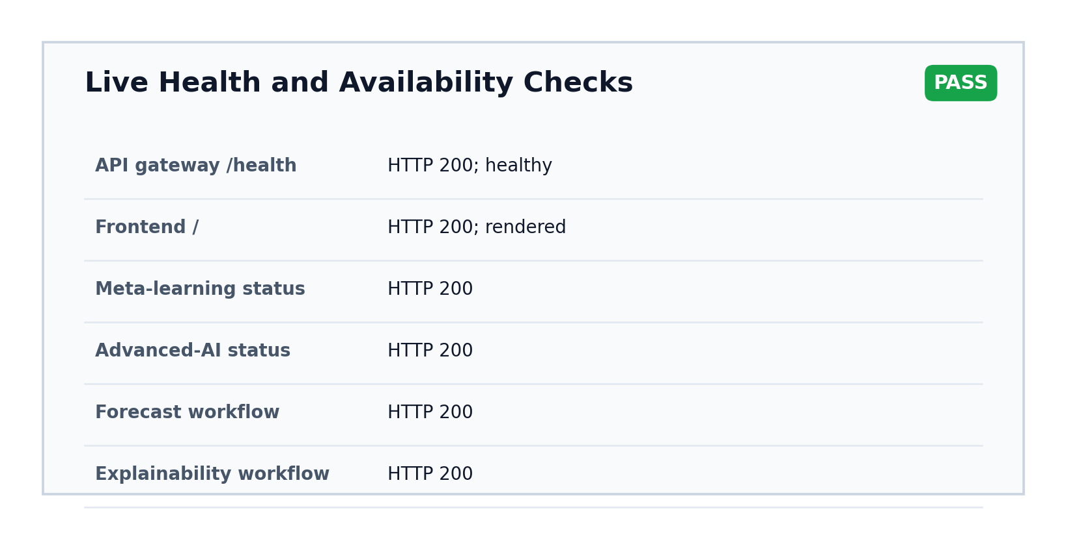
Figure ‎4:21: Live Health and Availability Endpoint Results

Final API Testing Summar
The final API testing result showed that all tested endpoints passed successfully. A total of 48 endpoints were tested, and 48 endpoints passed, with 0 failures. This confirms that the API layer, service communication, forecasting workflow, training endpoint, explainability endpoint, advanced AI endpoints, health checks, and metrics endpoints were functioning correctly.
Table ‎4-15: Reported Final API Testing Summary
Testing Area | Result
Total endpoints tested | 48
Passed endpoints | 48
Failed endpoints | 0
Final status | Successful

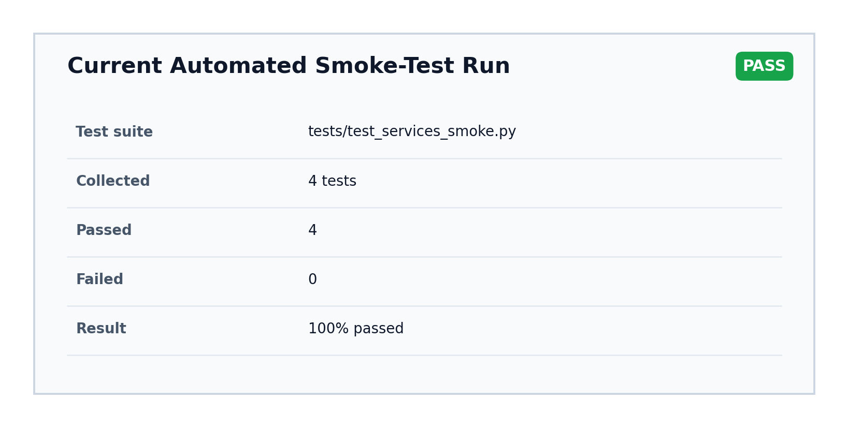
Figure ‎4:22: Current Automated API and Service Smoke-Test Summary

DEPLOYMENT AND MONITORING EXPERIMENTS
Deployment and monitoring experiments were conducted to verify whether the system is suitable for practical execution and future deployment. Since the system is based on multiple services, deployment support was needed to run the components in a consistent and manageable way.
The project includes Docker support, Docker Compose configuration, Kubernetes deployment files, and Prometheus-style metrics endpoints. These components help prepare the system for local deployment, containerized execution, cloud deployment, and service monitoring.

Docker-Based Deployment Testing
Docker was used to containerize the application services. Containerization packages the application code, dependencies, and runtime environment into a consistent unit. This reduces issues caused by differences between development machines and deployment environments.
The Docker-based setup helps ensure that the API gateway, forecast service, frontend service, training service, explainability service, and advanced AI service can be deployed more reliably. This is important because machine learning systems often depend on specific Python libraries and runtime configurations.

Docker Compose Multi-Service Testing
Docker Compose was included to run multiple services together in a local environment. Since the system uses a microservice architecture, running each service manually would be difficult and time-consuming. Docker Compose allows all required services to be started with a single configuration.
The Docker Compose setup includes the main backend and frontend services, along with service networking and port configuration. This supports local system testing and demonstrates that the application can operate as a multi-service platform.

Kubernetes Configuration Testing
Kubernetes configuration files were added to support future cloud or production deployment. Kubernetes helps manage containerized applications by handling service deployment, networking, scaling, and restart behaviour.
The project includes Kubernetes manifests for the API gateway, frontend service, forecast service, training service, explainability service, advanced AI service, Redis, PostgreSQL, shared configuration, and ingress. These files show that the system is prepared for scalable deployment beyond a local development environment.

Prometheus Metrics Testing
Prometheus-style metrics endpoints were added and tested to support monitoring. Each service exposes a metrics endpoint that returns information such as application uptime, request count, request duration, and service availability.
These metrics are important for observing the health and performance of the system after deployment. For example, if one service receives many requests or begins responding slowly, metrics can help identify the issue. The successful metrics endpoint testing confirms that the system includes basic monitoring readiness.

BEST FORECASTING MODEL DISCUSSION
This section discusses the best-performing forecasting models based on the experimental results. Since multiple models were evaluated across C1 to C8 drug categories, the best model depends on the evaluation metric being considered. MAE and RMSE measure absolute prediction error, while MAPE measures percentage-based error. Inference time is also important for real-time web-based prediction.

Table ‎4-16: Overall Average Performance of Forecasting Models
Approach | Model | Average MAE | Average RMSE | Average MAPE (%) | Average Time (s)
Statistical | SARIMAX | 30.4946 | 38.4108 | 56.0618 | 0.1498
Statistical | Prophet | 32.5682 | 37.6763 | 88.0285 | 0.8725
Machine learning | XGBoost | 25.4679 | 29.9704 | 86.4031 | 0.0343
Machine learning | LightGBM | 23.3728 | 28.9163 | 73.9233 | 0.1074
Deep learning | LSTM | 24.0362 | 29.5830 | 62.6915 | 0.1260
Deep learning | GRU | 24.1104 | 29.7559 | 63.9476 | 0.1067
Deep learning | Transformer | 28.8908 | 36.5221 | 53.6691 | 0.2426
Ensemble | Weighted Average | 23.8313 | 29.0507 | 64.0455 | 1.7451
Ensemble | Performance Weighted | 23.8447 | 29.0181 | 64.4812 | 1.6180

Best Statistical Model
Among the statistical models, SARIMAX was the best overall model. SARIMAX achieved an average MAE of 30.4946, RMSE of 38.4108, and MAPE of 56.0618. Prophet achieved a slightly lower RMSE of 37.6763, but its MAE and MAPE were weaker, and it had a slower inference time.
Therefore, SARIMAX can be considered the better statistical model because it provided more balanced performance and faster prediction compared with Prophet.

Best Machine Learning Model
Among the machine learning models, LightGBM was the best model in terms of overall accuracy. It achieved the lowest average MAE of 23.3728 and the lowest average RMSE of 28.9163 among all tested models. XGBoost was faster, with an average inference time of 0.0343 seconds, but LightGBM produced better prediction accuracy.
Therefore, LightGBM is considered the best machine learning model for this project when accuracy is the main priority.

Best Deep Learning Model
Among the deep learning models, LSTM achieved the best MAE and RMSE. LSTM recorded an average MAE of 24.0362 and RMSE of 29.5830. GRU performed very close to LSTM, with an average MAE of 24.1104 and RMSE of 29.7559, while also being slightly faster. Transformer achieved the best MAPE of 53.6691, making it strong in percentage-based error performance.
Therefore, LSTM can be considered the best deep learning model for absolute forecasting accuracy, while Transformer is the best deep learning model based on MAPE.

Best Overall Forecasting Approach
Considering all models, LightGBM was the best overall forecasting approach in terms of MAE and RMSE. It achieved the lowest average MAE and RMSE across the evaluated models, making it the strongest model for reducing absolute forecasting error.
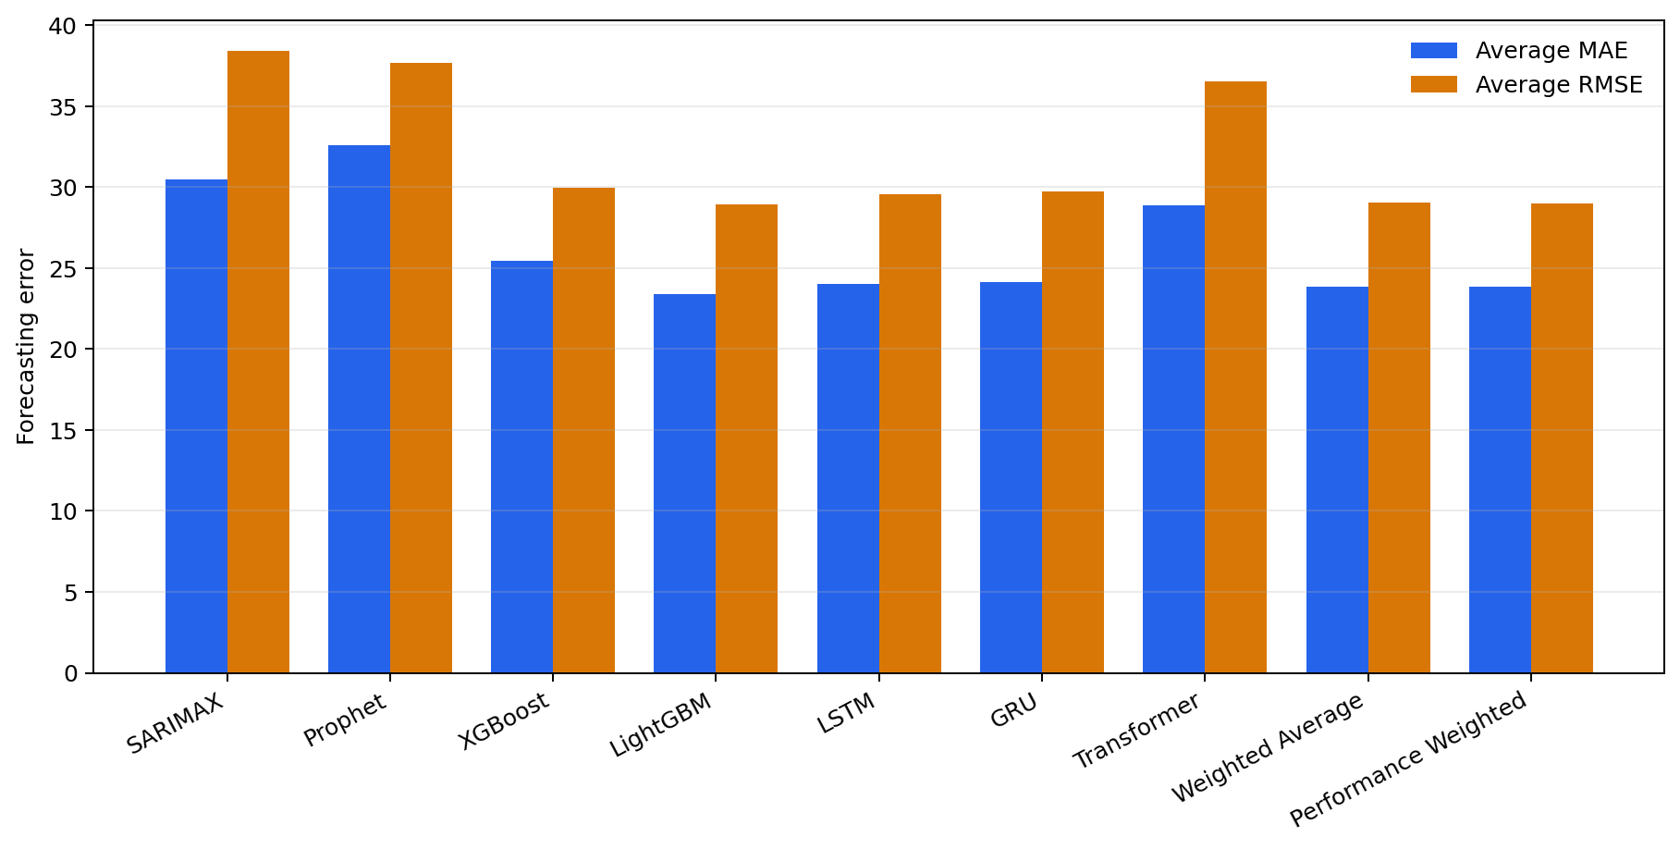
Figure ‎4:23: Overall Average MAE and RMSE Comparison of Forecasting Models

However, the best model can depend on the practical requirement. If fast prediction is required, XGBoost is useful because it had the fastest inference time. If percentage error is more important, Transformer is useful because it achieved the best MAPE. If balanced and stable forecasting is required, ensemble forecasting can be considered.

Practical Suitability for Pharmacy Decision-Making
For practical pharmacy decision-making, the forecasting model should be accurate, fast, and interpretable. Based on the results, LightGBM is suitable when accuracy is the main requirement. XGBoost is suitable when faster prediction is needed. LSTM and GRU are useful when sequential sales behaviour is important. Ensemble forecasting is useful when users want a balanced result from multiple models.
In real pharmacy environments, forecast results can support stock purchasing, inventory planning, and shortage prevention. The system also provides explainability outputs, which help users understand the reason behind a prediction. Therefore, the final system is practical because it allows users to choose the model based on their decision-making need rather than depending on a single forecasting method.

Discussion
This chapter discusses the findings of the drug sales forecasting system developed in this study. The main objective of the research was to predict pharmaceutical drug sales using machine learning and deep learning techniques, while comparing the forecasting performance of different models across multiple drug sales categories. The findings show that predictive modelling can support pharmacy inventory planning, demand forecasting, and decision-making by identifying future sales trends from historical weekly sales data.
The dataset used in this study consisted of weekly pharmaceutical sales records from 2014 to 2023, covering eight drug sales categories labelled as C1 to C8. The results indicate that the sales behaviour differed significantly between categories. For example, C4 had the highest average sales volume, while C6 had the lowest sales volume and included zero-sales weeks. This variation affected model performance, especially when percentage-based error measures such as MAPE were used. Therefore, the results suggest that drug sales forecasting should not depend on a single model or single evaluation metric.
The comparison of models showed that LightGBM achieved the best overall performance in terms of average MAE and RMSE. Its final MAE was 23.3728, and its final RMSE was 28.9163, making it the strongest overall model among the tested approaches. This result is consistent with existing machine learning literature, where gradient boosting models such as LightGBM and XGBoost often perform well on structured tabular datasets because they can capture nonlinear relationships, trend changes, and interactions between lag-based features.
The deep learning models, especially LSTM and GRU, also produced strong results. LSTM achieved a final MAE of 24.0362, while GRU achieved 24.1104, which were very close to LightGBM. This shows that recurrent neural networks are suitable for time-series sales forecasting because they are designed to learn sequential patterns. However, the small difference between LightGBM and LSTM/GRU suggests that for this dataset, tree-based models can perform as well as or better than more complex deep learning models, especially when the dataset is not extremely large.
The results also show that no single model was best for every category. For example, GRU produced the lowest MAE for C1, Prophet performed best for C2 and C3 by MAE, LightGBM performed best for C4, LSTM performed best for C5, C6, and C8, and XGBoost performed best for C7. This finding is important because it shows that pharmaceutical demand patterns are category specific. Some drug categories may follow stable seasonal patterns, while others may be affected by irregular demand, prescription behaviour, disease outbreaks, stock availability, or customer purchasing habits.
Table ‎5-1: Best Forecasting Model for Each Drug Category Based on MAE
Category | Best Model | MAE | RMSE | MAPE (%)
C1 | GRU | 9.8758 | 12.3715 | 19.6650
C2 | Prophet | 13.1088 | 14.6696 | 56.3744
C3 | Prophet | 10.2570 | 12.2604 | 41.5235
C4 | LightGBM | 72.6065 | 92.3468 | 29.3020
C5 | LSTM | 24.8986 | 30.4647 | 34.2579
C6 | LSTM | 3.1634 | 4.0392 | 58.0671
C7 | XGBoost | 26.0462 | 33.0924 | 106.2338
C8 | LSTM | 13.8154 | 15.1094 | 164.4483

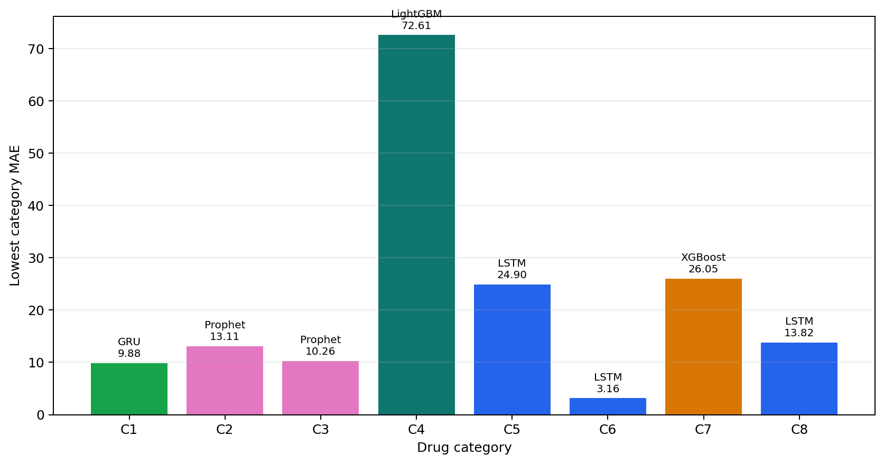
Figure ‎5:1: Category-Wise Best Forecasting Model Based on MAE

The performance of SARIMAX and Prophet was mixed. These traditional and statistical forecasting models are useful when trend and seasonality are dominant, but they were less consistent across all categories. Prophet performed well for some categories such as C3, but poorly for high-volume or irregular categories such as C4. SARIMAX also showed reasonable MAPE for some categories but had higher MAE and RMSE overall. This suggests that classical time-series models may be useful as baseline models, but they may not fully capture nonlinear sales behaviour in pharmaceutical datasets.
The MAPE results require careful interpretation. Some categories, especially low-volume categories such as C6 and C8, produced very high MAPE values even when MAE and RMSE were relatively small. This occurs because MAPE becomes unstable when actual sales values are very low or close to zero. For example, C6 had an average sales value of only about 5.76, and zero-sales weeks were present. In such cases, a small absolute error can become a very large percentage error. Therefore, MAE and RMSE are more reliable indicators for evaluating this forecasting system, while MAPE should be used only as a supporting metric.
The ensemble methods produced stable results but did not consistently outperform the best individual model. The weighted ensemble and performance-weighted ensemble reduced risk by combining multiple models, but their execution time was higher than individual models. This suggests that ensemble forecasting can be valuable when stability is more important than speed, but for practical pharmacy systems, LightGBM or LSTM may be more efficient choices.
From a practical perspective, the findings show that the proposed system can support better pharmaceutical inventory management. Accurate sales forecasting can help pharmacies reduce stock shortages, prevent overstocking, improve purchasing decisions, and manage category-level demand more effectively. This is especially important in healthcare supply chains, where poor forecasting can affect both business performance and patient access to medicines.
The study also contributes technically by implementing multiple forecasting approaches in one system, including machine learning models, deep learning models, statistical models, explainability components, and a web/API-based deployment structure. The inclusion of SHAP-based explainability and service-based architecture improves the practical value of the system because users can not only obtain predictions but also understand and access them through an application interface.
However, several limitations should be considered. First, the dataset contains weekly sales records for eight categories only, which limits the generalizability of the findings. Second, external factors such as holidays, epidemics, weather, promotions, supplier delays, economic conditions, and regional population differences were not included. These factors may strongly influence pharmaceutical demand. Third, the project data is category-based, so if the research aim is specifically area-based forecasting in Sri Lanka, future work should include explicit area, branch, or district-level data. Finally, the high MAPE values in low-volume categories show that evaluation metrics must be selected carefully.
In conclusion, the results demonstrate that machine learning models can effectively forecast pharmaceutical sales using historical weekly data. LightGBM provided the best overall performance, while LSTM and GRU showed strong capability in capturing sequential sales patterns. The study confirms that model performance varies across drug categories, and therefore a flexible forecasting system is more suitable than relying on a single universal model. These findings support the use of predictive analytics in pharmaceutical sales planning and provide a foundation for future improvements using real-time data, external demand factors, and area-specific forecasting.

Conclusion

INTRODUCTION
This chapter presents the conclusion of the study conducted on predicting pharmaceutical drug sales using machine learning and deep learning techniques. The main purpose of this research was to develop and evaluate a forecasting system that can support better decision-making in pharmaceutical sales, inventory management, and demand planning. In the pharmaceutical sector, accurate sales prediction is highly important because medicines are essential products, and incorrect demand estimation can result in serious operational and social consequences. Overstocking may lead to wastage, increased storage cost, and expiry-related losses, while understocking may create shortages and affect patient access to necessary medicines. Therefore, the development of a reliable forecasting system is useful not only from a business perspective but also from a healthcare service perspective.
The study focused on historical weekly drug sales data covering the period from 2014 to 2023. The dataset consisted of eight drug sales categories represented as C1 to C8 in the implementation. In the original dataset, these categories were related to pharmaceutical drug groups such as M01AB, M01AE, N02BA, N02BE, N05B, N05C, R03, and R06. These categories showed different levels of demand, sales variation, and forecasting difficulty. Because of this, the study did not rely on only one forecasting technique. Instead, several statistical, machine learning, and deep learning models were implemented and compared.
The models evaluated in this research included SARIMAX, Prophet, XGBoost, LightGBM, LSTM, GRU, and Transformer-based models. In addition to individual models, ensemble-based approaches were also tested. The performance of these models was measured using common forecasting evaluation metrics, including Mean Absolute Error, Root Mean Squared Error, and Mean Absolute Percentage Error. These metrics helped identify not only the most accurate models but also the strengths and weaknesses of each modelling approach under different sales patterns.
Overall, the research successfully achieved its main objective by developing a functional and comparative forecasting system for pharmaceutical sales prediction. The findings demonstrate that machine learning and deep learning techniques can be effectively used to forecast drug sales trends, although model performance depends strongly on the characteristics of each drug category.

ACHIEVEMENT OF RESEARCH OBJECTIVES
The first objective of this study was to understand the nature of pharmaceutical sales data and prepare it for forecasting. This objective was achieved by collecting and organizing weekly sales data across multiple drug categories. The dataset contained 517 weekly records from January 2014 to December 2023. The data showed that sales behaviour varied considerably between categories. For example, some categories had relatively stable sales patterns, while others showed higher fluctuations. Category C4 had the highest average sales volume, while C6 had the lowest average sales volume and included weeks with zero sales. This initial analysis was important because it showed that pharmaceutical sales forecasting is not a uniform problem. Different drug categories have different demand structures, and this affects how well each forecasting model performs.
The second objective was to implement different forecasting models suitable for time-series sales prediction. This objective was also achieved. The project implemented both traditional and advanced forecasting methods. SARIMAX and Prophet were used as statistical and time-series baseline models. XGBoost and LightGBM were used as machine learning models capable of handling nonlinear relationships in structured data. LSTM and GRU were used as recurrent deep learning models designed to capture sequential dependencies in time-series data. Transformer-based forecasting was also included to evaluate the ability of attention-based models to learn long-term patterns. By implementing this wide range of models, the study created a strong comparative framework for evaluating drug sales prediction.
The third objective was to evaluate and compare the performance of the implemented models. This was achieved by calculating MAE, RMSE, and MAPE for each model across the eight drug categories. The results showed that LightGBM achieved the best overall performance, with a final MAE of 23.3728 and a final RMSE of 28.9163. LSTM and GRU also performed strongly, with final MAE values of 24.0362 and 24.1104 respectively. These results show that both gradient boosting models and recurrent neural networks are suitable for pharmaceutical sales forecasting. However, the study also found that no single model was best for every category. For example, GRU performed best for C1 based on MAE, Prophet performed best for C2 and C3, LightGBM performed best for C4, LSTM performed best for C5, C6, and C8, and XGBoost performed best for C7. This confirms that different drug categories require different modelling approaches.
The fourth objective was to develop a practical forecasting system rather than only performing a theoretical comparison. This objective was achieved through the implementation of a complete software system. The project includes trained model artifacts, evaluation results, forecasting utilities, a web interface, API services, explainability components, and deployment-related files. This makes the work more practical and applicable to real-world use. A pharmacy, distributor, or healthcare organization could use such a system to support sales forecasting, inventory planning, and decision-making.
The final objective was to identify the limitations of the proposed system and recommend improvements for future research. This objective was addressed through the analysis of model performance, metric behaviour, data constraints, and practical deployment considerations. The findings show that the current system provides a strong foundation, but further improvements are possible by including external demand factors, expanding the dataset, improving area-level data representation, and integrating real-time inventory information.

SUMMARY OF KEY FINDINGS
The most important finding of this research is that machine learning models can effectively forecast pharmaceutical sales using historical weekly data. Among the tested models, LightGBM provided the best overall results in terms of MAE and RMSE. This suggests that gradient boosting models are highly suitable for structured sales forecasting problems. LightGBM can capture nonlinear relationships and interactions in the data while remaining computationally efficient. Compared with deep learning models, it also has the advantage of faster training and inference, making it useful for practical systems where predictions need to be generated regularly.
Another major finding is that recurrent neural networks, especially LSTM and GRU, are also highly effective for drug sales forecasting. These models are designed to learn temporal dependencies, which is important when past sales influence future sales. The results showed that LSTM and GRU performed very close to LightGBM overall. LSTM achieved the best MAE in several categories, including C5, C6, and C8, while GRU performed best for C1. This indicates that deep learning models can capture sequential sales behaviour well, especially where demand patterns depend on previous time periods.
The study also found that traditional forecasting models such as SARIMAX and Prophet were useful but less consistent. SARIMAX provided reasonable results for certain categories but had weaker overall MAE and RMSE values compared with LightGBM, LSTM, and GRU. Prophet performed well in some categories, especially C2 and C3, but performed poorly in others, such as C4. This suggests that traditional models may work well when trend and seasonality are clear, but they may not fully capture complex or nonlinear demand patterns in pharmaceutical sales data.
Another important finding relates to the use of evaluation metrics. MAE and RMSE were more reliable for interpreting model performance across categories, while MAPE was sometimes misleading. In low-volume categories, such as C6, MAPE values became very high even when the actual error was small. This happened because MAPE calculates error as a percentage of the actual value. When actual sales values are close to zero, even a small forecasting error can produce a very large percentage error. Therefore, this study concludes that MAPE should be interpreted carefully in pharmaceutical sales forecasting, especially for low-demand or irregularly sold drug categories.
The study also found that ensemble methods can provide stable predictions but may not always outperform the best individual model. Weighted average and performance-weighted ensemble approaches were tested. These methods reduced dependency on a single model, but they required more processing time because they combined outputs from several models. In practical environments, ensemble models may be useful when reliability and stability are more important than speed. However, when efficiency is important, LightGBM or LSTM may be better choices.

RESEARCH CONTRIBUTIONS
This research makes several contributions to the field of pharmaceutical sales forecasting and healthcare analytics. The first contribution is the development of a comparative machine learning framework for drug sales prediction. Instead of depending on one forecasting method, the study compared multiple models from different categories, including statistical models, machine learning models, deep learning models, and ensemble methods. This provides a broader understanding of which models are suitable for different types of pharmaceutical sales patterns.
The second contribution is the practical implementation of a forecasting system. The project is not limited to model training and evaluation. It includes a web-based interface, forecasting services, API endpoints, trained model files, and deployment support. This practical implementation increases the value of the research because it shows how forecasting models can be integrated into a real software environment. Such a system can support pharmacy managers, healthcare suppliers, and decision-makers by providing future demand estimates.
The third contribution is the category-wise analysis of model performance. The results clearly show that model performance differs between drug categories. This is an important contribution because it demonstrates that pharmaceutical demand is not uniform. Some categories may have stable demand, while others may be irregular, seasonal, or highly volatile. Therefore, the best forecasting approach may differ depending on the medicine category or product group.
The fourth contribution is the identification of limitations in percentage-based evaluation metrics. The study shows that MAPE can be unreliable for low-volume drug categories. This finding is useful for future researchers because it highlights the importance of selecting appropriate metrics when evaluating pharmaceutical sales forecasting models.
The fifth contribution is the inclusion of explainability and advanced system components. The project includes explainability-related functionality such as SHAP-based interpretation, as well as advanced concepts such as meta-learning, uncertainty quantification, and service-oriented architecture. Although these components can be further improved in future work, their inclusion shows that the system was designed with practical usability, transparency, and scalability in mind.

PRACTICAL IMPLICATIONS
The findings of this research have several practical implications for pharmaceutical sales and inventory management. A forecasting system such as the one developed in this study can help pharmacies and drug distributors estimate future demand more accurately. This can support better purchasing decisions, reduce unnecessary stock accumulation, and minimize the risk of stock shortages.
Accurate forecasting is especially important in pharmaceutical supply chains because medicines have expiry dates and storage requirements. Overstocking can result in financial losses due to expired medicines, while understocking can affect customer satisfaction and patient care. By predicting future sales more accurately, pharmacies can maintain a better balance between availability and cost.
The system can also support category-level planning. Since different drug categories showed different demand behaviour, pharmacy managers can use category-specific forecasts to make more informed decisions. High-demand categories may require closer monitoring and larger safety stock, while low-demand categories may require careful ordering to avoid wastage.
Another practical implication is that the system can support digital transformation in pharmacy operations. Many pharmacies still depend on manual experience or simple historical averages for stock planning. A machine learning-based forecasting system can provide more systematic and data-driven decision support. This can improve operational efficiency and help organizations respond better to changing demand patterns.

LIMITATIONS OF THE STUDY
Although the study achieved its objectives, several limitations should be acknowledged. The first limitation is related to the dataset. The study used historical weekly sales data from 2014 to 2023, but the data was limited to eight drug categories. A larger dataset with more product categories, brands, pharmacies, and regions would improve the generalizability of the results.
The second limitation is that the dataset did not include external factors that may influence pharmaceutical sales. Drug demand can be affected by many real-world factors, such as seasonal diseases, epidemics, holidays, weather conditions, promotions, doctor prescriptions, supplier delays, price changes, and economic conditions. Since these variables were not included, the models learned only from historical sales patterns. Including external variables could improve forecasting accuracy.
The third limitation is related to area-specific forecasting. The project title refers to predicting drug sales for specific areas in Sri Lanka. However, the available implementation data is mainly organized by drug category. If the final research objective is area-level prediction, future work should include explicit district, city, branch, or pharmacy-level sales data. This would allow the system to predict demand for specific geographical locations more accurately.
The fourth limitation is the instability of MAPE for low-volume categories. As discussed earlier, categories with very small sales values can produce very high MAPE values even when the actual prediction error is not large. This means that MAPE should not be used alone to judge model performance in such cases.
The fifth limitation is that the system was evaluated mainly using historical test data. Although this is suitable for academic evaluation, real-world deployment would require continuous monitoring. Sales patterns may change over time due to market conditions, medical trends, or supply chain disruptions. Therefore, the models may need to be retrained periodically to maintain accuracy.

RECOMMENDATIONS FOR FUTURE WORK
Future research can improve this study in several ways. First, the dataset should be expanded. More drug categories, longer historical periods, and data from multiple pharmacies or regions should be included. This would allow the models to learn broader and more realistic demand patterns.
Second, future studies should include external influencing factors. Variables such as holidays, seasonal illness trends, weather, disease outbreaks, promotions, price changes, and regional population data could improve prediction accuracy. For pharmaceutical demand, external factors can be very important because medicine sales are often affected by health conditions in the population.
Third, future work should focus more strongly on area-based forecasting. If the system is intended for Sri Lankan regional drug sales prediction, data should be collected at district, branch, or pharmacy level. This would allow the system to identify regional demand differences and provide more useful forecasts for local inventory planning.
Fourth, automated model selection can be added. Since no single model performed best for every category, the system could automatically select the best model for each drug category based on previous performance. For example, LightGBM may be used for some categories, LSTM for others, and Prophet or XGBoost where they perform better.
Fifth, future work can improve ensemble learning. More advanced ensemble methods, such as stacking with a meta-model, dynamic weighting, or error-based model selection, could be tested. These methods may improve stability and accuracy across different sales categories.
Sixth, the explainability component can be further developed. SHAP values and feature importance analysis can help users understand why a model makes a certain prediction. This is especially important in healthcare-related systems, where users may need to trust and justify data-driven decisions.
Finally, the system can be integrated with real pharmacy inventory management software. This would allow automatic data collection, real-time forecasting, reorder alerts, stock monitoring, and decision support. Such integration would make the research more useful in practical healthcare supply chain environments.

FINAL CONCLUSION
In conclusion, this study successfully developed and evaluated a machine learning-based pharmaceutical drug sales forecasting system. The research demonstrated that historical weekly sales data can be used to predict future drug sales with reasonable accuracy. By comparing multiple models, the study found that LightGBM achieved the best overall performance in terms of MAE and RMSE, while LSTM and GRU also produced strong and competitive results. The findings confirm that both machine learning and deep learning techniques are suitable for pharmaceutical sales forecasting.
The study also showed that drug sales patterns differ across categories. Because of this, one universal forecasting model may not be suitable for all drug groups. A flexible forecasting system that can evaluate and select different models for different categories is more appropriate. The research further highlighted that evaluation metrics must be selected carefully, especially when dealing with low-volume sales categories where MAPE can become misleading.
The proposed system has practical value for pharmaceutical inventory management. It can help reduce stock shortages, avoid overstocking, improve purchasing decisions, and support better planning in pharmacy operations. Although the study has limitations, especially regarding dataset size, external factors, and area-level data availability, it provides a strong foundation for future research and system development.
Overall, this research contributes to the application of predictive analytics in pharmaceutical sales forecasting. It shows that data-driven forecasting methods can support better healthcare supply chain decisions and improve the efficiency of medicine availability. With further improvements, such as real-time data integration, area-specific forecasting, external variable inclusion, and automated model selection, the proposed system can become a more powerful and practical tool for pharmaceutical demand prediction in Sri Lanka and similar healthcare environments.

References

[1] S. Abbas, A. Qaisar, M. S. Farooq, M. S. M. Ahmad, and M. A. Khan,
“Smart Vision Transparency: Efficient Ocular Disease Prediction Model Using Explainable Artificial Intelligence,” Sensors, vol. 24, no. 20, 2024.

[2] M. S. Khan, N. Tafshir, K. N. Alam, A. R. Dhruba, M. M. Khan, A. A. Albraikan, and F. A. Almalki, “Deep Learning for Ocular Disease Recognition: An Inner-Class Balance,” Computational Intelligence and Neuroscience, 2022.

[3] T. Nazir et al., “Detection of Diabetic Eye Disease from Retinal Images Using a Deep
Learning-Based CenterNet Model,” Sensors, vol. 21, no. 16, 2021.

[4] T. Gamage et al., “Age-Related Retinal Disease Identification Using Image Processing and Deep Learning,” in Proc. 4th Int. Conf. Computing and Artificial Intelligence (CCAI), 2024.

[5] K. H. Wijesinghe et al., “Identification of Diabetic Related Eye Diseases Using Deep
Learning,” in Proc. 5th Int. Conf. Advancements in Computing (ICAC), 2023.

[6] S. B. Ekanayake, G. Lakmal, A. Perera, M. Nasmeen, P. Vimanshani, and M. D.
Chandrasena Atampalage, “Predicting Medical Drug Sales in a Specific Area for Categorical Drugs Using Time Series Forecasting,” in Proc. Int. Research Conf. Smart Computing and Systems Engineering (SCSE), Colombo, Sri Lanka, Apr. 2025, pp. 1–6, doi:10.1109/SCSE65633.2025.11031056.

[8] P. Hewamalage, C. Bergmeir, and K. Bandara, “Recurrent Neural Networks for Time Series Forecasting: Current Status and Future Directions,” International Journal of Forecasting, vol. 37, no. 1, pp. 388–427, 2021.

[9] M. Lim and A. Zohdy, “Explainable Artificial Intelligence for Business Decision Support: A Case Study in Sales Forecasting,” in Proc. IEEE Int. Conf. Artificial Intelligence and Data Analytics (CAIDA), 2023.

[10] Y. Xiong, “Development of an AI-Driven Model for Drug Sales Prediction Using XGBoost and Enhanced Golden Eagle Optimization (EGEO),” Informatica, vol. 49, 2025.

Appendices

